1.2.1 Types of Organizations

Private vs. Public Sector:

- ____________________ sector: organizations owned, controlled and managed by private individuals, usually for the purpose of making profit.
- ____________________ sector: organizations owned, controlled and managed by the government.
  - Public ownership is much less common these days as it is felt that businesses are much more efficient if they are privately owned.

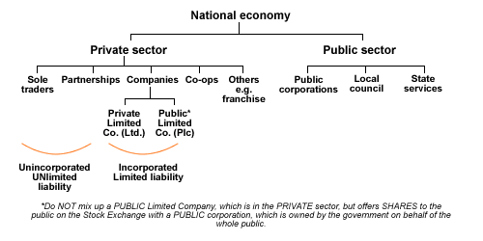
- ___________________________: the selling of government-owned industries to private investors.
  - Advantages:

    - Reduces _______________ – private firms are more efficient
    - Improved quality – competition
    - Encourages innovation/invention – profit motive
    - Increases ___________________ – competition

  - Disadvantages:

    - Monopolies can fall into private hands – exploit the consumers with high prices.
    - __________________________ – private firms may tend to pollute more in order to save money.

- _____________________________: the removal of government rules, controls, and restrictions on production and trade.

Starting a Business:

- People (usually) start a business to make money. This is termed _________________________________________

4 Key Elements to Starting a Business

- A product/service – What product or service are you going to sell?
  - Develop, create, and sell a brand new unique product. – patent it!!!
  - 'Me too' products are basically adapted copies of existing products or services.
  - Service activities are usually cheaper to set up and operate.

- A ____________________________ edge – Does the business have a unique selling point (USP)? What sets your product out from the rest?

- _____________________________________ – Depending on its structure, a company can have different sources of finance (e.g. bank loan, shareholder capital, self-financed, venture capitalist, etc).

- Personal skills – Does the company’s employees possess the necessary skills to run a successful business? (accounting, marketing, etc).

Problems Faced By Start-Up Businesses

- Finance:
    - Hard to raise ___________.
    - No security for loans, such as property or personal guaranty.
    - A new business has no track record for a bank to assess, thus the _____ are greater for banks.
- Location:
    - Costs can be minimized if the business starts at _______.
    - A good location might be very ____________.

- Delivering a customer base + brand loyalty + repeat business:
    - Building good relations with customers take a long time and costs a lot.
    - Investing in after-sales service or “custom-made” offers is challenging for a new business.

- Poor cash flow:
    - Many start-ups fail because they don’t manage their _________ in the early years.
    - Managing _________ for a new business might include:
      - Chasing new customers for payments
      - Slowing down payments to suppliers.

- Personality of the entrepreneurs:
    - Do they have the desire to make the business work at all costs?

- HR management skills:
    - Are the managers able to manage & _______ a workforce?

Activity – Build a Business Worksheet on Edmodo

