5.7 Stock Control – ‘Coffee-Cool’
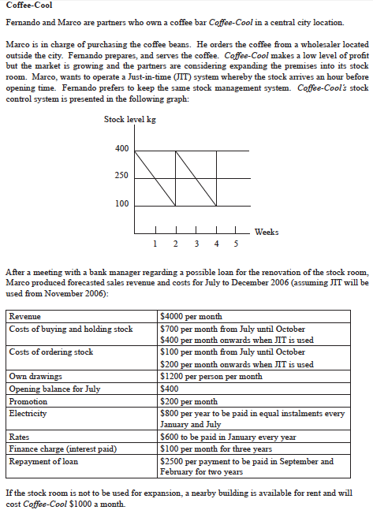
1) Identify the following: i) Lead time ii) Buffer stock iii) Re-Order Quantity (5 Marks)
2) Evaluate Marco’s proposal to change to a Just-In-Time (JIT) stock management system (7 Marks)

_____________________________________________________________________________________________________________________________________________________________________________________________________________________________________________________________________________________________________________________________________________________________________________________________________________________________________________________________________________________________________________________________________________________________________________________________________________________________________________________________________________________________________________________________________________________________________________________________________________________________________________________________________________________________________________________________________________________________________________________________________________________________________________________________________________________________________________________________________________________________________________________________________________________________________________________________________________________________________________________________________________________________________________________________________________________________________________________________________________________________________________________________________________________________________________________________________________________________________________________________________________________________________________________________________________________________________________________________________________________________________________________________________________________________________________________________________________________________________________________________________________________________________________________________________________________________________________________________________________________________________________________________________________________________________________________________________________________________________________________________________________________________________________________________________________________________________________________________________________________________________________________________________________________________________________________________________________________________________________________________________________________________________________________________________________________________________________________________________________________________________________________________________________________________________________________________

