IB Spanish AB Initio, Year 2

Instructor: Profesora Jennifer Crick
j.crick_daa@gemsdaa.com

Prerequisite
None. AB initio is a two-year language course for students who have little or no previous experience learning Spanish.

Course Description
The main focus of this course is on the acquisition of language required for purposes and situations in everyday social interaction. The AB initio course aims to develop a variety of linguistic skills, and a basic awareness of the culture(s) using the language. During class, students are expected to participate in activities, practices, and discussions when appropriate and to the best of their ability in a positive manner. You are also expected to SPEAK IN SPANISH FOR THE ENTIRE TIME—you only get better with effort!

Themes and Topics

Grade 11
The Individual and Society: personal identification, family, relationships, physical appearance, character, daily routine, education, food and drink, types of accommodation, life at home, household tasks, invitations, celebrations, shopping

Leisure and Work: Professions, leisure activities, holidays, customs, popular media, sports, technology, transport

Urban and Rural Environment: weather, seasons, countries and regions, neighborhood shops, goods, town services, public transport

Grade 12
The Individual and Society: meals in a restaurant, university goals, physical health, lifestyle, emergencies

Leisure and Work: job applications, salaries, the arts, holiday arrangements, road signs and transport, regional foods, news reports, Internet relationships

Urban and Rural Environment: environmental concerns, environmental responsibility, global issues, geographical features, natural catastrophes

Resources En Marcha B1: Libro

Materials 2-ring binder and loose-leaf paper
Recommended: 4 dividers: Español, Calentamientos, Apuntes, Tarea
Black or blue pens. Pens are required for graded work.
Optional: Spanish/English dictionary
Workbook: En Marcha B1, Cuaderno de ejercicios

Grade distribution
Semester grades: 80%
Summative (Exam, Composition) 60 %
Formative (Quizzes, Classwork) 40 %
Practice outside of class 0 %

End-of semester Exam 20 %

Also note that IB style assessments (Paper 1 and Paper 2, Orals, and the intercultural Written Assignment) are graded along the IB scale.

Homework and make-up work policy:

It is important for the student to do regular practice and homework in order to succeed. The teacher will evaluate student progress through assessment of quizzes and activities in class.

Homework practice outside of class is assigned to reinforce class concepts. It is the student’s responsibility to complete all assignments, research, or project completion as required by the teacher. Though homework is checked for completion and for understanding, the practice done outside of class is not graded.

If a student requires an extension for an assignment or project due date, he/she must request it from the teacher at least one day before the due date. (example: extension for MESAC event)

Academic Honesty and Consequences
Independently written assignments will be submitted through TurnItIn.com.

Note that any work with content partly or completely copied and pasted from any Internet website will be penalized with a 0%.

In the case of the Written Assignment, where the use of a computer is allowed by the IB organization, please note that any plagiarism will be notified to the IB Coordinator.

IB Evaluation - Standard Level, Senior Year

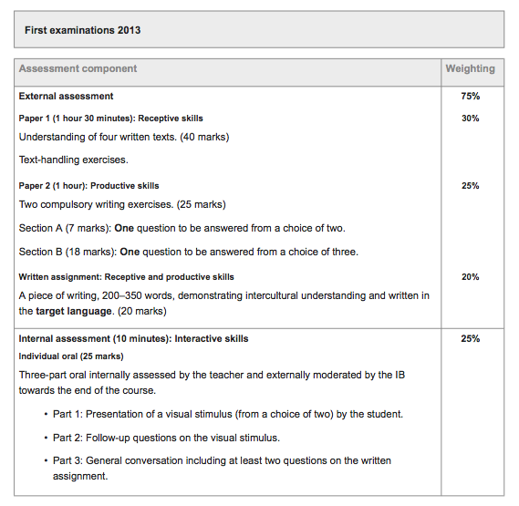
IB Language AB Initio Guide, Updated 2015

WRITTEN ASSIGNMENT (January)

SEMESTER EXAM: DAA MOCK (January)

ORAL (Internal Assessment) (February - March)

READING COMPREHENSION (PAPER1) _ (May)

WRITTEN PRODUCTIVE SKILLS (PAPER2) (May)

