Recycled Coffee Table

FULL NAME
IB Student Number:
SCHOOL NAME
Design Technology HL

Internal Assessment

BRAINSTORM

PLANNING
Aspect 1- Identify the Problem
While living in small apartments during the summer, it occurred to me that many people compromise for furniture. In my opinion, I think that all apartments can have all sorts of furniture but in different shapes, sizes, and uses, in order to keep them organized and spacious, therefore I decided to head into the direction of a multifunctional, recyclable table. This problem, of small apartments due to locations, and prices of rent, and a comprise in the purchase of home furniture, initiated a desire to find a solution. Organization and space are an essential for an easy, everyday lifestyle. Having a more organized and spacious apartment can create a less stressful, and organized lifestyle. Organization eliminates the thought of cleaning up everyday, not having space, and losing materials. The reason why this furniture should be created is because it gives the customer to have the freedom to use it in anyway wanted, and also create it in any way, which wanted. The ultimate problem that people in small apartments face everyday is, space and organization. While having a random survey shows that 40/50 people would rather live in an empty house rather than buying new furniture to fit the space of their home, and this shows that pricing was a problem for them. Clearly, this problem was worth for more investigation on the though of how should people with apartment 40m or less save up space by using multifunctional furniture?

Aspect 1- Design Brief:
Consider a table, which is multifunctional, with storage space that can be used in apartments that are (40 meters of less).
To design and manufacture coffee tables that includes both space and multifunctional purposes. The goal of the project is to make a table that will be multifunctional for apartments that are 40 meters or less. This will allow potential customers to have more furniture but be able to distribute it to different parts of the house and if they want a bigger table then put them all together to get the size of furniture that they want. Major constraints of this product is that the table may be too heavy or have sharp edges due to the glass on top of the table, the recycled pieces of table and the square shape of the table. In order to measure my success I created a small survey on www.freeonlinesurvey.com, and got 50 people who own apartments that are (40 meters or less) to respond and help with the research on, (whether they would throw out furniture due to lack of space, or would keep old furniture because of its efficiency, etc.) I did this to see what people would like to see in the product because I am designing a product for people with apartments (40 meters or less), so therefore, the democracy in this research is suitable. I will also be looking samples of the IKEA room layout, and small apartment floor plans in Dubai to consider how big the tables should be and how they could be used in an apartment space, which is (40 meters or less).

Initial Specifications:
- Must be easy to carry around the house
- Must not have sharp edges on the ledges for easy carrying
- May include drawers
- May include a large glass on top
- May include drawers

Guiding Questions:
- What type of materials would be the most attractive through still fully recyclable?
- What type of material would last longer?
- What measurements am I going to need to have a table not to short/tall and not to small/big?
- How is my target market going to affect the design?
- How many multifunctional characteristics is my table going to have?
- What materials are safe to use just the way they were recycles, without being altered?

Research Strategy:
Date | Research | Method | Why is it relevant? | Limitations
 | Research benefits of creating the product out of fully recycled material | Online research will be done, with the use of common knowledge. | This will help with the improvement of writing a design brief and it will show the limitations of the design, and it will show whether or not the design will meet its purpose or not. | Information that is found online may not be very reliable, and useful information may not be found.
 | Different types of recycled material | Other than internet research, a survey will be given out. | The research will help understand what recycled material will meet the standards of a proper coffee table, and there will be an understanding of the risks of damage is recycled materials are used. | Again online research may not be so reliable and accurate due to the different conditions that the recycled materials are exposed to.
 | Existing design that could be made by fully recycled material | Internet research will be done to see the existing designs of coffee tables, and will be analyzed on which will be the best to be made from recycled material. | This can help me see the general idea for multifunction tables and possible requirements for the table’s measurements. | This will be hard to analyzed because it is going to be made fully out of recycled material, and depending on where the recycled material is collected from then different conclusions will be made.
 | Research limiting factors that could affect the design | During the processes of building, research will be done to see the limitations of the project | This will help me reflect at the end of the project on what the improvements could be if the project was going to be done again | As this is going to be an ongoing process during the project, all the conclusions may not be the same if the project is done in another way.
 | Materials and Research | Research will be done on what different recycled materials would be best for the coffee table production. | Research on the materials will help me determine on what materials would be able to sustain themselves as they are recycled materials and have been already used. | This can again not be reliable due to the outside factors depending on the regions that the project has been made.

Specification:

Specification | Justification
Tables will be square shaped | A decent shape which most costumers are comfortable with and more fitting with the environment.
Tables will have recycled material used for its decorations | Recycled materials will bring down the cost of the overall product, and will be eco-friendly.
Tables will be multifunctional | This will help with space and organization in the small apartments
Tables will have a thin glass over the table top | The glass will help with making the table have a flat surface, decorative, easy to clean.
Tables will be set next to each other to create on big square table | The connection between the four tables will let for more freedom of setting for the customer.
Product will be handmade | Product is very simple to make, and the coloring of the wood should be delicately done.
Easy to use/not too heavy | Table should not be too heavy so that any one can easily pick it up and place it in different parts of the apartment.
No lose pieces of recycled material | Broken pieces of recycled material may be hazardous to apartments and people and needs to be double checked so that there are no lose pieces.
May include drawers | This will help the storage space of more objects in less amount of space.

Research:
- Benefits of creating the product out of fully recycled material.
From research it is shown that customers usually want a comfortable yet unique living space, so as a designer they must think of decors, which will fit the clients space and ideals. And since currently we live in a world, which people care environmentally aware and want to have the best impact on the world around them, they demand for environmentally friendly designs of furniture, challenging the minds of the designers.
Having ‘Environmentally Friendly Furniture’ has different meanings to different customers. As some people like to use from certified sustainable sources such as leather and wood, while others so not want new material and prefer to have secondhand furniture or have their furniture build out of old furniture or other recycled material.
‘Benefits of using recycled material’ is that it has a clear meaning, such as there were no new trees being cut down, no new cotton farmed, no cows raised and slaughtered and every single piece of furniture has been made in order to have the least amount of harmful impact on it. That is not the only benefit, as using recycled material will genuinely give the furniture a unique look, which barely anyone else will have and it has a very creative look in terms of its looks.
And in terms of ‘Marketing Benefits’ using recycled material will help with green credentials for the business, as it will make the profile more unique and more professional.

- Different types of recycled material
Basically, any kind of recycled material could be used in order to make the furniture, and these items can usually be found in a normal household. Items are: fabric, wood, plastic and metal. Sample of their uses are shown in the figures below.
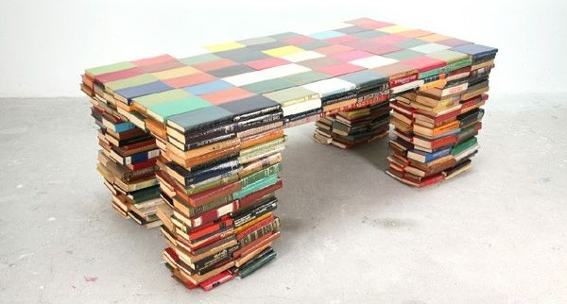

Figure 1: table made from recycled paper (books)

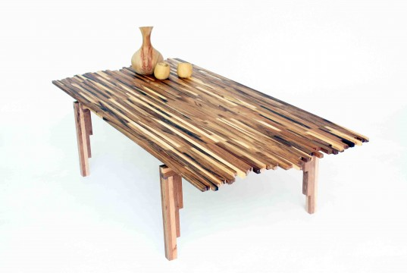

Figure 2: Table made from recycled wood

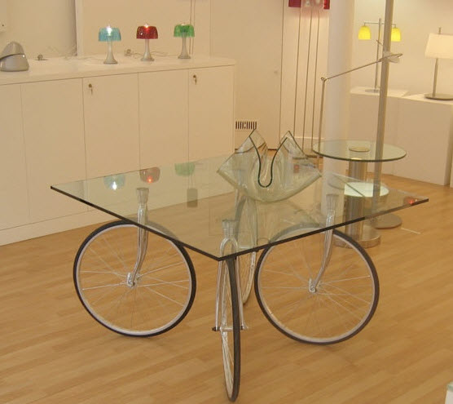

Figure 3: Table made from recycled metal (bicycle tires and glass)

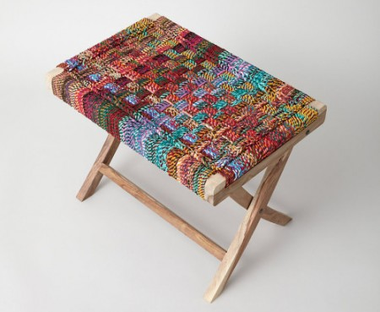

Figure 4: Table made from recycled fabric and wood

- Existing design that could be made by fully recycled material
The following sketches are from existing designs that can be altered in order to be made from recycled materials. Current table designs could be combined with another design to create a new and unique design.

- Research limiting factors that could affect the design
Regarding the limiting and disadvantage factors is that when using recycled material it may:
-Not always be cost effective
-May not last for long
-Unsafe and Unhygienic
All these factors affect the idea of whether or not recycled material should be used as the idea has both its advantages and disadvantages.

- Materials and Research
As mentioned before any material could be used in order to make the multifunctional coffee table, though if using existing designs, some need to be modified in order to create a fully environmentally friendly product.

Life Cycle Analysis:
-Coffee table made from recycle materials
 | Pre-Production | Production | Distribution | Utilization | Disposal
Water | Before the project had started, the seeds of the trees had to be watered in order to the trees to grow. And the pieces of wood may have been shipped by boats and this creates a possibility of a small amount of pollution in water. | During production water was used to clean the machines, and water was also used to be mixed with ink or colored powders for the staining of the wood | Water was not used for the product during distribution phase | Water was not used for the product during utilization phase | Water was not used for the product during disposal phase
Soil Pollution/Degradation Air Contamination | There is minimum pollution of soil and air. The soil could be polluted as the farm grounds may have been burned in order to clear up the lands, and there is some amount of air contamination due to the use of vehicle transportation for the materials, which causes the release of carbon dioxide and other pollutants in the air. | The product is manufactured completely by hand therefore there is no soil or air contamination. | Again transportation is used to distribute the products, which causes air pollution. | There is no soil or air contamination during the utilization process. | Depending on the way of which this product is disposed could affect the sir contamination. As if the wood and nails are recycled then there won’t be much air contamination, but if the wood is burned then there will be some air contamination.
Noise | There will be little to no noise during the pre-production phase. | During the manufacturing processes there will be a very small amount of noises. | There will be little to no noise during the distribution phase, as the only sound will be from the delivery process, such as delivering by trucks. | There will be little to no noise during the utilization phase. | There will be little to no noise during the disposal phase.
Energy consumption | The transportation of materials would require energy consumption. | The production would require a lot of energy consumption and it is all-handmade, with the use of tools. | The transportation of the finalize product to different places will require the result in energy consumption. | There will be no use of energy consumption during the utilization phase. | There will be some amount of energy consumption depending on how the product will be disposed, as if the product is recycled then there will be little energy consumption, though if it is thrown away as a part of trash then there will be more energy consumption.
Consumption of natural resources | Though this is a product made from recycled material, the product started from the use of a natural resource the (tree). | If there are mistakes on the design and the plans of the manufacturing processes then there would be a need of more natural resources in order to fix the problems. | Fuel is natural resource and during the transportation phase fuel will be needed for distributing the product, which causes the consumption of natural resources. | There is no consumption of natural resources during the utilization processes. | There is no consumption of natural resources during the disposal phase.
Pollution and effects on ecosystem | During the transportation phase there would be carbon discharge, which will increase pollution in the long term leading to more long-term problems such as climate changes. | Since the product is fully handmade there will be no pollution during production phase. But if wanting to do bulk productions with machines then harmful fumes will be produced, and even with the dust particles pollution in the air could cause health and safety issues in the factory. | During the transportation phase vehicles will be contributing to the pollution and its effects on the eco system. | There will be no pollution or effects on the ecosystem during the utilization process. | Depending on the way which the table is disposed of there may be little to no pollution. As if the table is recycled then there is no pollution, though if it is burned then there is a small amount of pollution.

Materials needed for the prototype:
- Scissors (250,000 Rials, Shahre Ketab, Iran)
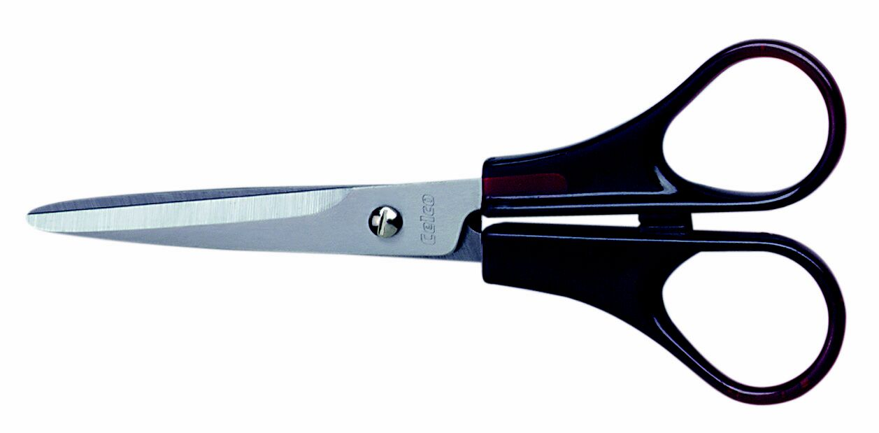

- Thick Poster Paper (50,000 Rial, Shahre Ketab, Iran)
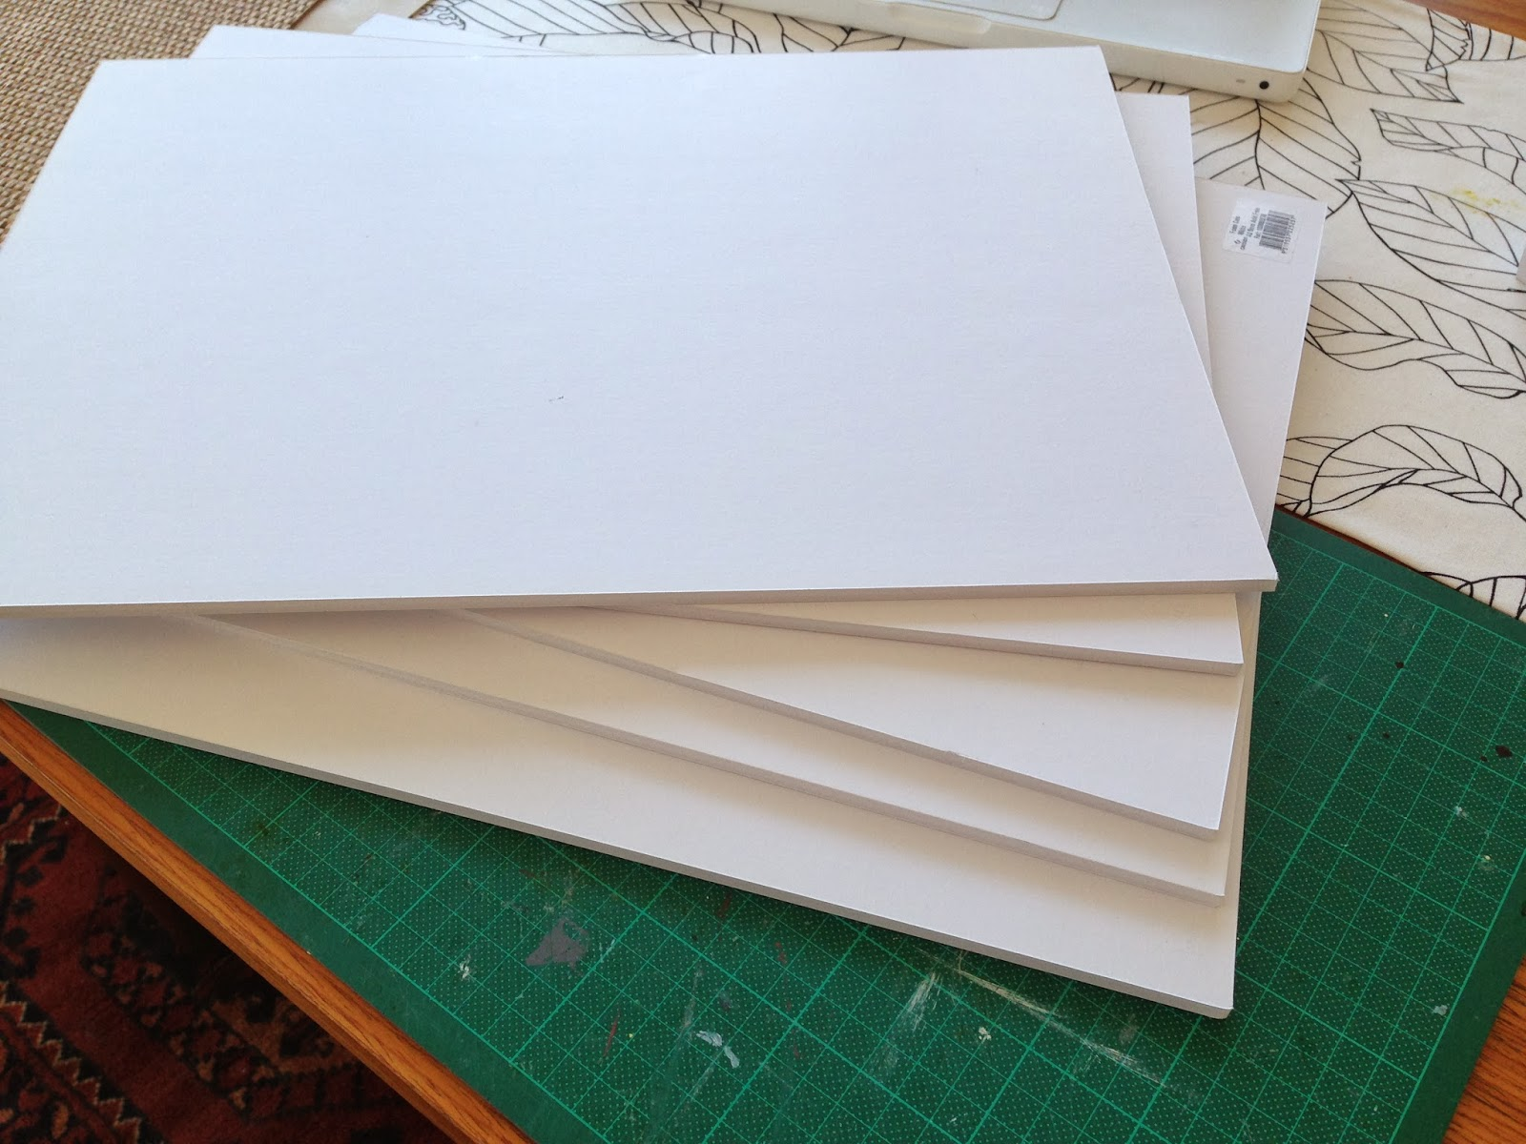

- Glue Stick (50,000 Rial, Shahre Ketab, Iran)
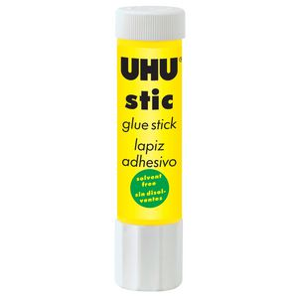

- Wall paper ‘wood design’ (250,000 Rial, Shahre Ketab, Iran)

Materials for the final model:
- 47cm*47cm ‘4 pieces’ MDF Wood (800,000 Rial)
- 10cm*15cm ‘8 pieces’ Fagas Wood
- 10cm*47cm ‘8 pieces’ Fagas Wood (Both equal to 250,000 Rial)
- 38cm*4cm*4cm ’16 pieces’ Platanus Wood (300,000 Rial)

Strategy 1:
What do I want to find out?
If there is a demand in my target population in creating the product that is coffee tables that are made partly from recycled material, multifunctional, and that have storage space.
How do I find it?
I will be conducting a survey with questions that are listed below, with 25 males and 25 females whose houses are 40 meters or less. The survey is constructed in a way that whoever puts a check mark next to the answer “yes” is favor of the demand in product and whenever circled “no” then is not in favor of the product. There are 5 questions and each question is worth 2 points in total of 10 points per quiz and total of 20 points for both genders.
Please circle your satisfactory answer:
Did you choose to move houses?
Yes No
Do you think furniture prices are really high?
Yes No
Would you like to have cheap/new furniture in your new living space?
Yes No
Would you rather have your furniture made out of recycled material?
Yes No
Would you rather your table be multifunctional?
Yes No

Why do I need it?
To investigate whether or not there is a demand for this product or not.
How will it help me?
There will not be a waste in the time and money which will go into the design and manufacture of this product, that is not in demand by a certain target population.

Strategy 2:
What do I want to find out?
The standard measurements (mm) of coffee tables.
How do I find it?
I will be researching online on what is the standard size for square coffee tables.
Why do I need it?
In order to ensure that the tables are a standard size, which will be not too short or not too high.
How will it help me?
This strategy will ensure that the coffee tables are not a random height and it is the most comfortable height for use of everyone.

Strategy 3:
What do I want to find out?
Recycled materials that customers prefer to be used to create the table
How do I find it?
Listing different materials in surveys, which will be conducted, and potential customers will choose their 4 favorite materials

Males
 | Broken pieces of wood | Marbles | Fake Fur | Pieces of different colored cloth | Seashells | Broken pieces of mirror
1
2
3
4
5
6
7
8
9
10
11
12
13
14
15
16
17
18
19
20
21
22
23
24
25

Females
 | Broken pieces of wood | Marbles | Fake Fur | Pieces of different colored cloth | Seashells | Broken pieces od mirror
1
2
3
4
5
6
7
8
9
10
11
12
13
14
15
16
17
18
19
20
21
22
23
24
25

All Participants
 | Broken pieces of wood | Marbles | Fake Fur | Pieces of different colored cloth | Sea Shells | Broken pieces of mirror
Males
Females
*Note all these pieces will be recycled material and will not be bought from a store.

Why do I need it?
The most liked product will increase in sales, if it is what is the customer likes
How will it help me?
This will help me choose the different decorations that will be used for the table

Strategy 4:
What do I want to find out?
Size/floor plans of apartments
How do I find it?
Conducting a survey that will tell me the different size apartments that the potential customers have.
Why do I need it?
To see how big the table can be in the smallest apartment spaces
How will it help me?
This will help me see how big or small my final product can be

Strategy 5:
What do I want to find out?
The weight that can be held by the table
How do I find it?
Primary research will be done to help with the gathering of information
Why do I need it?
To have a restriction amount of weight so that the table does not collapse with no reason behind it.
How will it help me?
This will help me to find the best way to be able to keep lots of weights on my table without it breaking easily.

Strategy 6:
What do I want to find out?
Size of an average coffee table/ normal table
How do I find it?
Primary research will be conducted online.
Why do I need it?
The researched gather will help with the construction of 4 coffee tables that will be connected together to create a large square table.
How will it help me?
Tables can look various shapes and sizes but since a specific table is in mind then research should be done in order to create an average coffee table.

Strategy 7:
What do I want to find out?
Types of wood which table could be made out of
How do I find it?
Primary research will be conducted in order to understand the different characteristics of wood and which would be the best for the product going to be made.
Why do I need it?
Knowing what type of wood is the best will help me know what kind of wood will best for creating a table
How it will help me?
This will help me find the best wood for the product and the cost of wood per table made.

Strategy 8
What do I need?
To decide on how to attach the recycled material to the wood
How do I find it?
I will explore different techniques that I can stick different recycled material on to the wood without ruining the material.
Material | Possibilities

Why do I need it?
To ensure that the recycled material would stick firmly to the wood and will not be removed so easily, but a way which can be fixed at home easily with materials around the house.
How will it help me?
Consumers will easily be able keep there coffee tables in any room and not have lose materials falling off it and incase of anything falls off they will easily be able to stick it back on with materials laying around their house.

ASPECT 2 AND 3 –Data collection and Data analysis

Collected Data from Surveys:

This pie chart asked people who own apartments (with the space of 40 meters squared or less), whether they own a square end table, I was expecting majority to say no due to lack of space but mostly say yes. This shows that if product is made to the customer needs then the product will be popular in use.

This bar graph shows the responses the people gave when asked what problems they had with square tables. Majority of the people answered that space was their problem, where as the minority was looks. This shows that if a good looking, price, and a good size to fit in a space the furniture could be created then the product will be popular.

Here the people were ask what kind of table they would purchase, majority picked multifunctional. Personally I think that if the product that is being made it would be best if one of the multifunctional abilities to be a fold away, that way most people would like to purchase the furniture product.

When asking potential customers what characteristic is most important in home furniture, particularly a square table, majority people answered color/looks this shows that most customers mostly look at the design and the color of the product, then the size, and then the price. But considering that most people who own small apartments may have low salaries, the price option should be most important. So while making the product, one must consider all the aspects and not just focus on one characteristic.

This was a small survey in order to see if the potential customers are in favor of using recycled/re-used materials for parts of the product. Using this idea would cut costs for them and give them and environmentally friendly feel towards the product.

After the survey the people with the small apartments were asked how much they would pay for a square table, which will help with storage and space, and the answers ranged from 1,000,000- 2,000,000 Rials.

Main Things That Can Be Concluded From The Collected Survey Data:
- Most people with small apartments focus more on the looks and the size of the product than the price.
- Most people want multifunctional tables, rather than, just a table.
- Most people will more likely be interested in a table, which is made out of recycled materials.
With all the data that I have collected I can now see which direction I will have to go for my design process regarding the information that is given to me by the potential customers.

Research regarding re-using products in the product:
To cut costs, re-using materials that no longer have any use can be seen as a way to be effective with money, and resources. This could be applicable to people who are not willing to pay a lot of money for the product, they may also be eco-champions and admire the environment.

Item that can be reused | Why could this be used? | What use would it be in an apartment organization product?
Extra wood | Extra broken pieces of wood can be found in carpentry shops (available for reuse, with no cost). If I wanted the pieces to be in different shapes, I would cut them with a saw | This can be used to decorate the product and create storage space within the product.
Marbles | Marbles are commonly found in houses with small children. Reusing marbles would be cost effective and can have a fun and beautiful design. | This product can be used in order to decorate the product or cut out the sharp edges to create round surfaces.
Pieces of fabric | New and old pieces and fabric can be found in any house, whether its an old jean, to a brand new cleaning cloth, it will cut down the cost for buying the product and can be formed to make storage spaces. | Pieces of fabric can be used to create pouches for organization, or mixed and matched for decoration.
Rope | Jump rope or sisal rope, anything that is like a rope can be use for organization for hanging or tying things around the product | Rope can be used to create different designs on the product for decoration or used to create some organization hanger.
Mirror | Broken mirrors can be found in all kinds of household. It may seem very useless but its very reusable and cost effect, which will reduce the price of the final product. | Broken mirror can be used to recreate the mirror on the product for re-use or for decoration.
Sea shells | Easy, cheap product, which can be found in all kinds of shape, and sizes by the beach. Re-using this product will not only make the final product look good but will reduce the price of the product if made by self. | Seashells can be used for the decoration of the product.

Other than using reusable product, I would use wood because it is sturdy and can be easily attained from local hardware stores in Iran. Hard wood is more expensive than softwoods, which would be the best for the product, which is in mind to be built. This would be helpful for me incase the materials of products need to be changed for final material.

From the beginning of research it was finalized that it would be best to use MDF Wood 47cm*47cm ‘4 pieces’ at (800,000 Rials), Fagas Wood 10cm*50cm ’8 pieces’ plus Fagas Wood 10cm*47cm ’8 pieces’ at (250,000 Rials) and Platanus Wood 38cm*4cm*4cm ’16 pieces’ at (300,000 Rial). The overall cost of the wood of the table wood will be 1,350,000 Rial with the additional cost of a worker who has worked for 2 full hours 140,000 Rial, and 20,000 for the addition cost including nails, glue, electricity and workspace. Overall cost 1,510,000 Rials.

DRAWINGS

Progress of Manufacturing:
*Note: Wood had been cut by a professional, and this step could be done at any carpentry shop.
* In step 2, be careful as wood can become really hot and tree sap may drip from the wood.
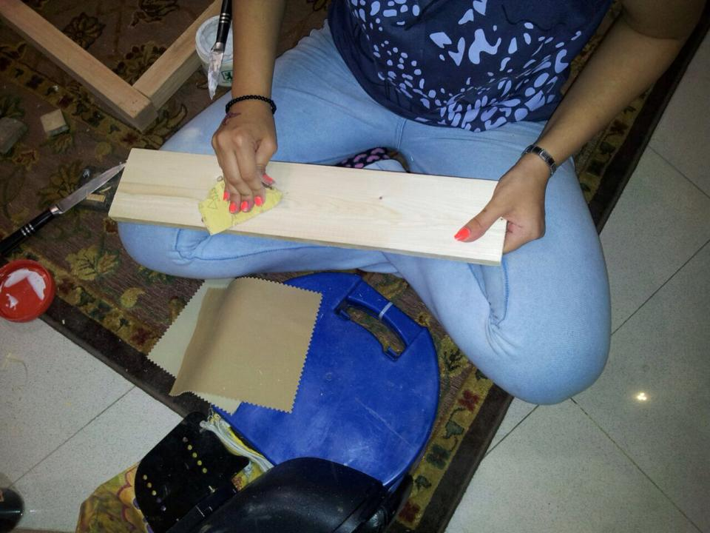
Step 1: I started off by sanding each of the Fagas and Platanus pieces of wood. This is because we need the wood to be smooth before we stain it and to try to ignore any injuries because of sharp edges.

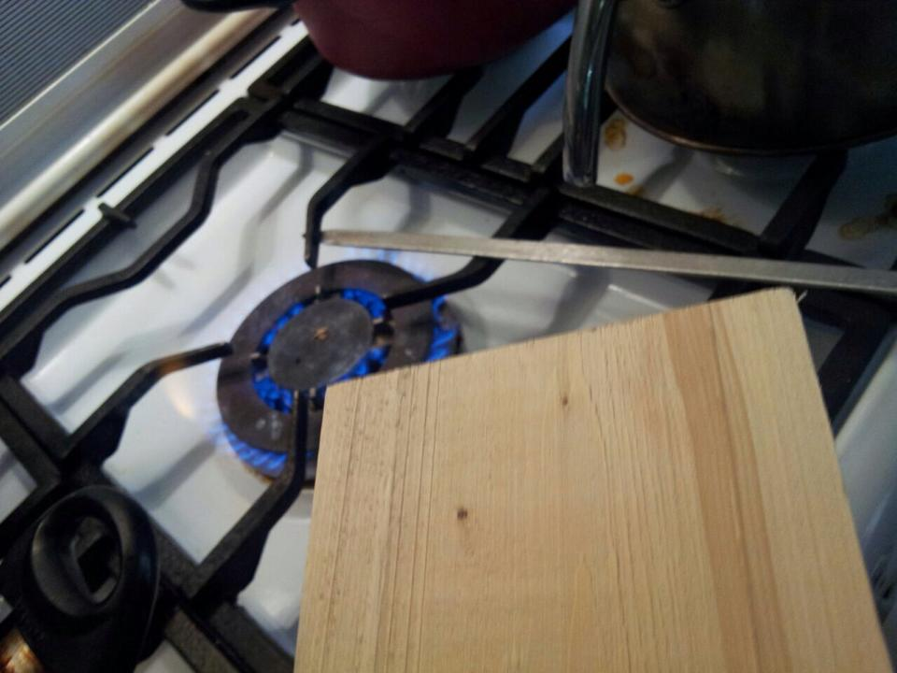
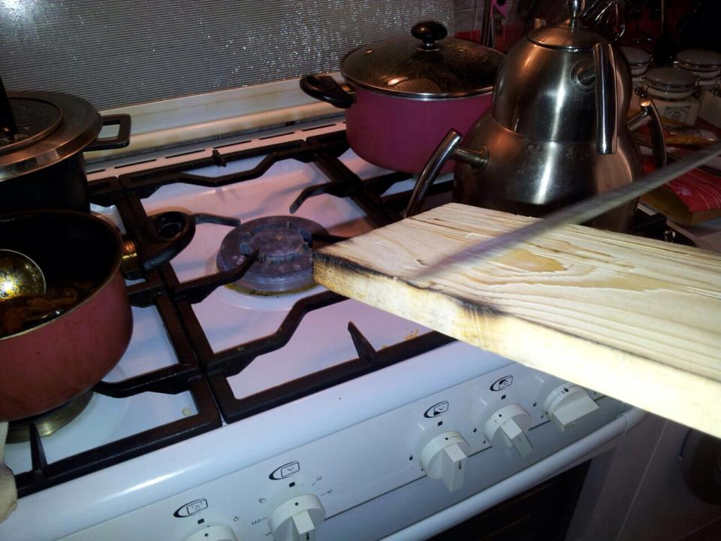
Step 2: Then using a gas stove I heated up a flat metal skewer straight on the fire for about 3 minutes on each side then I rubbed the hot skewers on the Fagas wood creating a burnt look.
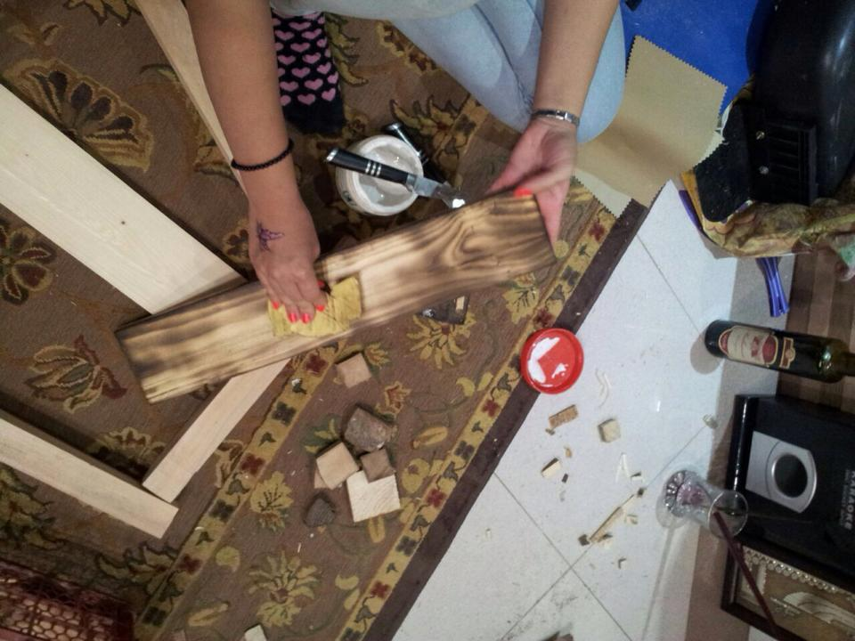

Step 3: The step above could be repeated as many times until the preferred look is gotten. Then after all the Fagas pieces of wood are burnt to a certain extent, sand the pieces of wood again in order to get rid of any pieces of wood again to prevent any injuries, and to have a smooth finish.

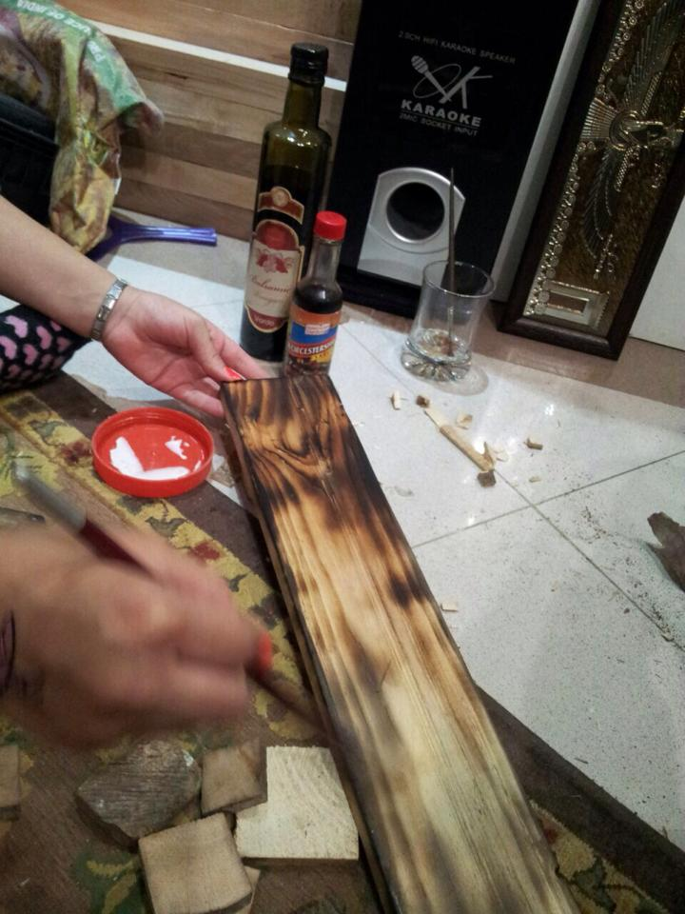
Step 4: After each piece is sanded off use any paint brush in order to stain the wood with wither ink, food coloring, or food items.
I decided to stain my pieces of wood with soy sauce, balsamic vinegar, and coffee, since I am creating this coffee table from fully recycled material and household items.
This time can be done depending on how dark it is desired for the wood to look like.
After done painting each piece of wood, let the pieces of wood dry for at least 2 hours.

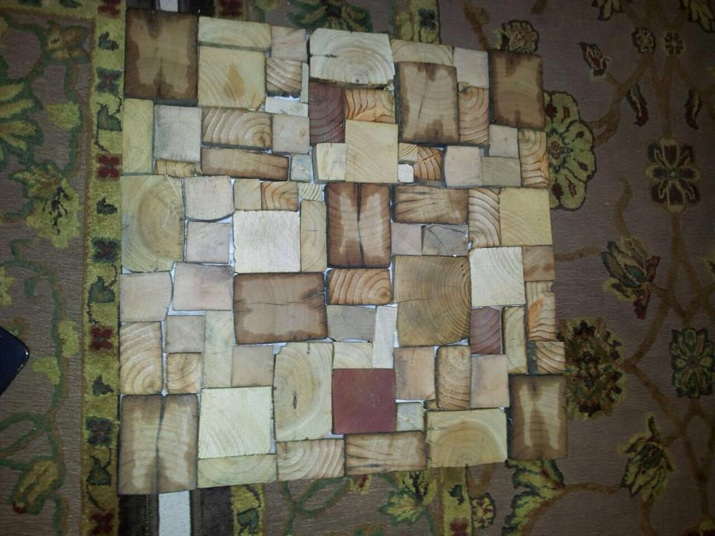
Step 5: While the staining of the pieces of wood are drying place the ‘recycled pieces of material for decoration’ on top of the MDF wood, and stick on with wood glue and let dry for at least 2 hours. After 2 hours check for any lose pieces and if there are any, re-glue pieces and let to dry again.

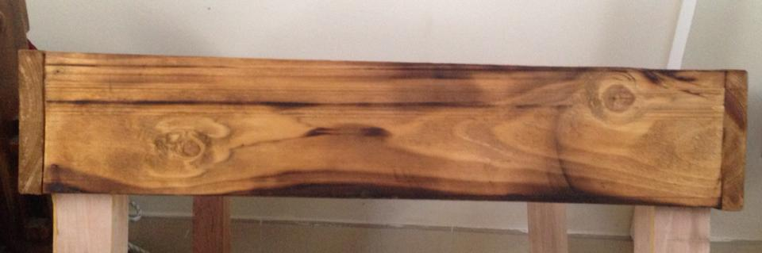
Step 6: After the Fagas pieces have dried from the staining, glue one of the smaller pieces to the larder pieces, the a small piece to the large piece and then the last small piece. Then let to dry for 3 hours.
Small

Large
Large

Small
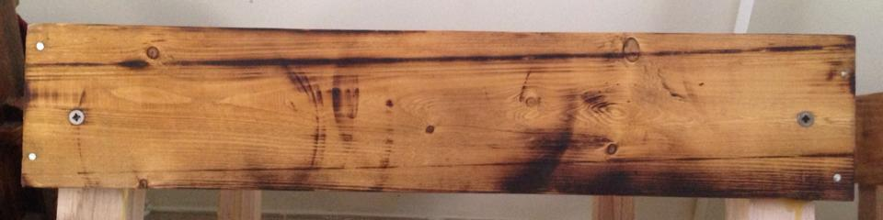
Step 7: Once the pieces are stuck together, drill in 2 nails (3cm long) on each side for the wood as seen in the picture. These do not have to be exact and can be drilled in roughly at 1cm from the top and bottom of the wood. This is does not have to be exact as we want a natural, rough look to the table so exact measurements are necessary, but can be done so if one wished to measure. Do this to 2 parallel sides of the wood as seen labeled in the below diagram with red. dots.
Small
Large
Large
Small

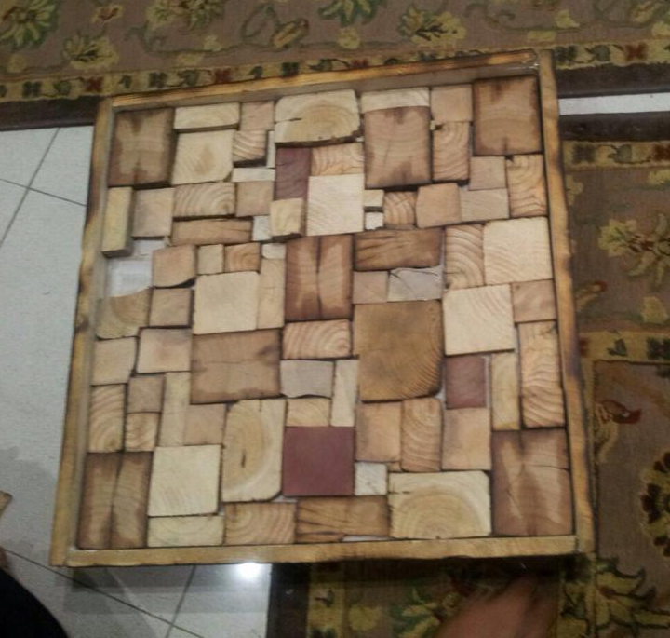
Step 8: Once the drilling is done, then place your decorated MDF piece of wood and make sure the sides are leveled with to the highest piece of decoration. Then label with a pencil how deep the MDF wood is going to be placed.

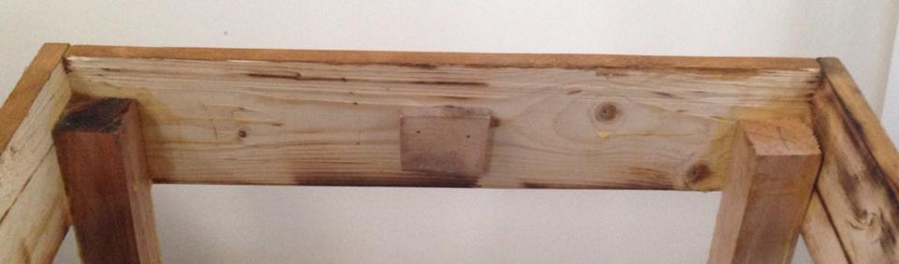
Step 10: Once done measuring stick a scrap piece of wood in the inner center of the Fagas wood, and drill a 3cm nail in the wood so it stays put. Again this does not have to be measured. Do this step to all 4 sides of the table, and all 4 tables. Then place in the MDF decorated piece and glue the bottom to the scrap pieces of wood.

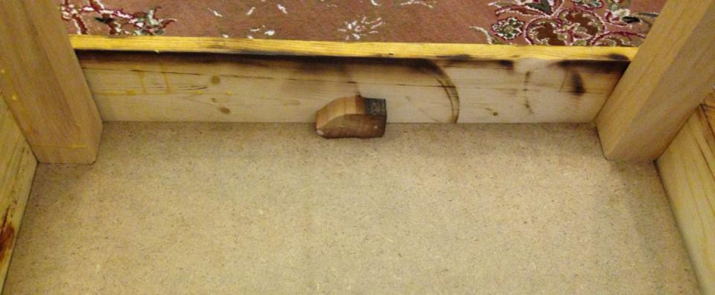
Step 11: Once the glue for step 10 has dried, flip the table over to stick on the legs on each corner, as seen in them image. Let the wood glue set for 30 minutes then flit the table around standing on it legs and let it dry fully for at least 2 hours.

Step 12: Once Table is fully dry and stable, screw in two 4-inch screws on each side of the table as seen in the picture on the left and diagram below.
Large
Large
Small
Small

Step 13: At this point you can decide whether or not you would like to place a glass over the whole table or not. Or if wanting a longer lasting table put a clear, shiny spray varnish over. If you would like to keep your table that way it is skip this step and you are done with the making of this table.

Conclusion and Evaluation:

Conclusion:
The final product of the coffee table made completely from recycled material was a great success as it was easily used for the functions that it was used for. The users were able to use the tables as coffee tables, bedside table, and full size tables. The flexibility of the model made it easy for the users to use the table as they wanted to. One user even came up with the idea of stacking up all the tables, and using it as a shelf, while not wanted to use it as a table, which worked very well. The tables were not too heavy and could be picked up easily to be moved around. The tables even passed the test of a person sitting on them with the weight of 83KG.

Planning:
The concept of using recycled material at first seemed so easy, because the idea seemed as if already made products just needed to be stuck together to make another product. But when coming up with the problem, the idea became harder due to the fact that what would a small house need that could be made out of recycled products? That is when the first challenge occurred. Having friends and family that live in apartment less than 40 meter squared I asked them what their problem is living in a small space would be and most of them said:
- “Space because old furniture does not fit into smaller space.”
- “Organization because we have no place to fit what we had from our bigger home.”
That’s when I started to come up with questions that would help me with coming up with ideas on what I want to make.

Research:
Research was not the hardest part of the project, as that is the part when I was becoming comfortable with my idea and I could imagine what I wanted y final product to end up looking like. For example I researched existing products and the I analyzed them on how I could make them from recycled material and what designed would be mixed with other designs to make a better design.

Development:
The development of this product was somewhat difficult as I kept on wanting to change my idea as I kept on moving along because I had better ideas, but I couldn’t change my idea because of the limited time that we had.

Manipulative Skills:
When I started making the product I thought that it will only take about 3-4 class, as my design is very basic and should not be that hard to make, but as I started it took more than 3-4 classes, as the sanding took a very long time at the start of the project, and also since I had to do the burning of Fagas wood at home and we had changed our stove to an electric stove I had to think of different ways to burn it. Also I made one of the tables completely before doing the other ones just to see how all of them would mostly turn out, but that was not the best ideas and the MDF wood had been bloated because of the humidity in the air, and therefore the sides of the MDF wood had to be sanded off to fit the square sides of the table. Another problem was that at first the idea for the legs was just to stick them on to the table, but later on the legs could not hold on to the table and they fell off when the table was lifted up, therefore they had to be screwed in.

Procedure:
All in all, the table ended up turning into what I had planned from the beginning though the decorations of the top of the table had to be changed a bit, and so did the design of the legs of the table due to limitations to the cost and amount of material

Evaluation of different stages:

Planning:

 | Strengths: | Weaknesses:
 | - There was some good amount of planning of what I was hoping of the final design.  - Great designs and notes on pre-existing designs and how they could be changed into being changed into recycled designs. | - There could be more research on existing designs only regarding recycled material.  - Questionnaire from potential customers on what items would be useful in a house that is ’40 meters of less’.
Improvements: | - Next time have a questionnaire asking each customer about your sketches and what they would be interested in. | - Research regarding what sort of multifunctional abilities the furniture you are planning to make can have.

Research:

 | Strengths: | Weaknesses:
 | - A good amount of research was done on the different factors of the use of recycled material.  - Good research and analysis on the different recycled material that can be used during the product. | - Not a lot of research regarding why you chose to make a certain size of table, even though you had just gotten results from existing designs
Improvements | - It would have done to label the sketches of existing designs with their measurements and it would have been good if you analyzed why they are like that and why people would choose certain sizes against others.

Development:
 | Strengths: | Weaknesses:
 | - Good amount of brainstorming and analysis | - The final design should have been picked faster in order for the production to be started sooner, and experimented on more, and edited if needed to.
Improvements | - More experimentation should have been done regarding different ways to make the table more multifunctional.

Manufacturing:

 | Strengths: | Weaknesses:
 | - During the manufacturing phase modifications were done in order to improve the designs, though the modifications did not affect the sketches. | - Manufacturing took longer than expected because of small mistakes and the glue not gluing fast enough, and not sticking well enough.
Improvements | - It would have been best if the screws were measured first before being screwed in because it would give a more professional and sharp look. | - Some measurements were one to two millimeters off and this should be check when cutting, as they had to be sanded off before being used, and that did waste time.

http://www.edcmag.com/blogs/14-edc-blog/post/95432-the-benefits-of-using-recycled-furniture-in-design-projects
http://www.edcmag.com/blogs/14-edc-blog/post/95432-the-benefits-of-using-recycled-furniture-in-design-projects
http://www.edcmag.com/blogs/14-edc-blog/post/95432-the-benefits-of-using-recycled-furniture-in-design-projects
http://www.edcmag.com/blogs/14-edc-blog/post/95432-the-benefits-of-using-recycled-furniture-in-design-projects
http://www.greendiary.com/wp-content/uploads/2012/07/coffee_table_from_phone_directory_e6sa5.jpg
http://www.inhabitat.com/wp-content/uploads/2010/04/Wildfire-Table_Main-537x360.jpg
https://mattermore.files.wordpress.com/2011/06/table8.jpg
http://www.environmentteam.com/wp-content/uploads/2013/09/recycled-materials-folding-table-450x369.jpg
http://www.okoffice.com.au/categories.asp?cID=929&c=31057
http://tinydistinction.blogspot.ae/2013/11/mid-century-in-miniature-disposable.html
http://www.clipartpanda.com/categories/glue-stick-clipart
http://www.texturex.com/Wood-Textures/wood+texture+red+grain+wooden+panel+design+wallpaper.jpg.php

