Internal Assessment
SL Design Technology

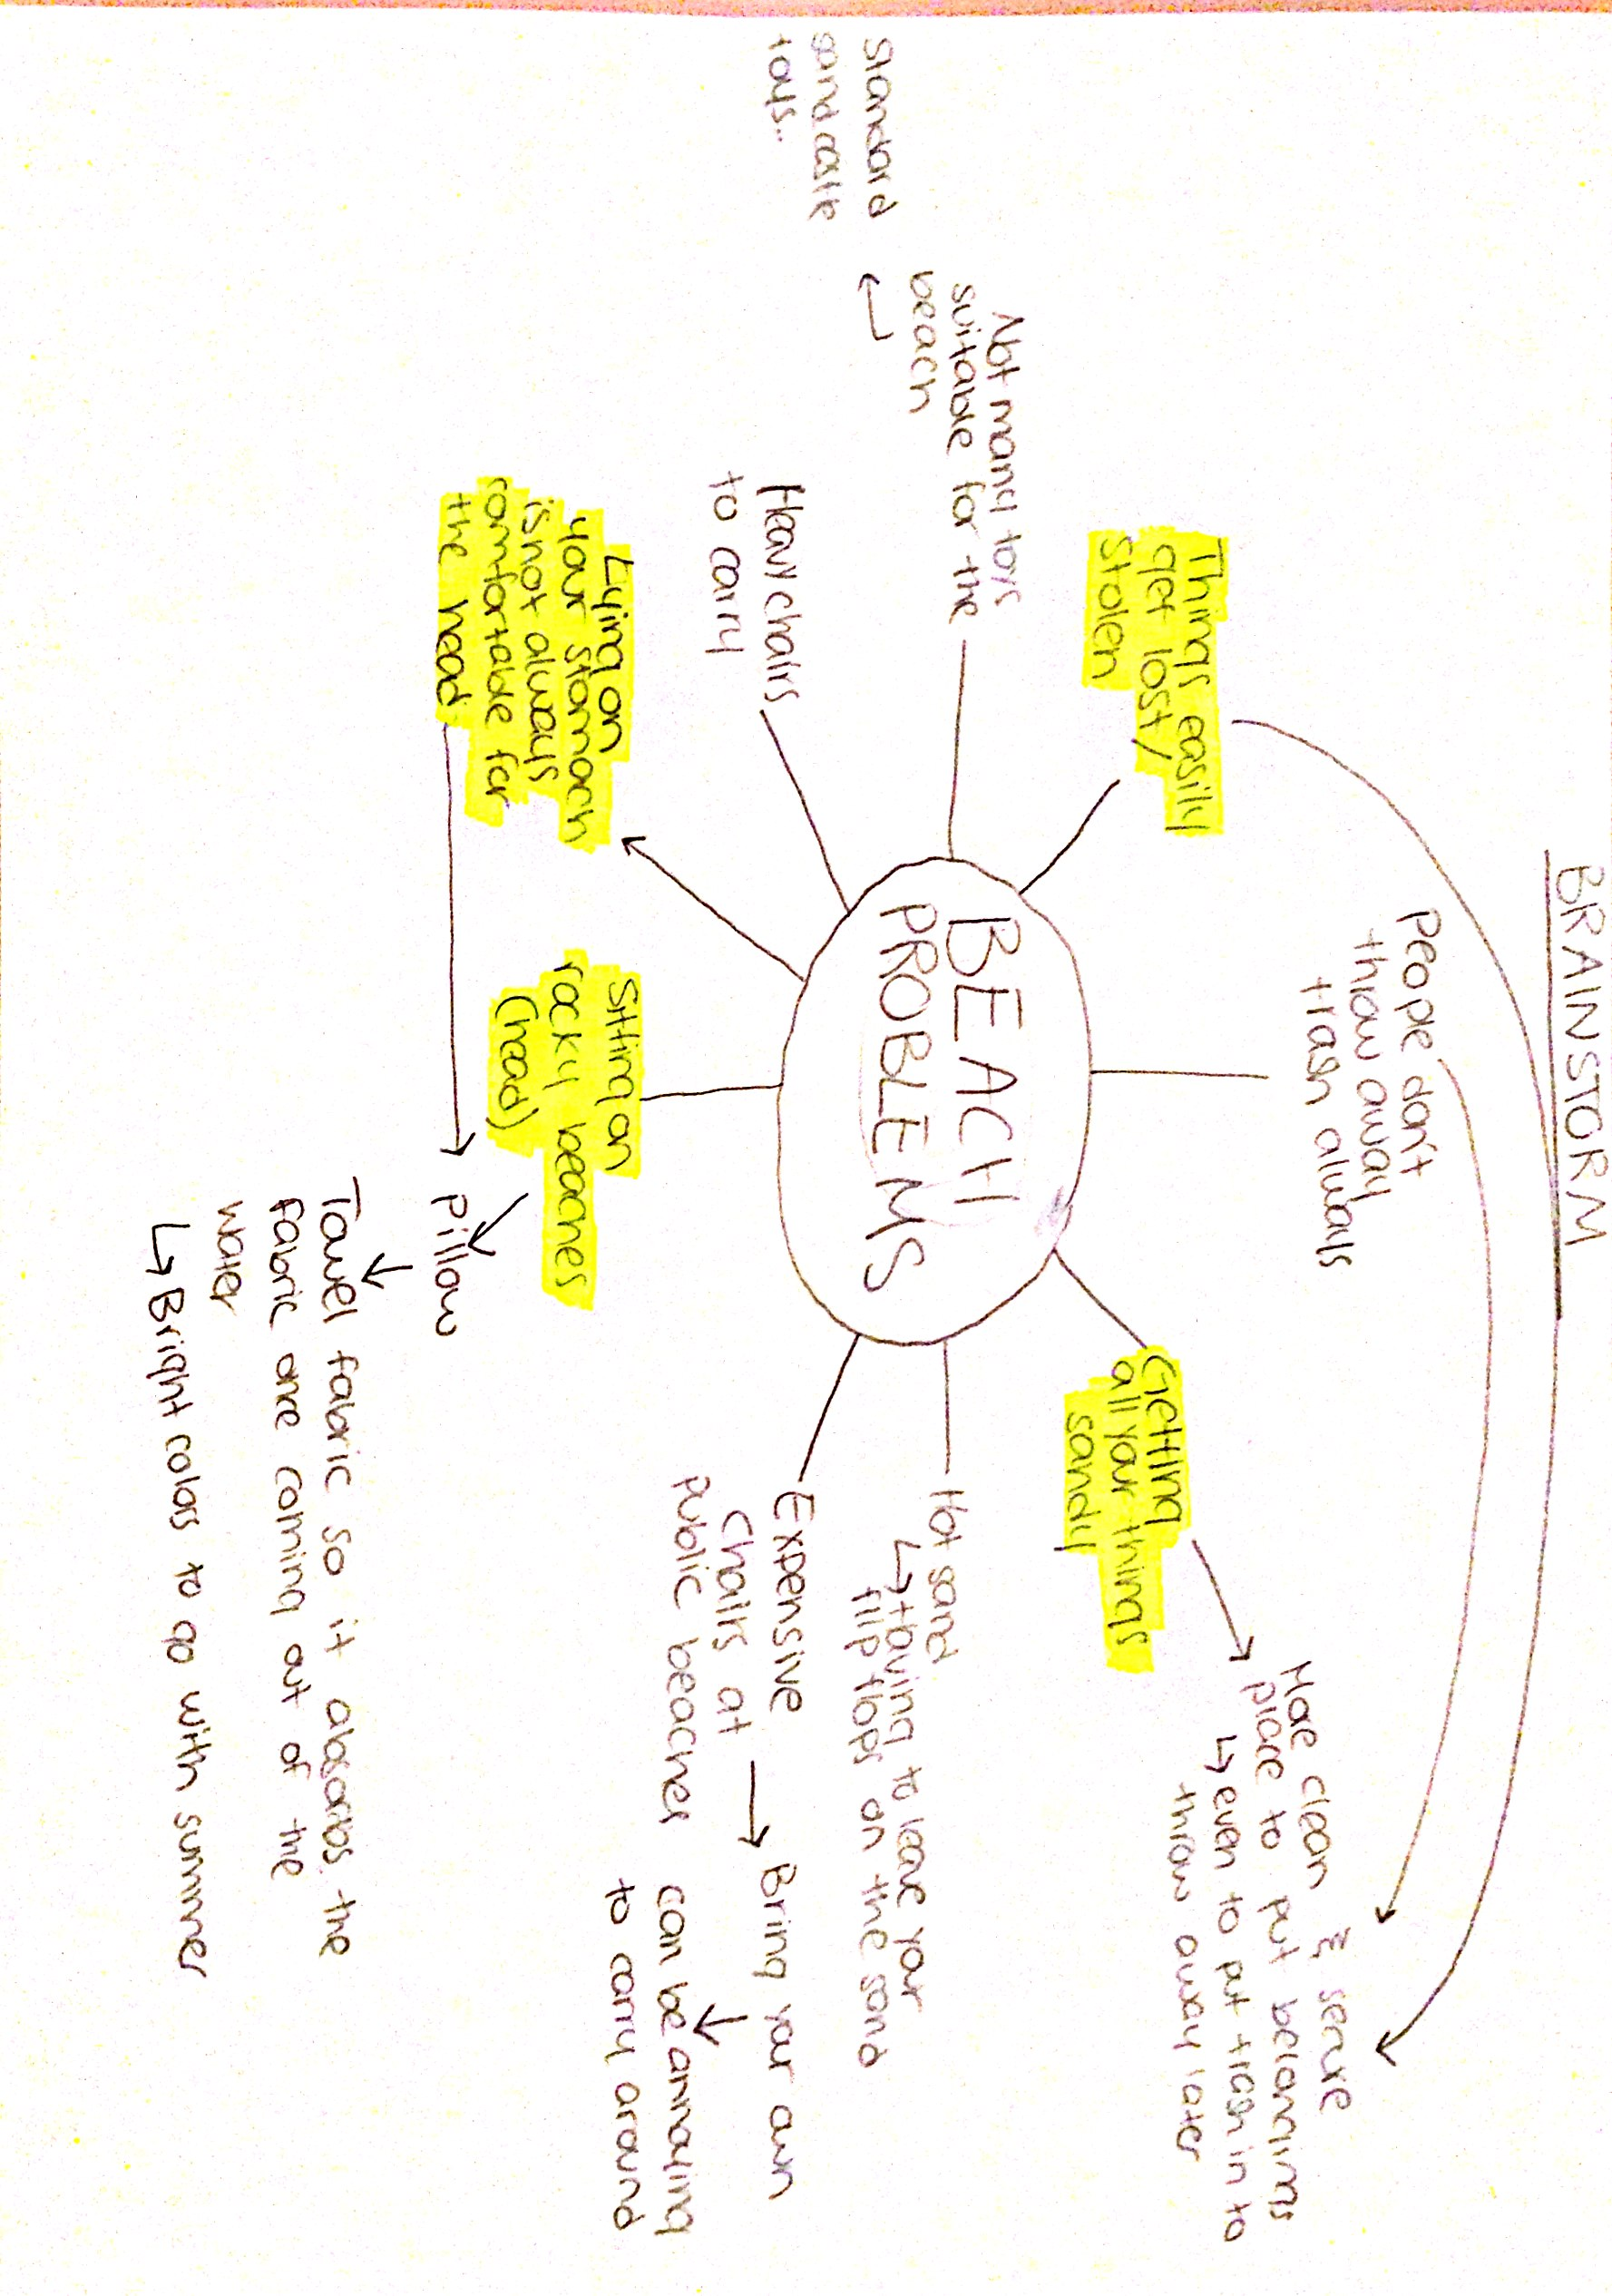
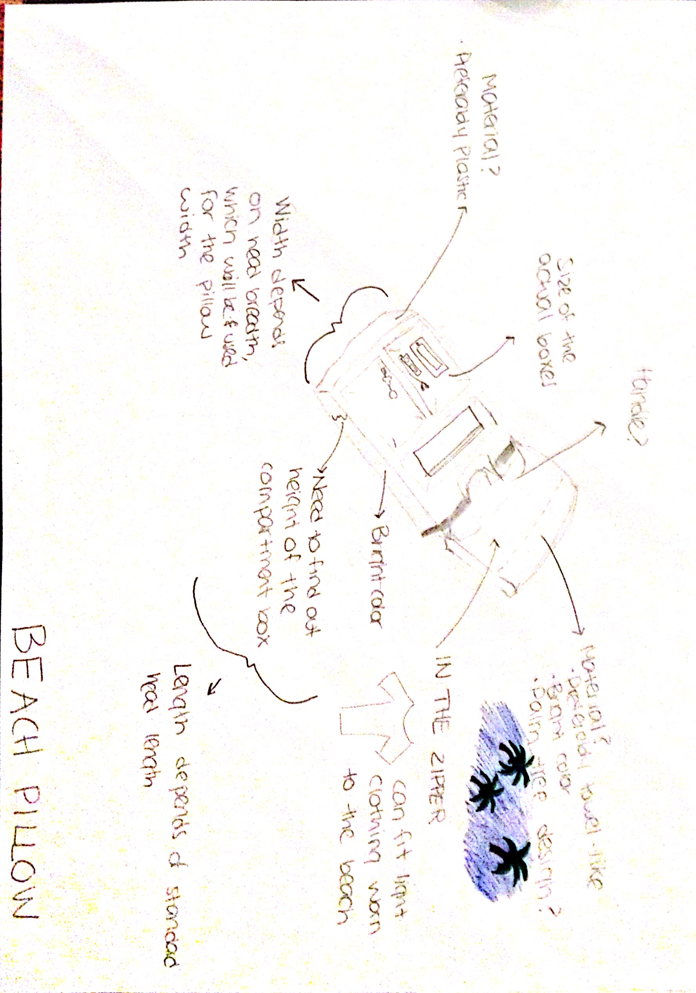PLANNING
Aspect 1 – Identify the Problem
While enjoying the sun during the summer holiday as many other vacationers on the beach, I realized that the spot of where you sit in order to soak in the sun is crucial. Many public beaches are filled with people looking to have a great day at the beach while spending a reasonable and minimal budget. The temptation in purchasing a tanning bed to relax on instead of the rocky and burning sand in the Jumeirah Beach Hotel in Dubai for non-members is about 360 AED! This forces vacationers to sit uncomfortably on the sand. To add to the problem, without a tanning bed or side table to place your necessities; this creates a risk of typical belongings such as phones, keys, iPod, and oils/lotions/creams to become sandy and dirty. A random survey shows that 35/40 individuals laying on the sand preferred laying on a bed, merely for the luxury of having a place to rest their heads and have their belongings in a secure place, as therefore they wouldn’t have to worry about leaving their possessions open to the public while taking a din the ocean. However the high prices were preventing them. Clearly, this is an area worthy of further investigation.

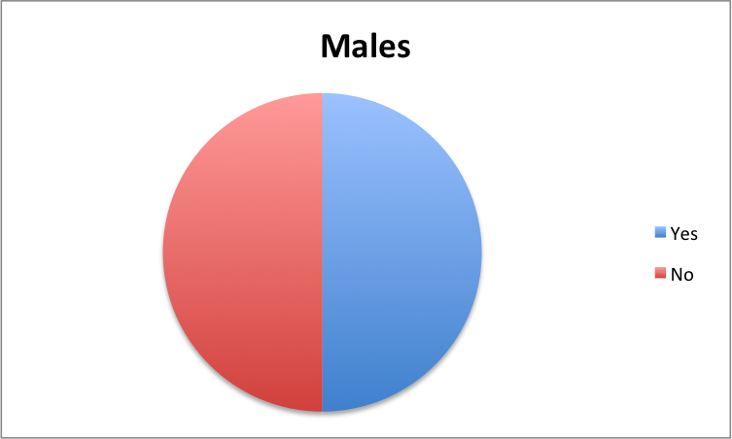
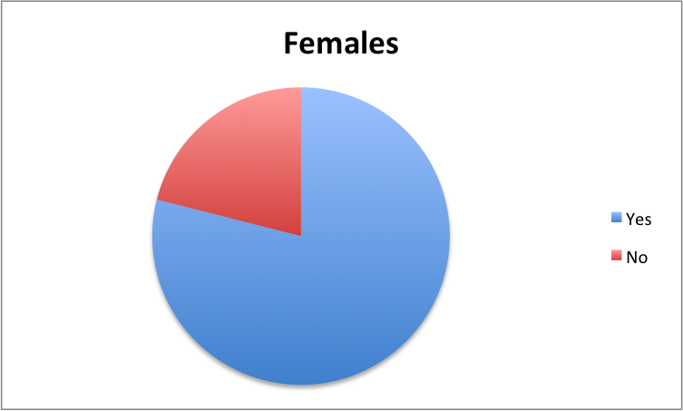 Blue = 75%, Red = 25%
50%
50%
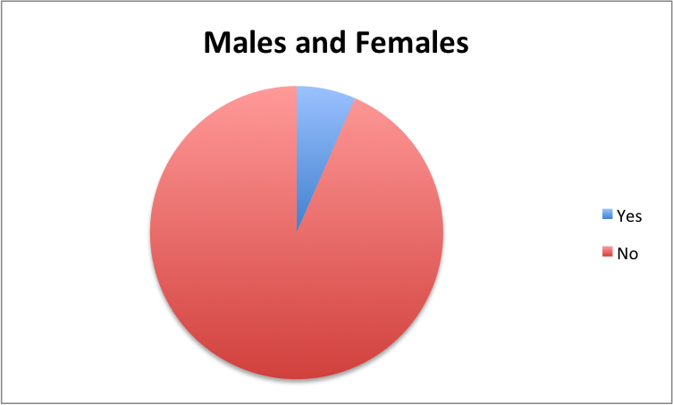 Blue = 87.5%, Red = 12.5%

Aspect 2 – Design Brief
Consider a small plastic storage box with a pillow over it for tanning purposes
To design and manufacture a plastic storage box including a flip able pillow used to rest on while at the beach. The beach pillow should be very comfortable as it must endure an individual laying on it for hours, as well as practical in including compartments for the typical necessities that an individual takes to the beach. Also, there should be a zipper on the pillow, where customers can put in their clothing (such as a t-shirt) or any other belongings. This product will be aimed at teenagers from 15 years of age, as this is when parents typically allow their children to go to the beach alone and be responsible for their belongings, until adulthood. Major constraints of the product include stability, as there will be a storage system under the pillow and the product is targeted for the head shape and weight for teenagers and adults. Other constraints include cost in terms of material in order to ensure the beach pillow is aesthetically pleasing, as well as comfort, which will be measured in terms of anthropometrics of the human head. The success of the product will be measured through user trials and interviews in order to further enhance the product.

Aspect 3
Initial Specification
- Must include a zipper within the pillow in order to insert further necessities such as light clothing (E.g. T-shirt)
- Must be stable in order to support a teenagers up to an adults head size and weight
- May include miniature drawers within the compartment box
- May include a cushion
- May include a compartment on the side to place mini ball speakers
- Should have black UV rays surrounding the compartment box in order to resist heat
- Should include Styrofoam and changeable ice packs within the box in order to keep it cool

Materials for practice model:
- Plastic box (AGD Junk Drawer 390 x 290 mm – ACE) AED 35.00
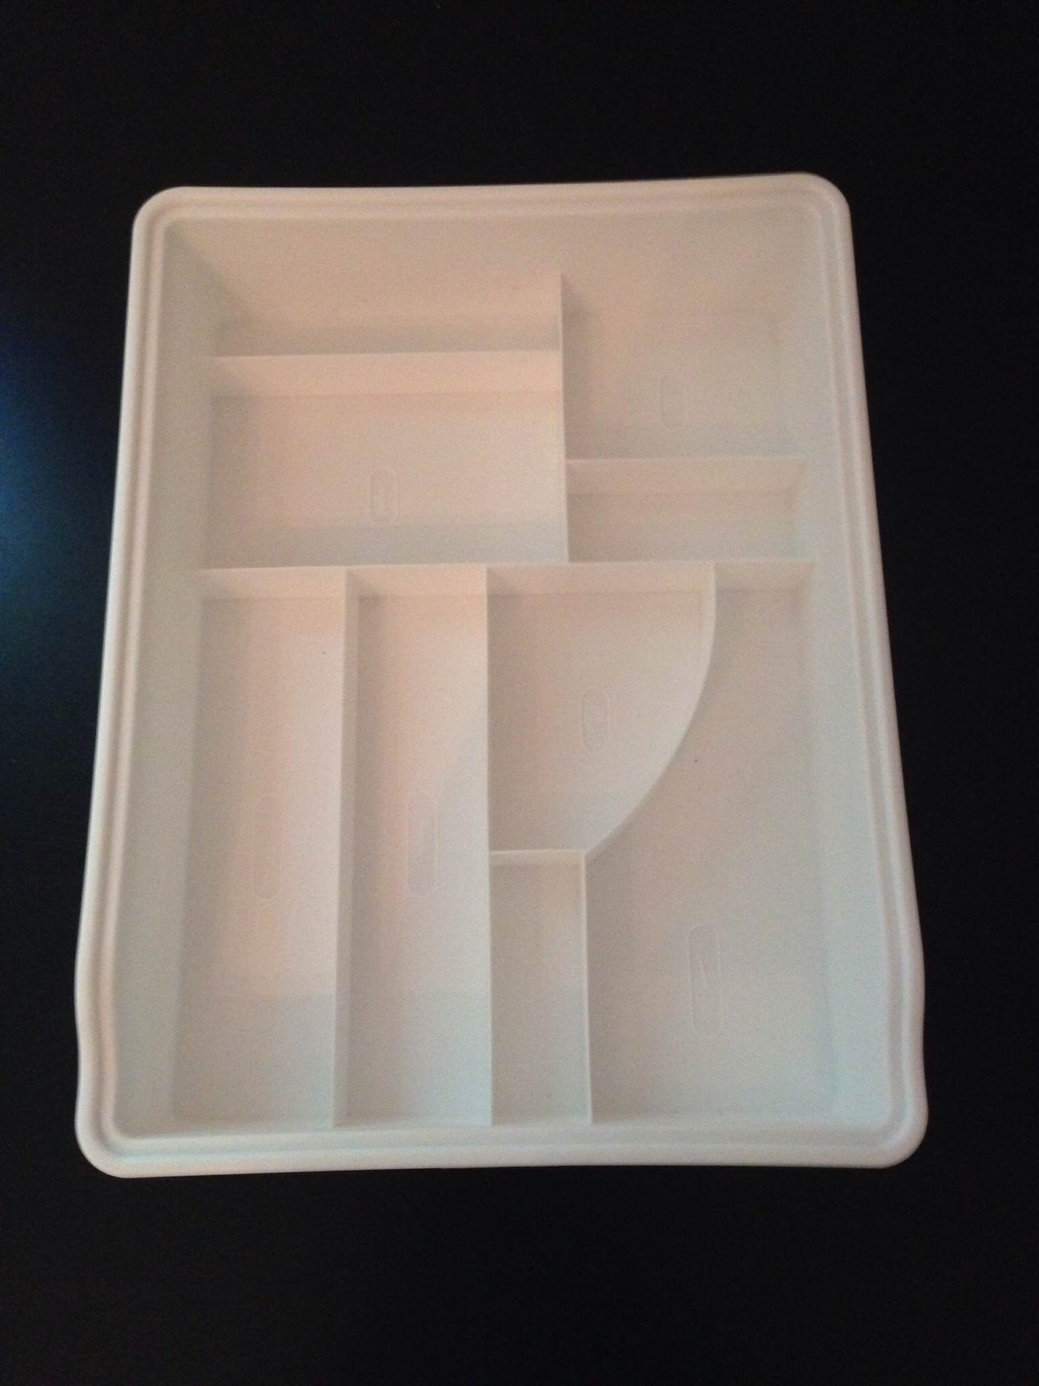

- Terry towel 600 x 1200 mm (any color – Value bath towel – ACE) AED 10.00
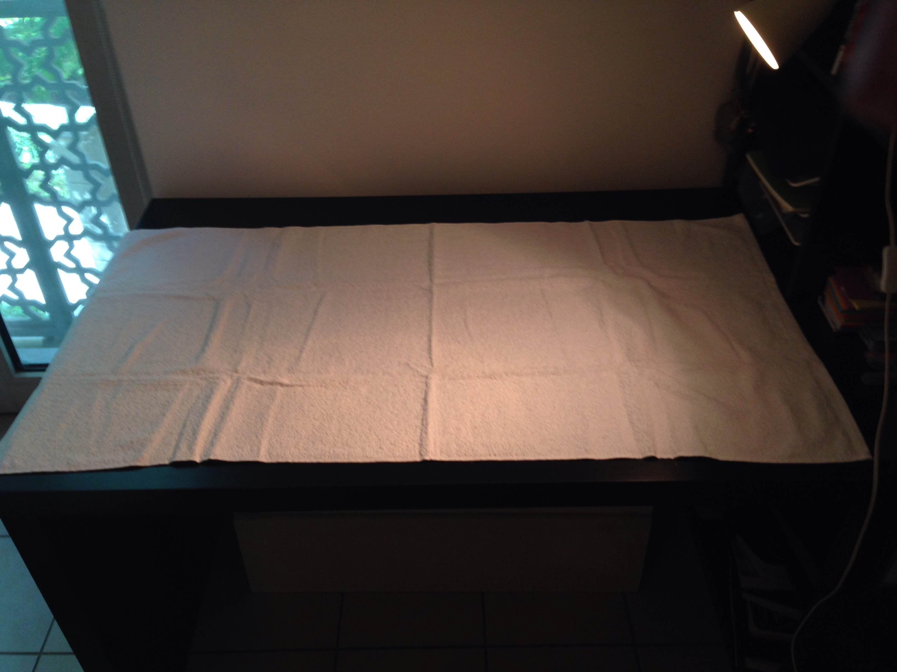

- Velcro (Scotch Multi Purpose Fastener – ACE) AED 50.00
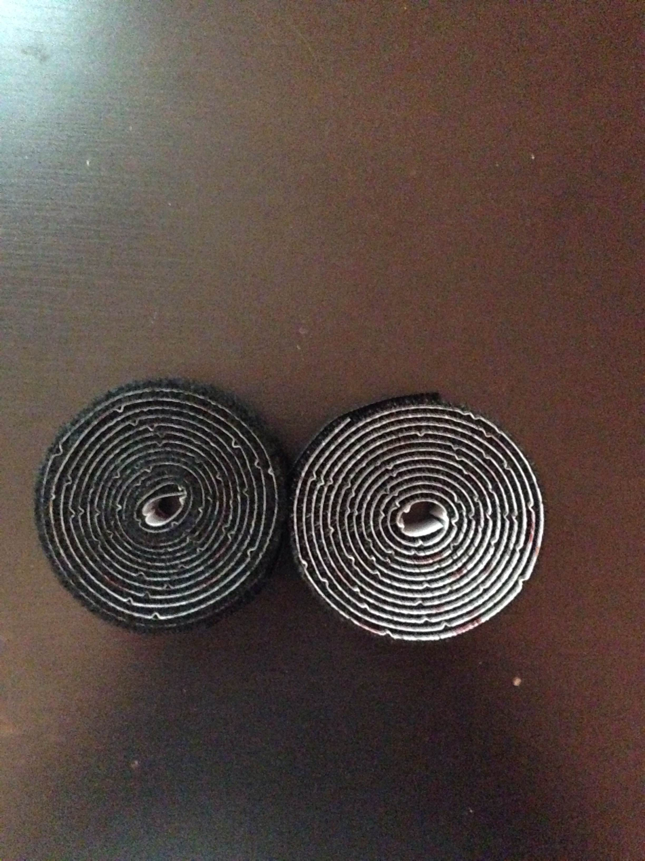

- Window film (Sun spot – ACE) x2 AED 19.00
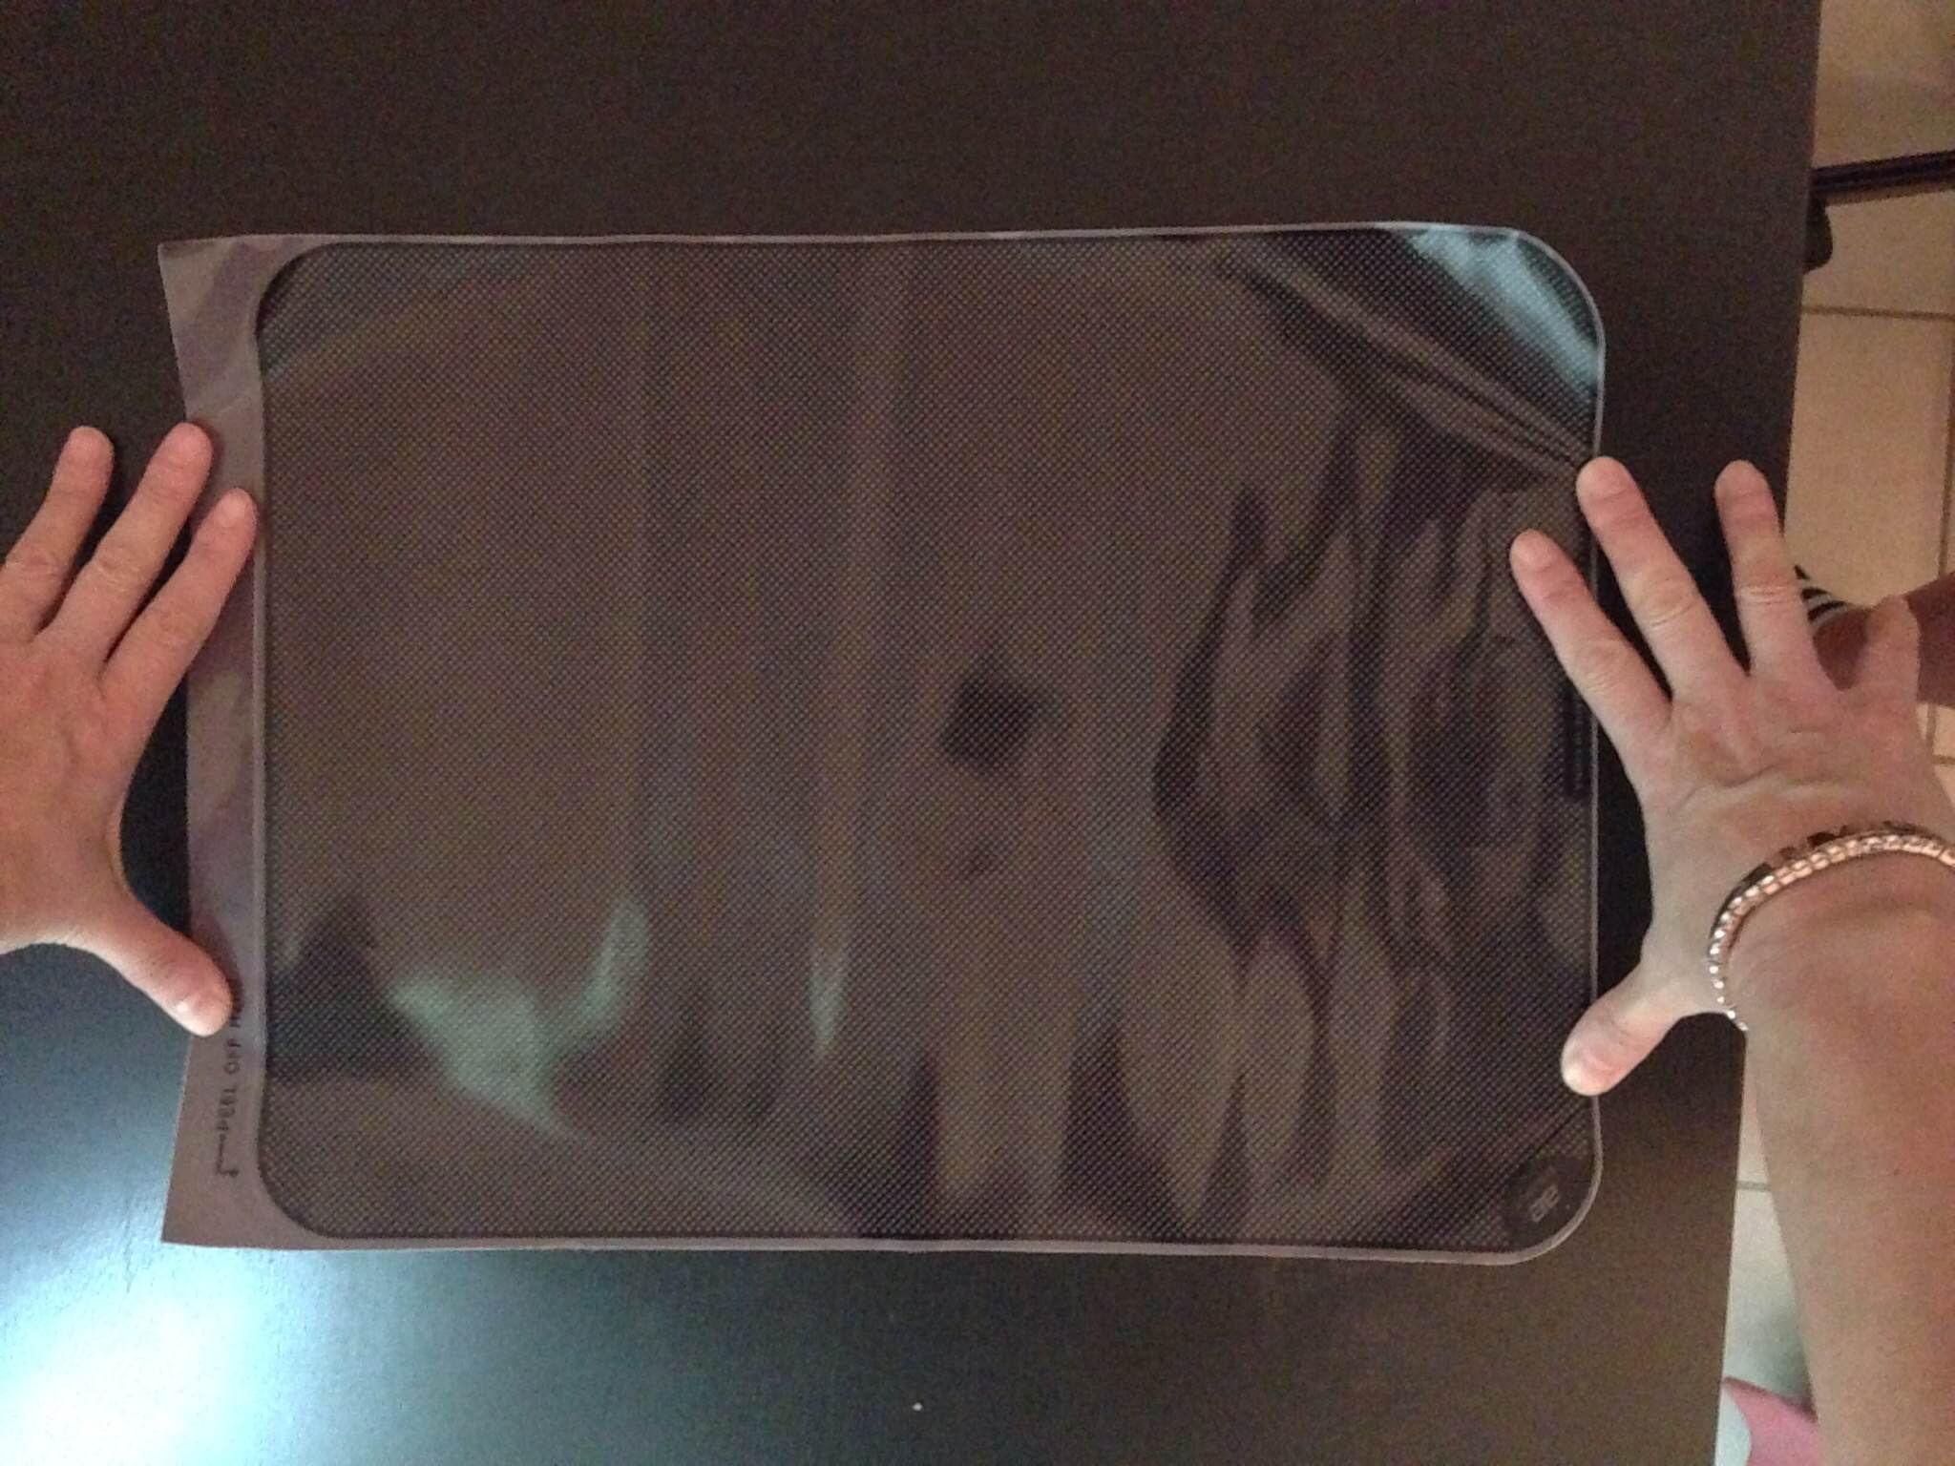

- Ice packs (GIO Ice pack Drop 6 pcs – ACE) x4 AED 29.00 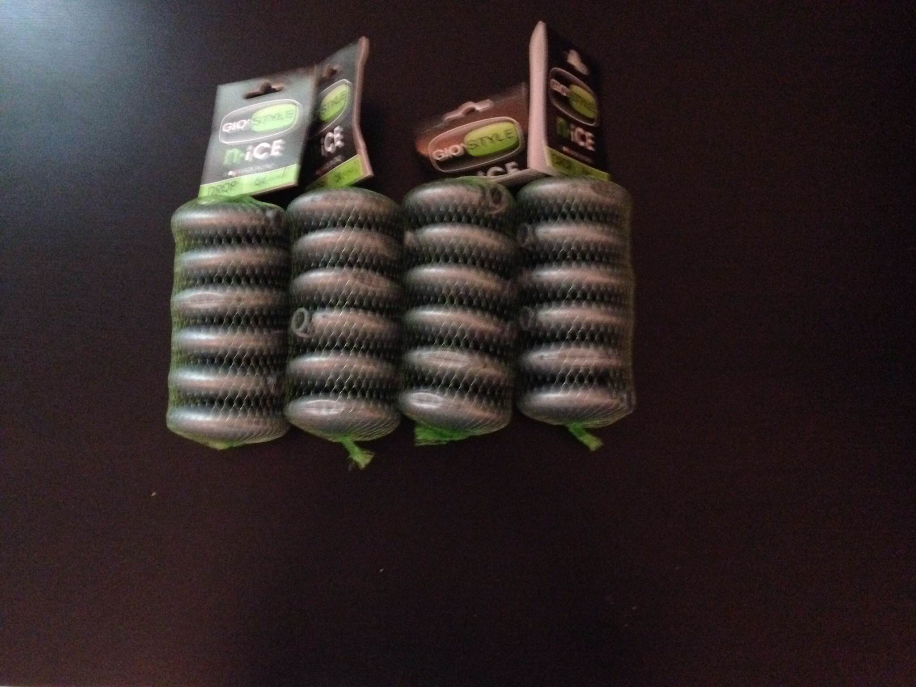

- Styrofoam
- Ruler
- Cutter
- Duck Tape
- Pen
- Thermometer
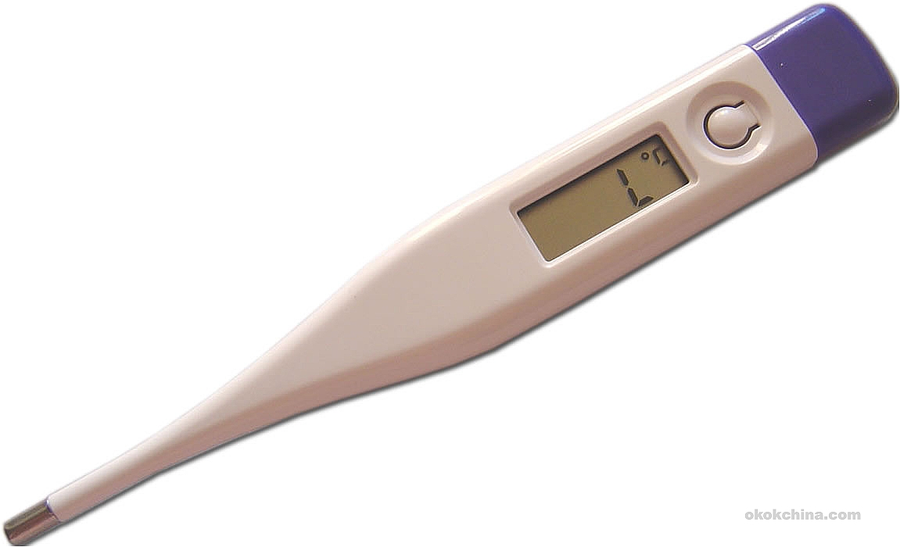

Materials for final model:

RESEARCH PLANNING
Aspect 1
Strategy 1:
What do I want to find out?
If there is a demand within the target population in creating a product that is a replacement for a beach bed, includes a safe place to place an individual’s belongings, and is more comfortable than lying on the sand.
How do I find it?
I will conduct a survey with the questions listed below with 20 males and 20 females at the beach who are not lying on a tanning bed. The survey is constructed as a way that whenever the participant circles the answer “Yes”, this shows favoritism toward the demand for the product. The results of this survey will be analyzed by allocating 2 points to a participant whenever they circle “Yes” and 1 point whenever they circle “No”. The maximum number of points for questions 1-4 is 40 points for one gender and 80 points for both genders. In terms of the fifth question, results will be analyzed by determining the mode of how many times “head”, “shoulders”, “legs”, “back”, or “feet” is circled throughout the 40 surveys.

Please circle your favorable response
- Did you choose to lie on the sand?
Yes No
- Do you think the prices for a beach bed are too high?
Yes No
- Would you prefer having a secure place to place your belongings?
Yes No
- Would you prefer lying on something more comfortable instead of on the sand?
Yes No
- What part of your body hurts the most when lying on the sand? (Circling more than one is acceptable)
Head Shoulders Legs Back Feet

Why do I need it?
In order to investigate if there is a demand for this product
How will it help me?
To not waste any costs for designing and manufacturing a product that is not in demand by the target population.

Strategy 2:
What do I want to find out?
The standard measurements (mm) of head breadths in males and females from the ages of 15 and above
How do I find it?
With the table below, I will conduct online research of universal anthropometrics tables regarding head breadths for males and females ages 15 and above. Then, I will find the average of the three head breadths in order to determine the width of the pillow.
Online Resource 1 | Online Resource 2 | Online Resource 3

Why do I need it?
In order to ensure that the pillow is of a standard width, which will ultimately aid in deciding on the final width of the plastic box underneath the pillow.
How will it help me?
This strategy will ensure that the beach pillow is comfortable for the target population. This is very important, as according to the Data Analysis of strategy 1, the demand for a comfortable place to rest an individual’s head is high.

Strategy 3
What do I want to find out?
The standard measurements (mm) of head lengths in males and females from the ages of 15 and above
How do I find it?
With the table below, I will conduct online research of universal anthropometrics tables regarding head lengths for males and females ages 15 and above. Then, I will find the average of the head breadths in order to determine the length of the pillow, and ultimately the length of the plastic box.
Online Resource 1 | Online Resource 2 | Online Resource 3

Why do I need it?
In order to create a standard length for the pillow that will ensure comfort for all users, regardless of the wide target age. This will also help in deciding on the final length of the plastic box.
How will it help me?
This strategy will ensure that the beach pillow is as comfortable as possible for the consumer in terms of size. This is very important, as according to the Data Analysis of strategy 1, the demand for a comfortable place to rest an individual’s head is high.

Strategy 4
What do I want to find out?
The most practical and safest material for the pillowcase
How do I find it?
I will conduct online research regarding different types of fabrics, and record their characteristics in the table below

Fabric 1 | Fabric 2 | Fabric 3
Pros:  Cons: | Pros:  Cons: | Pros:  Cons:

Why do I need it?
To ensure that the material of the pillow is suitable for the circumstances of the product, such as exposure to heat and water
How will it help me?
To decide on the most pragmatic fabric for the product

Strategy 5
What do I want to find out?
The most suitable material for the compartment box, this will most likely be a plastic base.
How do I find it?
I will conduct online research regarding different types of plastics, and record their characteristics in the table below

Plastic 1 | Plastic 2 | Plastic 3
Pros:  Cons: | Pros:  Cons: | Pros:  Cons:

Why do I need it?
To ensure that the type of plastic is suitable for the circumstances of the product, such as exposure to heat and water
How will it help me?
To decide on the most effective plastic for the product

Strategy 6
What do I need?
The most preferred color for the terry towel that will be used as the pillowcase. The data will be analyzed by adding up the numbers for each color.
How do I find it?
I will conduct a survey with a scale of 1-4, (4 being the most preferred and 1 being the least preferred) with 30 males and 30 females from the ages of 15+. Also, the pictures below the table will be shown to the participants

Males
 | Green | Turquoise | Lilac | Orange
1
2
3
4
5
6
7
8
9
10
11
12
13
14
15
16
17
18
19
20
21
22
23
24
25
26
27
28
29
30

Females
 | Green | Turquoise | Lilac | Orange
1
2
3
4
5
6
7
8
9
10
11
12
13
14
15
16
17
18
19
20
21
22
23
24
25
26
27
28
29
30

All Participants
 | Green | Turquoise | Lilac | Orange
Males
Females

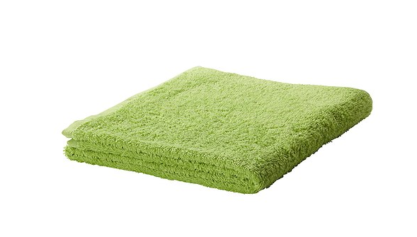 Green – 15 AED – Ikea

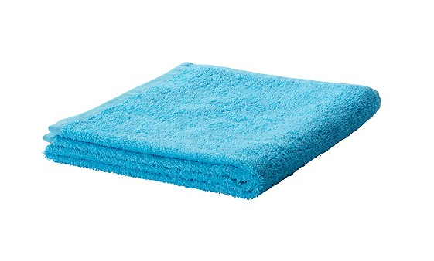Turquoise – 15 AED – Ikea

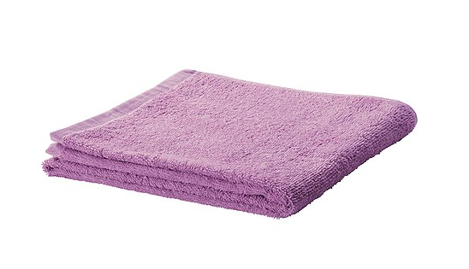Lilac – 15 AED – Ikea

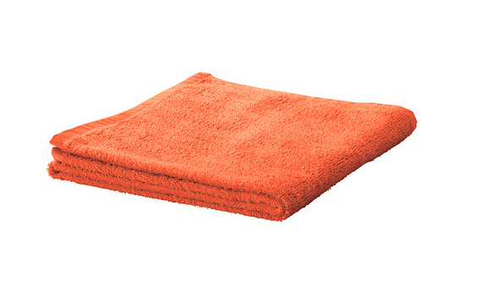Orange – 15 AED – Ikea

Why do I need it?
To determine the color that the target market highly prefers
How will it help me?
To ensure that a color will be used for the pillowcase that attracts the target market directly

Strategy 7
What do I need?
To investigate the standard items individuals 15 years old and above take with them to the beach
How do I find it?
I will conduct an online survey using the empty questionnaire below with 14 males and 14 females who are 15 years old and above
From a scale of 1-15, which items do you most regularly take with you to the beach? (1 being the most regular, 15 being the least regular)
Phone
IPod
Small headphones
Big headphones
Book
1-2 Tanning Oils/Sun Lotions
Sun glasses
Keys
Makeup
Extra clothes
Beverages
Snacks
Goggles
Hat
Wallet

Why do I need it?
To observe the most typical items that the target market brings with them to the beach and therefore decide on the sizing of the compartments within the plastic box
How will it help me?
This will enable the product to fulfill the demands of the target consumers by providing a space to place items that they usually take with them to the beach

Strategy 8
What do I need?
To determine the average sizes of the top 5 items that individuals take with them to the beach, according to the data collection and analysis of strategy 7
How do I find it?
I will measure the sizes of
How will it help me?
To determine the sketches of the plastic sheet

Strategy 9
What do I need?
To find out how to ensure that the items stored inside the plastic box are kept cool and do not over heat
How do I find it?
Explore different materials to place inside and out of the plastic box. I will use this table in order to fill out the information from online resources. Then, I will conduct an experiment with each material to see if they keep the items within the plastic box cool
Materials To Consider | Characteristics

Experiments
Temperature without material (Celsius) | Temperature with material (Celsius)

Why do I need it?
To ensure that the items placed inside the plastic box, such as a phone, headphones, wallet, do not overheat, as the products will be exposed to heat for a great amount of time.
How will it help me?
One of the purposes of this product is for customers to feel secure when leaving their belongings within the plastic box while they enter the ocean. Therefore, customers should not have to worry about their items being over exposed to heat, and having to spend a minimal amount of time in the ocean.

Strategy 10
What do I need?
To decide on how to attach the pillow to the plastic box
How do I find it?
I will explore different techniques that the terry towel can be securely attached to the plastic box. Therefore, I will design a model of the product in order to investigate which technique is the most pragmatic.
Possibilities

Why do I need it?
To ensure that the pillow sticks firmly to the plastic box, as well as can be easily removed. Therefore, when an individual carries the product, he or she does not have to worry about the pillow falling off as it will be securely fastened.
How will it help me?
Consumers will easily be able to access their belongings within the plastic box by removing the pillow, while at the same time not have to worry about the pillow flying away due to the possibilities of wind,

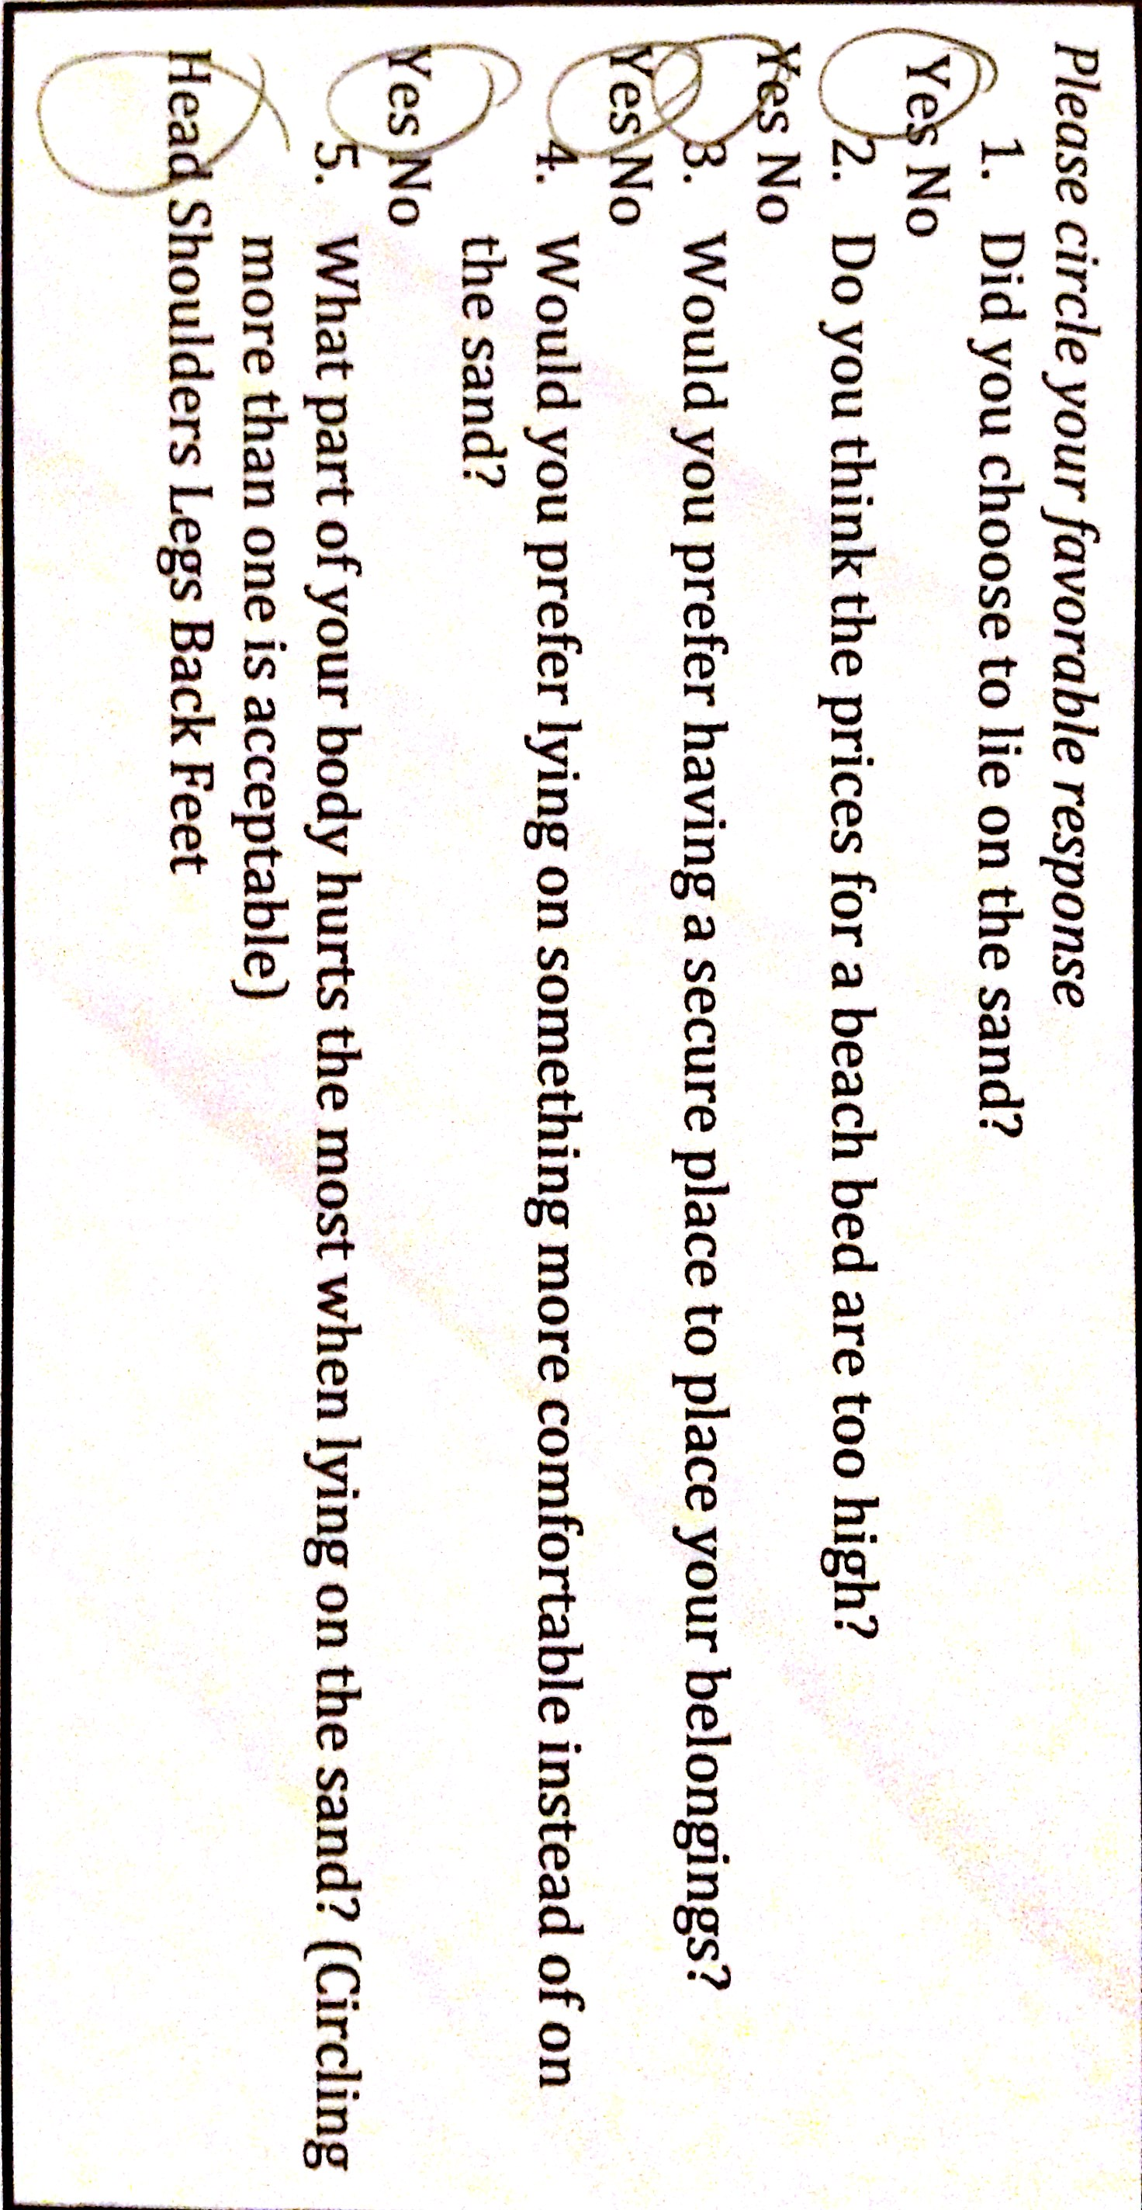
ASPECT 2 AND 3 – DATA COLLECTION AND DATA ANALYSIS
Strategy 1
What do I want to find out?
If individuals enjoy or do not enjoy lying on the sand at the beach

Here is a copy of one of the participant’s survey responses

Overall female response to questions 1-4:
Question | Points Distributed
Question #1 | 36/40
Question #2 | 36/40
Question #3 | 37/40
Question #4 | 33/40
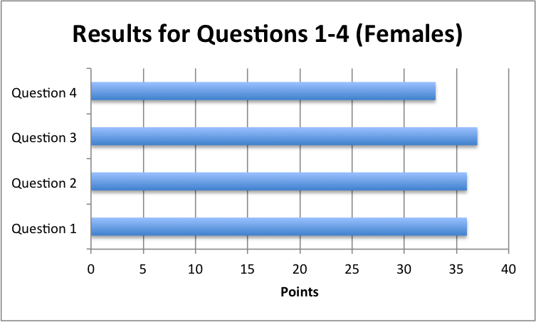
This graph shows how females responded to questions 1-4 on the survey. Since the maximum points was out of 40, the large numbers show how many participants were uncomfortable with their situation of lying on the sand and feeling insecure about their belongings. According to the graph, females were mainly concerned about having a secure place to place their belongings as this question scored 37/40. This gives insightful information regarding the demand of a product to place an individual’s belongings, such as phone, wallet, iPod, while at the beach.

Overall male response to questions 1-4
Question | Points Distributed
Question #1 | 36/40
Question #2 | 37/40
Question #3 | 36/40
Question #4 | 35/40

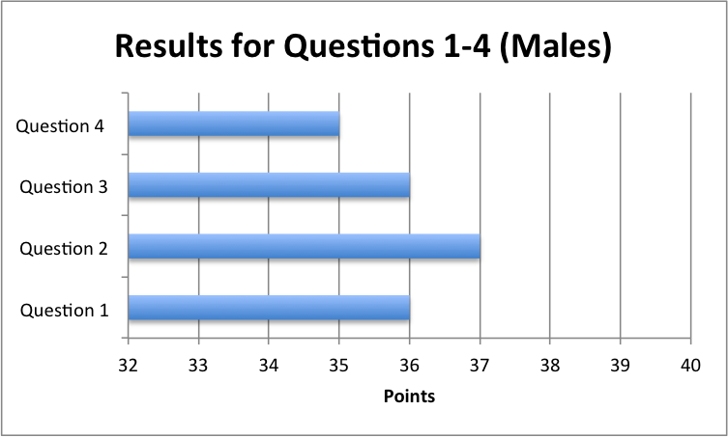

According to the graph above, males were most concerned about the high prices of the beach beds as a majority responded “Yes” to question 2, which asked, “Do you think the prices for a beach bed are too high?”, and the points calculated to 37/40. This gives insightful information regarding the target population’s perception of the over-priced beach beds, and creates a demand for a product that is more price sensitive and possibly reusable.

Overall male and female response to questions 1-4
Question | Points Distributed
Question #1 | 72/80
Question #2 | 73/80
Question #3 | 73/80
Question #4 | 68/80

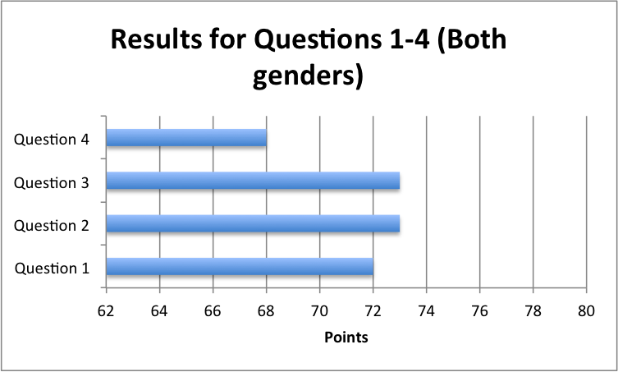

Overall, males and females were mostly concerned with the price of the beach beds and the security of their belongings, which is also presented in the separate male and female graphs. This can be seen as a majority of participants circled “Yes” to question 2 which asked, “Do you think the prices for a beach bed are too high?” and to question 3 which asked, “Would you prefer having a secure place to place your belongings?” This provides detailed information regarding the purposes of the product and what demands of the target population need to be fulfilled.

Different aches in body parts in females (Question 5)
Body Part | Points Distributed
Head | 20/20
Shoulders | 14/20
Legs | 0/20
Back | 6/20
Feet | 0/20
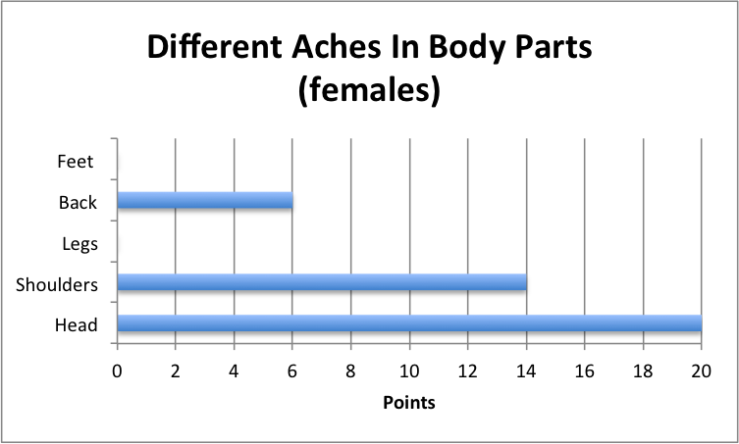

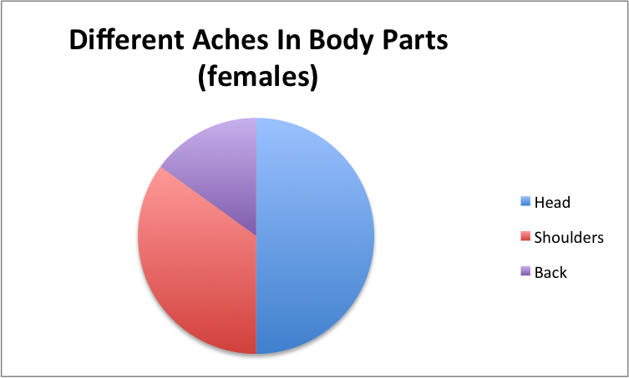
The results for the final question of the survey were analyzed by how many times each body part was circled throughout the surveys. As the graphs show, 20/20 female participants stated that their head ached them the most when lying on the sand. The second body part that participants were concerned about was the shoulders. Therefore, this gives insightful information regarding what body parts the product should cater to. In this case, females are most concerned about the comfort of their heads and shoulders.

Different aches in body parts in males (Question 5)
Body Part | Points Distributed
Head | 12/20
Shoulders | 13/20
Legs | 3/20
Back | 12/20
Feet | 0/20
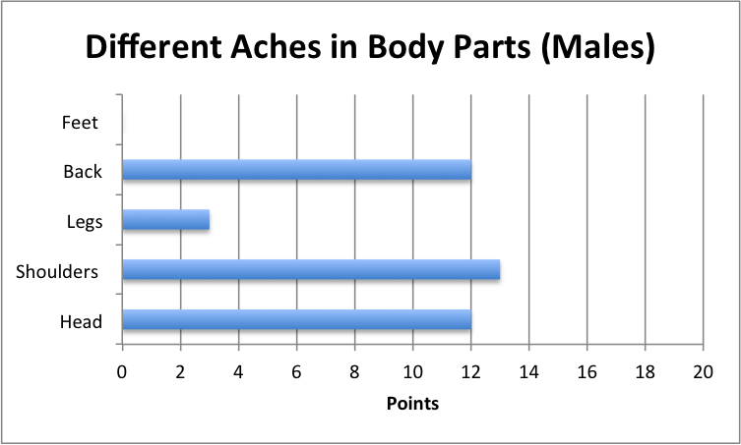
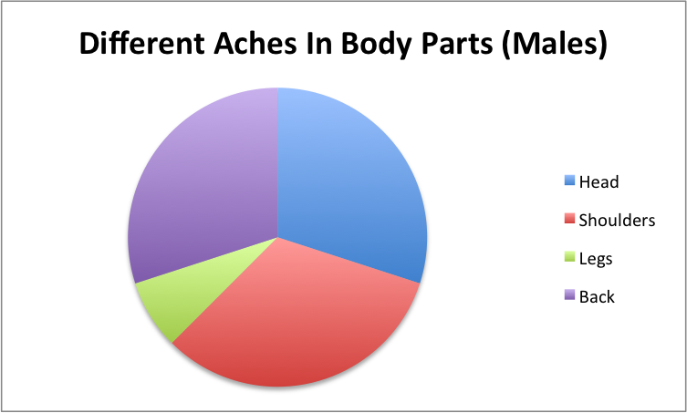
According to the graphs, the complaints of pain were distributed among the head, shoulders and back through the male target population. This is due to the fact that 12/20 participants complained about their head hurting the most while lying on the sand, 13/20 participants complained about their shoulders, and 12/20 participants complained about their back. This is very insightful information, as now we know that the comfort of the product must be focused on the head, shoulders and back.

Overall male and females aches in body parts (Question 5)
Body Part | Points Distributed
Head | 32/40
Shoulders | 27/40
Legs | 3/40
Back | 18/40
Feet | 0/40
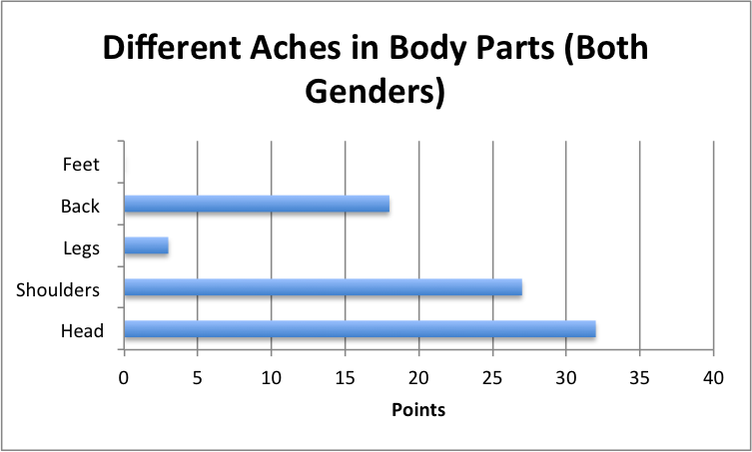
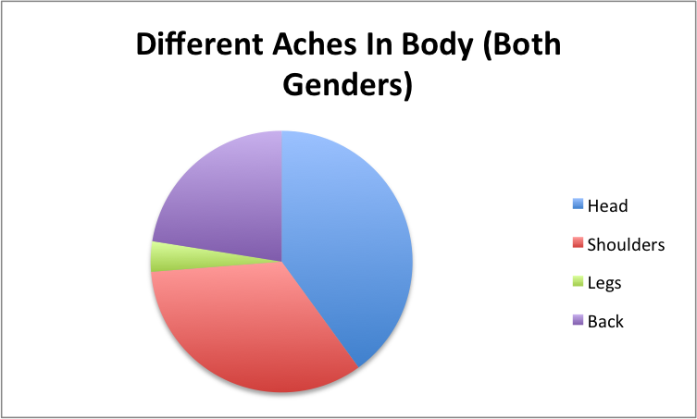
Overall, the results show that the target population were most concerned with heads and shoulders, as they complained that those two body parts hurt them the most while lying on the sand. This strongly contributes to the development of the product, as the demands of creating a product that targets the comfort of an individual’s head and shoulders are recognized and therefore can be fulfilled.

Strategy 2
What do I want to find out?
The standard measurements (mm) of head breadths in males and females from the ages of 15 and above
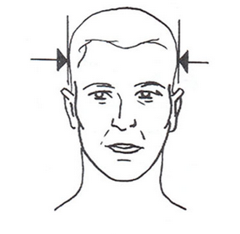

Online Resource 1 - http://www.roymech.co.uk/Useful_Tables/Human/Human_sizes.html | Online Resource 2 – http://mfleisig.wordpress.com/page/11/ | Online Resource 3 - www.nap.edu/html/11815/Anthrotech_report.pdf
Males:  - 5th percentile: 140 mm  - 50th percentile: 155 mm  - 95th percentile: 170  Females:  - 5th percentile: 140 mm  - 50th percentile: 150 mm  - 95th percentile: 160  Average = (160 +170)/2  Average = 165 mm | Males:  - 5th percentile: 144.78 mm  - 50th percentile: 154.94 mm  - 95th percentile: 165.10 mm  Females:  - 5th percentile: 134.62  - 50th percentile: 144.78 mm  - 95th percentile: 154.94 mm  Average = (165.10+154.94)/2  Average = 160.02 | Males:  - 5th percentile: 144 mm  - 50th percentile: 153 mm  - 95th percentile: 163 mm  Females:  - 5th percentile: 137 mm  - 50th percentile: 146 mm  - 95th percentile: 156 mm  Average = (163 + 156)/2  Average = 159.5
*The 95th percentiles have been used to calculate the average in order to ensure that the pillow fits a large amount of the target population

(165+ 160.02 + 159.5)
------------------------ = 161.506667 162 mm (rounded to 3 significant figures)
3

Data Analysis - Strategy 2
What do I want to find out?
The standard measurements of head breadths in males and females from the ages of 15 and above

Online Resource 1 | Online Resource 2 | Online Resource 3
- 165 mm | - 145 mm | - 148.97
(165 + 145 + 148.97)
------------------------ = 152.99 153.0 mm (rounded to 3 significant figures)
3
Online research has provided three standard measurements for head breadths. Therefore, the average has been calculated to about 153 millimeters. Overall, this is vital to the production of the product as the pillow and plastic box must be at least 151 millimeters in order to fit the breadth of the target population’s average head and ensure comfort.

Strategy 3
What do I want to find out?
The standard measurements (mm) of head lengths in males and females from the ages of 15 and above
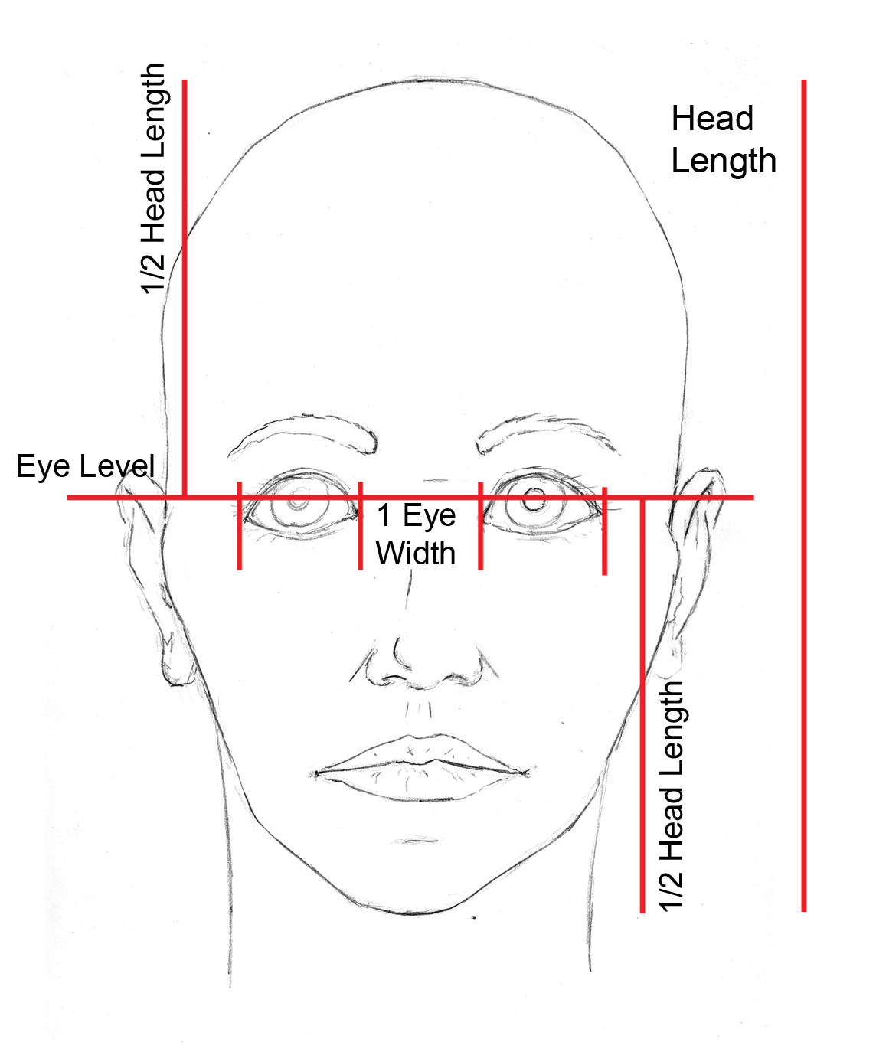

Online Resource 1 - http://www.roymech.co.uk/Useful_Tables/Human/Human_sizes.html | Online Resource 2 - http://mfleisig.wordpress.com/page/11/ | Online Resource 3 - www.nap.edu/html/11815/Anthrotech_report.pdf
Males:  - 5th percentile: 170 mm  - 50th percentile: 190 mm  - 95th percentile: 210 mm  Females:  - 5th percentile: 160 mm  - 50th percentile: 175  - 95th percentile: 190 mm  Average = (210 + 190)/2  Average = 200 mm | Males:  - 5th percentile: 180.34 mm  - 50th percentile: 195.58 mm  - 95th percentile: 210.82 mm  Females:  - 5th percentile: 165.10 mm  - 50th percentile: 180.34 mm  - 95th percentile: 195.58 m  Average = (210.82+195.58)/2  Average = 203.2 | Males:  - 5th percentile: 185 mm  - 50th percentile: 197 mm  - 95th percentile: 210 mm  Females:  - 5th percentile: 175 mm  - 50th percentile: 187 mm  - 95th percentile: 199 mm  Average = (210 + 199)/2  Average = 204.5

*The 95th percentiles have been used to calculate the average in order to ensure that the pillow fits a large amount of the target population
(200+203.3+204.5)
------------------------- = 202.6 203 mm (rounded to 3 significant figures)

3
Data Analysis - Strategy 3
What do I want to find out?
The standard measurements (mm) of head lengths in males and females from the ages of 15 and above
Online Resource 1 | Online Resource 2 | Online Resource 3
- 200 mm | - 203.3 mm | - 204.5 mm
(200+203.3+204.5)
------------------------- = 202.6 203 mm (rounded to 3 significant figures)
3
According to online research, the average head length for the particular target population is about 203 millimeters. Therefore, this is vital for the development and production of the product as the pillow as well as the plastic box must be at least 203 mm long in order to ensure comfort for the head and shoulders.

Strategy 4
What do I want to find out?
The most practical and safest material for the pillowcase
Cotton – 89 AED (Ikea) | Nylon – 47.75 AED (Ali Express) | Terry Cloth - 15 AED (Ikea)
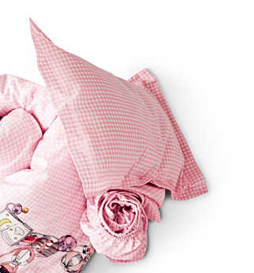  Pros:  - Nature fiber that is non-allergic, therefore it does not irritate sensitive skin  - Soft  - Very easy to dye as it is very absorbent  - High absorbency rate that holds up to 27 times its own weight in water  - Becomes strong once wet  - Doesn’t heat up in the sun as cotton keeps the body cool in the summer  - Not easily damaged by sunlight  - Natural product that contains no chemicals  - Regularly used for bed sheets and pillow cases  Cons:  - Not wrinkle resistant  - Fades in sunlight  - Dries slowly  - Prone to shrinking and stretching | 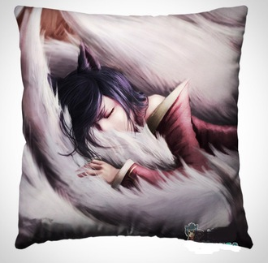  Pros:  - Smooth  - Light weight  - High Strength  - Low absorbency rate, meaning that the water remains on the surface of the fabric and runs off the smooth fabric and dries quickly  - Dirt will not cling to the smooth fiber  - Does not shrink after contact with water  - Can be easily dyed  Cons:  - Nylons washed with other fabrics pick up even the lightest of colors when in the washing machine, creating a grey appearance that is difficult to remove  - Low absorbency rate forces the fabric to feel uncomfortable in humid, warm weather  - Nylon whites easily pick up color  - Strength of nylon fabric is greatly decreased when wet  - Weakens when exposed to sun light | 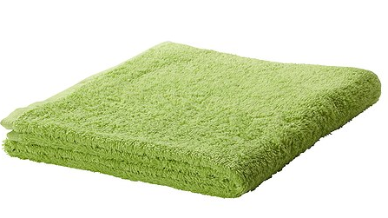  Pros:  - Loops are made from long-stapled top grade cotton  - The narrower the loops, the faster and more efficient is the transfer of moisture along the loops  - Very good absorbency characteristics  - Resistant to heat  - Does not require ironing  Cons:  - Since the material is made from cotton loops, once another object catches on the loop, this may force an entire line to be pulled out

Data Analysis - Strategy 4
What do I want to find out?
The most practical and safest material for the pillowcase

According to the research presented by the three resources, the use of a terry cloth is the most pragmatic option. Even though cotton is a natural fiber that does not irritate sensitive skin and is regularly used for pillowcases, the material is clearly not suitable for outdoor conditions as dries slowly and fades in sunlight. This does not correspond with the direction of the product, as the material must withstand exposure to sunlight and water, and therefore must be able to dry quickly. Nylon is of lightweight and can be dyed easily, however the fabric loses its strengths when exposed to heat and water, which does not fit the circumstances of the product. The terry cloth is the most suitable material in relation to the product as has very good absorbency characteristics and is resistant to heat. Also, the use of a towel corresponds with the enviorment that the product will be used, which is the beach. Even though there is a risk of an object entering one of the loops and breaking the link of cotton, this can be stitched easily and at low costs. Also, the terry towel comes in a range of different colors, such as blue, white, purple, green, and orange, which is aesthetically pleasing for the customer. Finally, the terry towel is the cheapest option in comparison to the other materials, which will decrease the cost of production and ultimately the final price. Therefore, this caters to the price sensitive customers of the target market that have been analyzed in strategy 1.

Strategy 5
What do I want to find out?
The most suitable type of plastic for the compartment box

Acrylonitrile Butadiene Styrene (ABS) | Polyvinyl Chloride (uPVC) | Polypropylene
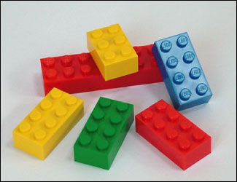  Pros:  - Strong  - Tough  - Hard  - Lightweight  - Durable  - Good surface finish  - Resistant to chemicals  - Typically used to make round or square shaped tubes  - Good for making structures  - Available in different shapes and colors  - Thermoplastic  - High heat resistance  - High impact resistance  - High gloss  Cons:  - Relatively high cost  - Flammable with high smoke generation  - Limited weathering resistance | 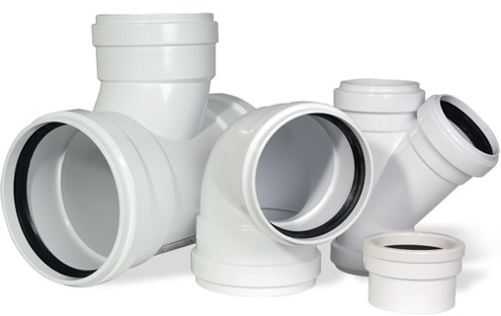  Pros:  - Stiff  - Hard  - Tough  - Lightweight  - Suitable for outside use  - Typically used for plastic windows  - Maximum temperature = 70 degrees Celsius  - Rigid  - Tensile strength = 6,500 psi  - Minimal negative enviormental impact throughout the life cycle  Cons:  - Looks “tired” after a few years  - Sensitive to UV sunlight | 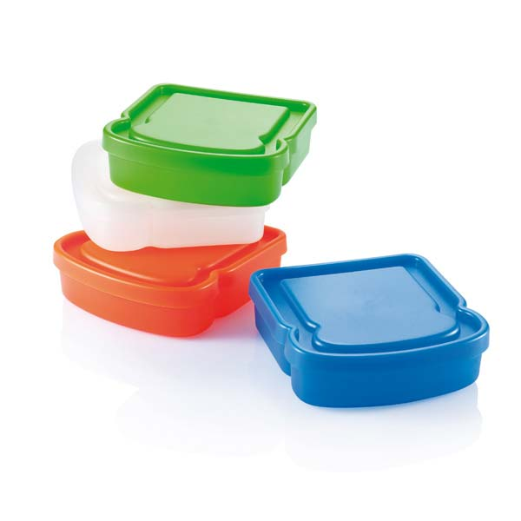  Pros:  - Good chemical resistance  - Good fatigue resistance  - High temperature resistance  - Frequently used for everyday products such as toys, sandwich boxes, buckets, packaging and housewares  - Low cost  - Flexible  - Good impact strength  Cons:  - Resistance to paint/ink once the cooling process is complete  - Flammable  - Poor weathering resistance  - High thermal expansion

Data Analysis – Strategy 5
What do I want to find out?
The most suitable type of plastic for the compartment box
According to online research, the most suitable plastic for the product is polypropylene. Even though Acrylonitrile Butadiene Styrene (ABS) is very strong, has high heat resistance and is suitable for creating different structures, its increasing cost for the plastic places as a large disadvantage. In order for this product to be successful, the designer and manufacturer must use price-sensitive materials in order to set a low price for the price-sensitive customers and attract attention. Polyvinyl Chloride (uPVC) contains similar properties to Acrylonitrile Butadiene Styrene (ABS) as it is lightweight, tough, and also has minimal negative enviormental impact throughout its life cycle. However, a large disadvantage with this plastic is that it is sensitive to ultra violet rays. This does not suit the enviorment of the product, as the product will repeatedly be used outside on the beach. Overall, propylene is the most pragmatic plastic to use for the compartment box underneath the pillow as it has high temperature resistance, flexible, low cost, and is frequently used for everyday products.

Strategy 6
What do I need?
The most preferred color for the terry towel that will be used as the pillowcase.
Males
 | Green | Turquoise | Lilac | Orange
1 | 2 | 4 | 3 | 3
2 | 2 | 4 | 3 | 2
3 | 3 | 3 | 3 | 1
4 | 2 | 2 | 2 | 1
5 | 2 | 1 | 3 | 1
6 | 2 | 4 | 3 | 2
7 | 1 | 4 | 2 | 2
8 | 4 | 3 | 3 | 3
9 | 4 | 3 | 3 | 4
10 | 3 | 4 | 2 | 1
11 | 2 | 2 | 4 | 1
12 | 2 | 4 | 4 | 1
13 | 2 | 4 | 4 | 2
14 | 3 | 4 | 3 | 1
15 | 3 | 3 | 4 | 1
16 | 2 | 2 | 2 | 1
17 | 2 | 2 | 2 | 1
18 | 3 | 3 | 3 | 2
19 | 4 | 1 | 2 | 3
20 | 3 | 3 | 3 | 2
21 | 3 | 3 | 1 | 2
22 | 2 | 4 | 1 | 2
23 | 2 | 3 | 3 | 2
24 | 3 | 2 | 2 | 3
25 | 3 | 3 | 4 | 3
26 | 2 | 3 | 2 | 3
27 | 3 | 3 | 3 | 4
28 | 2 | 3 | 3 | 1
29 | 3 | 4 | 2 | 1
30 | 2 | 4 | 4 | 1
Green = 73/120
Turquoise = 92/120
Lilac = 83/120
Green = 57/120

Females
 | Green | Turquoise | Lilac | Orange
1 | 2 | 1 | 3 | 2
2 | 2 | 3 | 3 | 2
3 | 1 | 4 | 3 | 2
4 | 4 | 4 | 4 | 3
5 | 1 | 3 | 3 | 2
6 | 1 | 2 | 3 | 3
7 | 1 | 3 | 3 | 3
8 | 2 | 3 | 4 | 3
9 | 1 | 3 | 3 | 4
10 | 1 | 4 | 3 | 1
11 | 1 | 4 | 4 | 2
12 | 1 | 4 | 3 | 2
13 | 2 | 4 | 3 | 2
14 | 3 | 2 | 3 | 2
15 | 4 | 4 | 2 | 3
16 | 2 | 4 | 3 | 3
17 | 3 | 4 | 4 | 2
18 | 3 | 2 | 2 | 3
19 | 1 | 3 | 3 | 2
20 | 1 | 4 | 3 | 4
21 | 1 | 4 | 3 | 1
22 | 1 | 4 | 3 | 1
23 | 1 | 3 | 3 | 1
24 | 2 | 3 | 4 | 2
25 | 2 | 4 | 4 | 3
26 | 1 | 3 | 4 | 3
27 | 2 | 4 | 3 | 3
28 | 1 | 3 | 3 | 3
29 | 1 | 4 | 4 | 3
30 | 3 | 2 | 4 | 2
Green = 52/120
Turquoise = 99/120
Lilac = 97/120
Orange = 72/120

All Participants
 | Green | Turquoise | Lilac | Orange
Points | 125/240 | 191/240 | 180/240 | 129/240

Data Analysis - Strategy 6
What do I need?
The most preferred color for the terry towel that will be used as the pillowcase
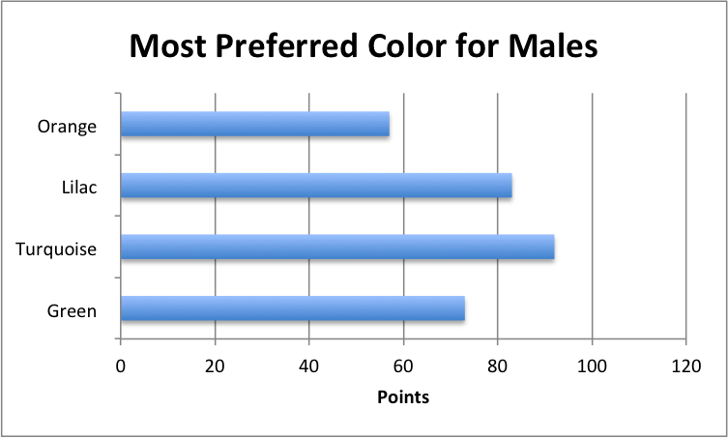

According to the graph, males highly preferred the turquoise towel when shown a picture to them, as the score for turquoise was 92/120. The least preferred color was orange, whereas green and lilac fell in the middle.

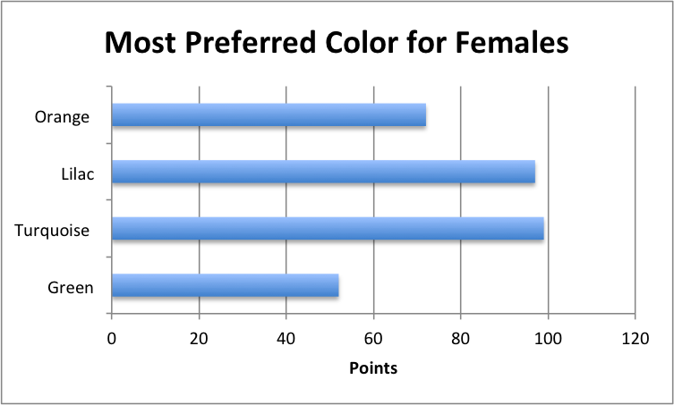
In regards to the female sample, participants also highly preferred the turquoise towel over the other choices. The ranking fell within the same order as the males, as the female participants highly preferred the turquoise towel, then the lilac, orange and green.

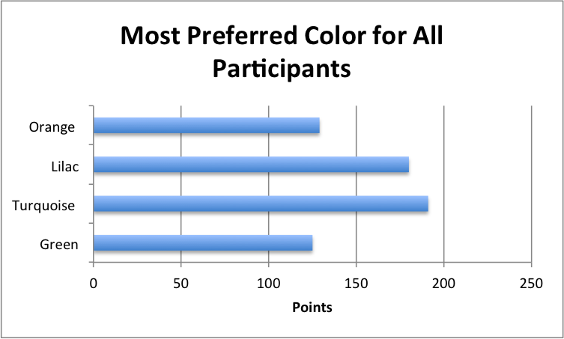

Overall, both male and female participants showed a great liking towards this turquoise towel. This is highly insightful and useful information for the design and manufacturing of the product, as this color will be used as the pillowcase and therefore attracts more customers from the target market.

Strategy 7
What do I need?
To investigate the standard items individuals 15 years old and above take with them to the beach

Items | Rating
Phone | 5
iPod | 9
Small headphone (E.g. Apple) | 6
Big headphones (E.g. Beats) | 11
Book | 9
Tanning Oils/Sun Lotions | 7
Sun glasses | 6
Keys | 9
Make up | 11
Extra clothes | 7
Beverages | 7
Snacks | 8
Goggles | 10
Hat | 9
Wallet | 6

Data Analysis - Strategy 7
What do I need?
To investigate the standard items individuals 15 years old and above take with them to the beach
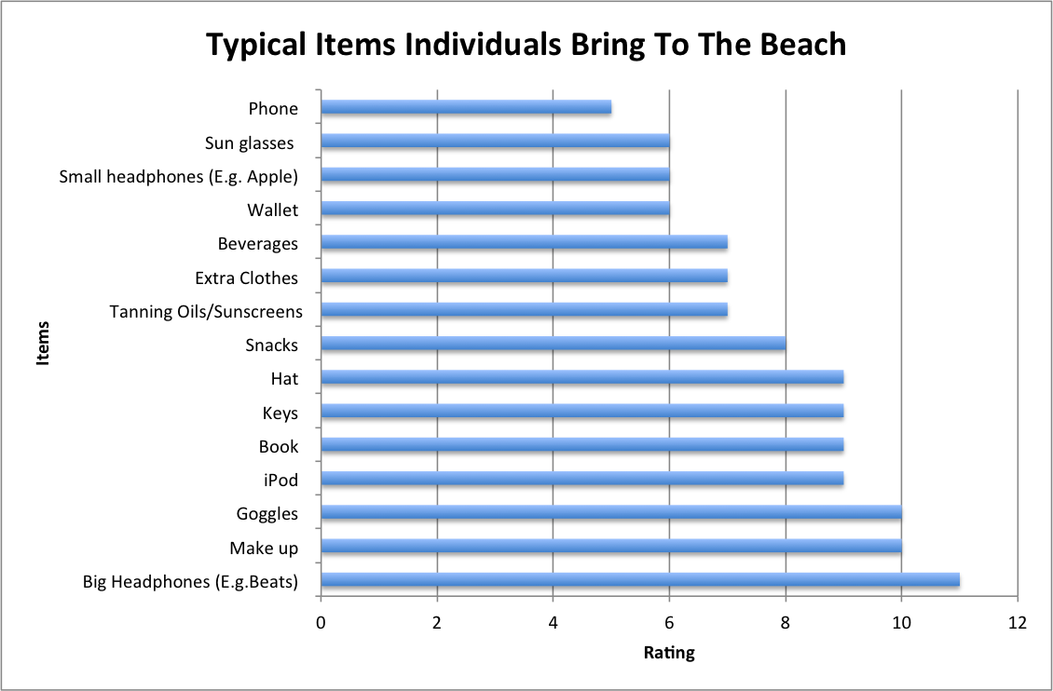
According to the online survey, the top 5 most recurring items that individuals take with them to the beach are big headphones (E.g. Beats), makeup, goggles, iPod and keys. This is very insightful in relation to the manufacture of the product, as the compartments created within the plastic box will correspond to the sizes of these items.

Strategy 8
What do I need?
To determine the average sizes of the top 5 items that individuals take with them to the beach, according to the data collection and analysis of strategy 7

Strategy 9
What do I need?
To find out how to ensure that the items stored inside the plastic box are kept cool
Materials To Consider | Characteristics
Window Film | - Against UV rays  - Cut out 99% of UV rays  - Slow the affects of fading  - Can be tinted or clear  - Consider placing around the plastic box  - Removable and reusable
Ice packs | - To keep the items inside, such as a phone, big headphones, and wallet, cool  - Consider placing inside of the plastic box on the sides
Styrofoam  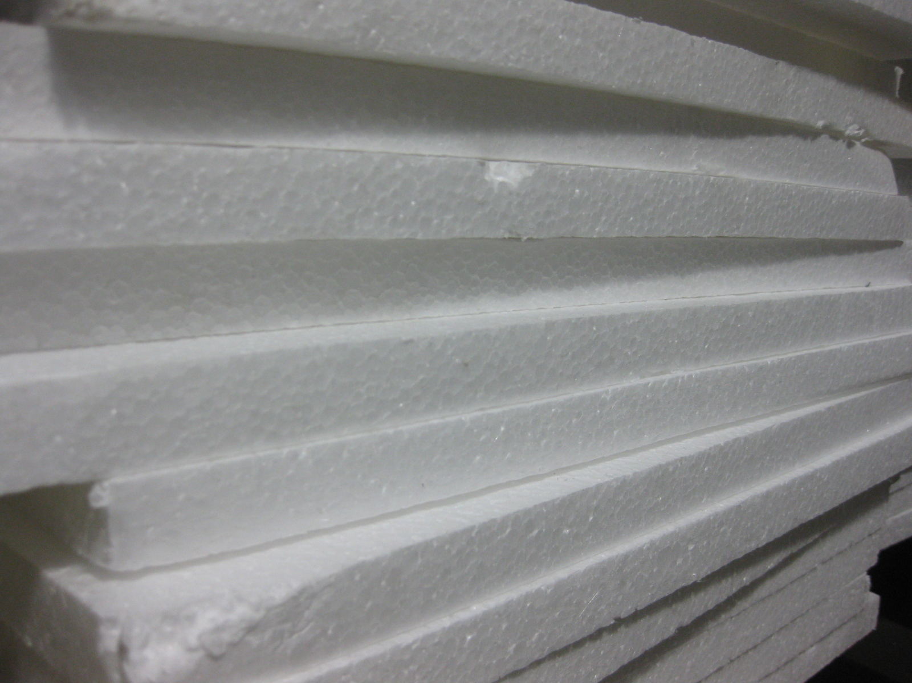 | - Consider placing inside of the plastic box on the sides  - Low cost  - Limit the items within the plastic box from freezing (in conjunction with the ice packs)

Experiment 1
The window film was wrapped around the plastic box and then placed in the sun for investigation
Temperature of plastic without window film (Celsius) | Temperature of plastic with window film (Celsius)
40 ° C | 35 °C
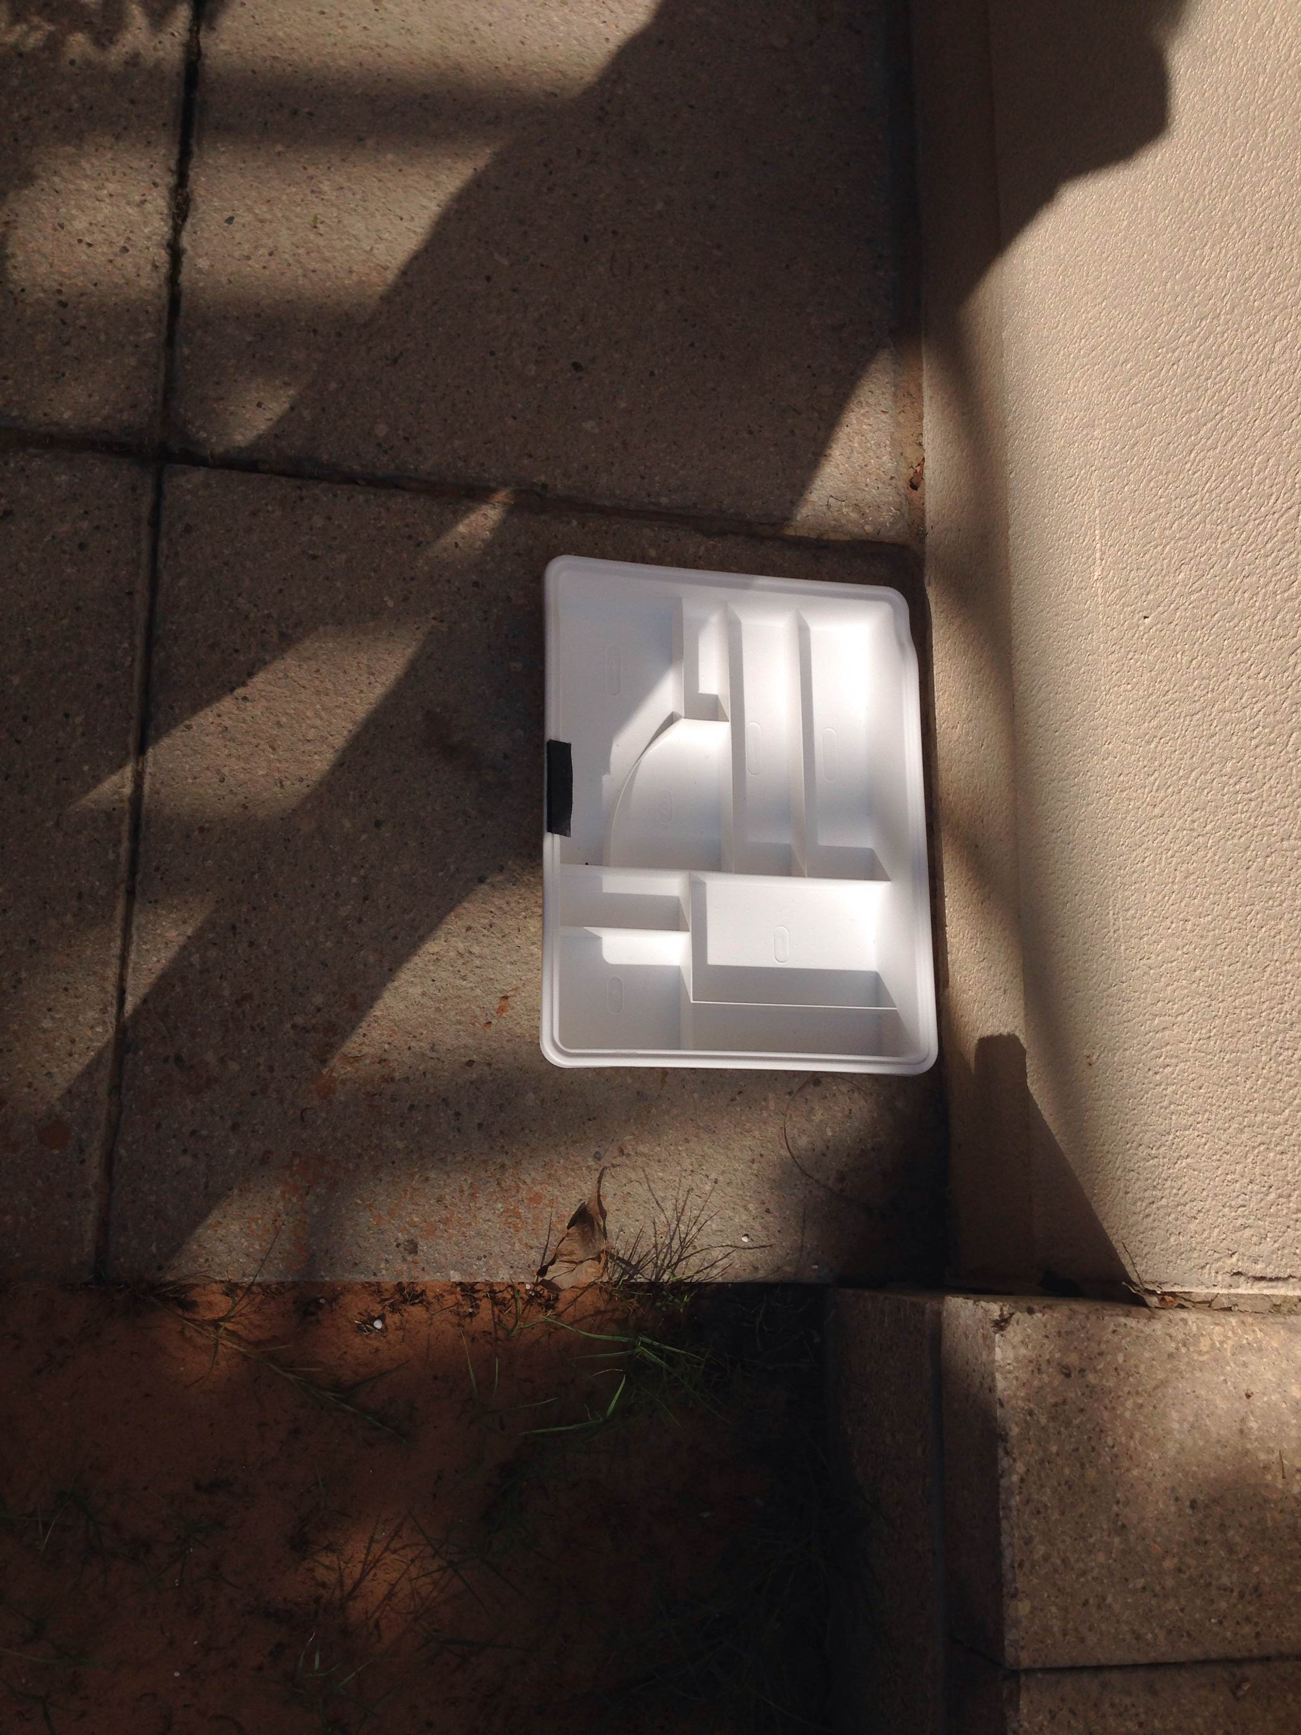
Experiment 2
The ice packs were placed inside the plastic box surrounding the edges, and then the Styrofoam in front of the icepacks.
Temperature without Styrofoam and icepacks (Celsius) | Temperature with Styrofoam and icepacks (Celsius)
40 ° C | 32.2°C
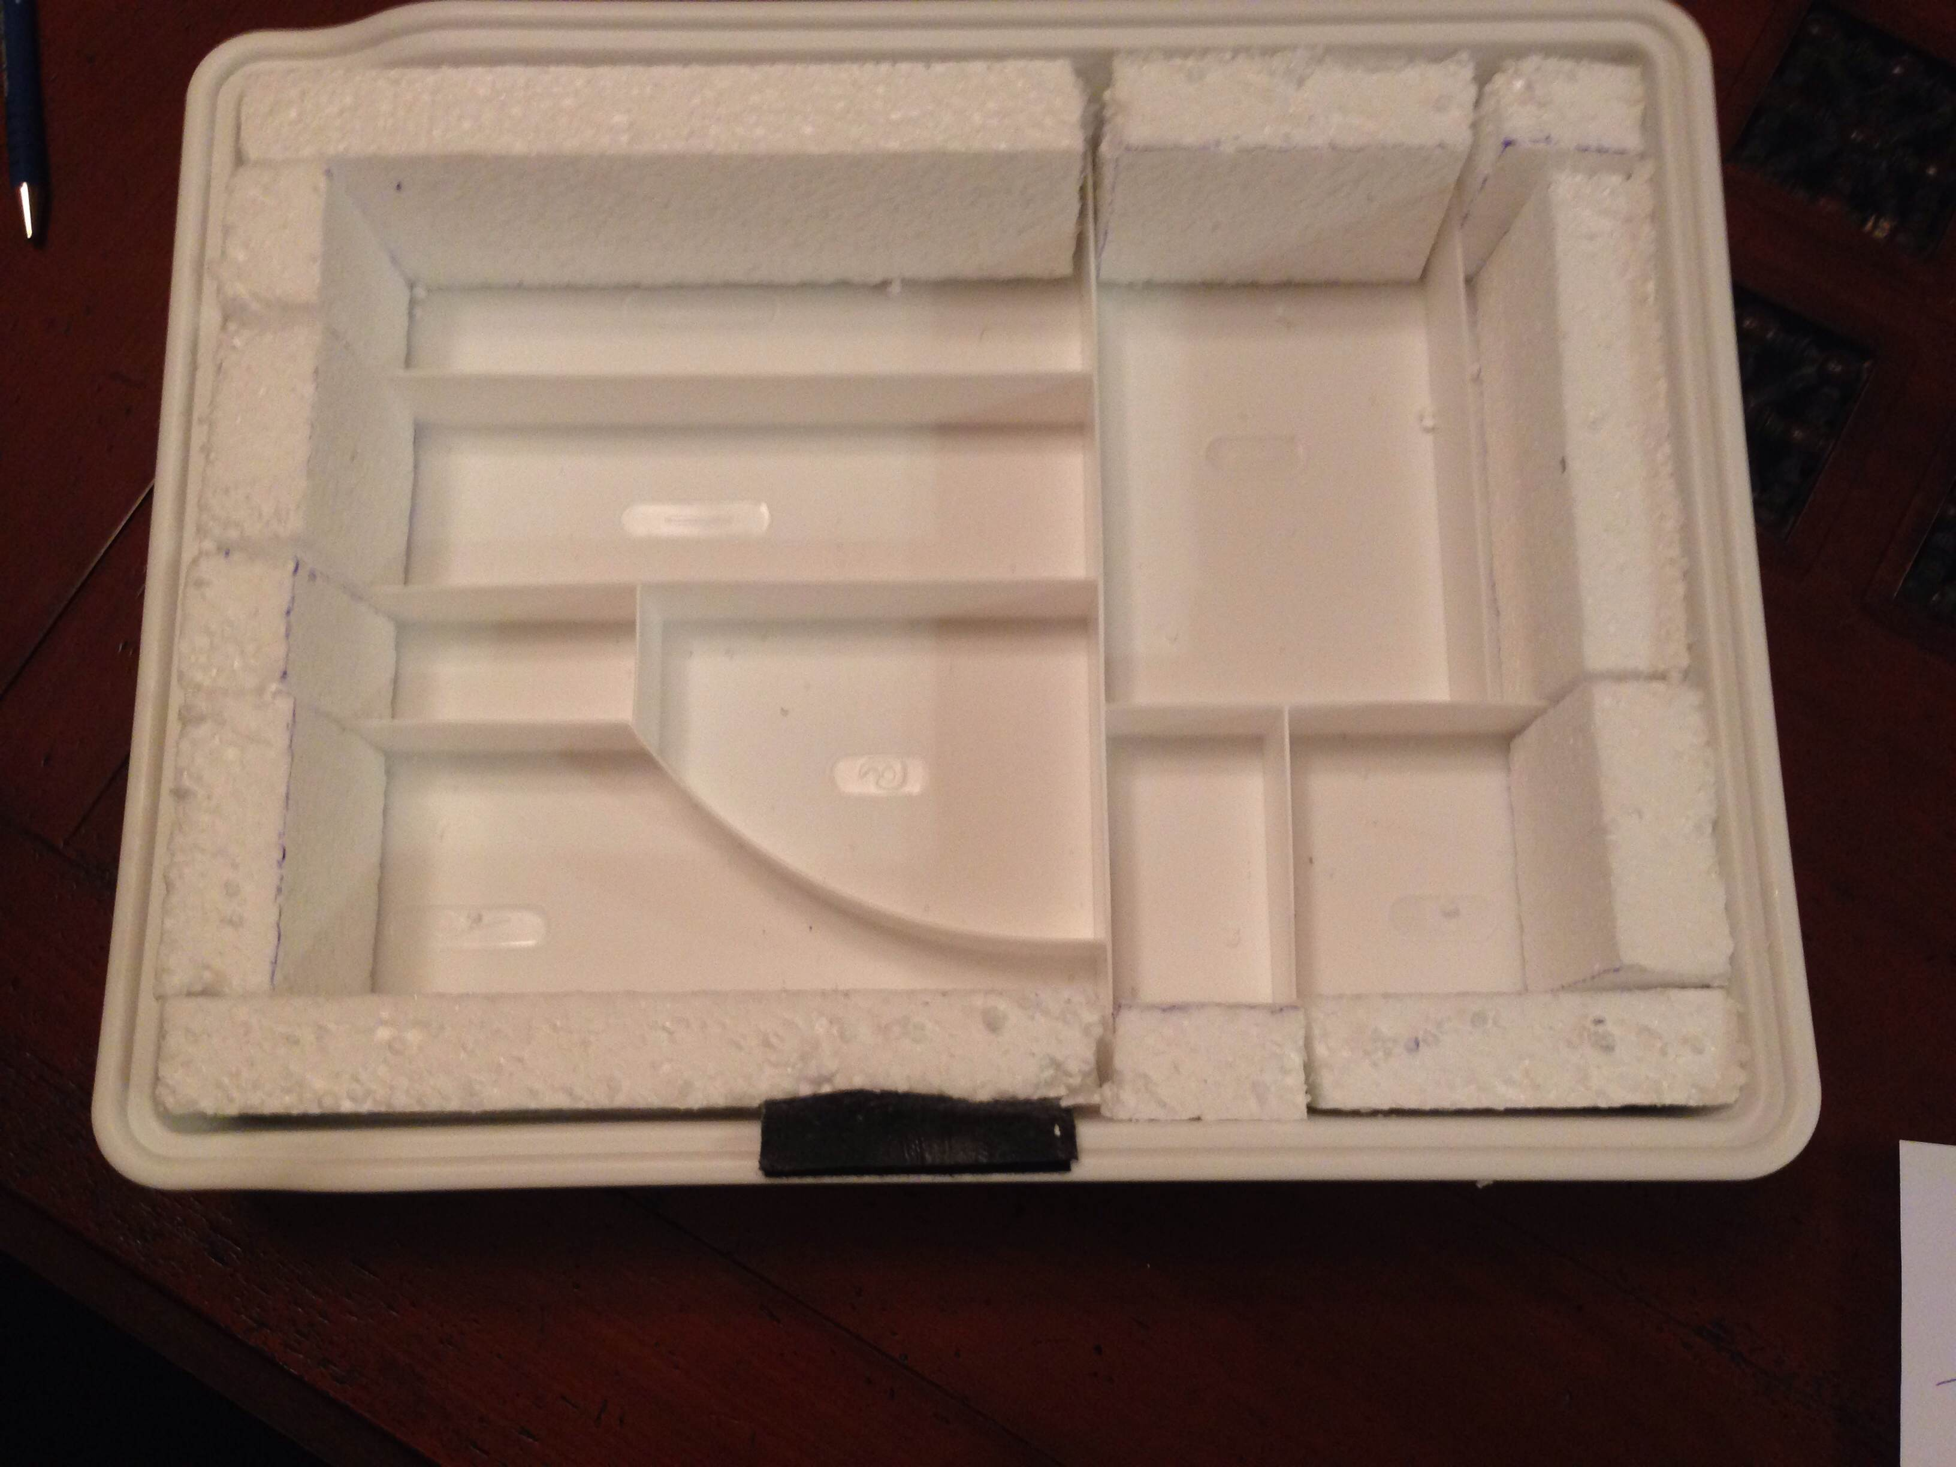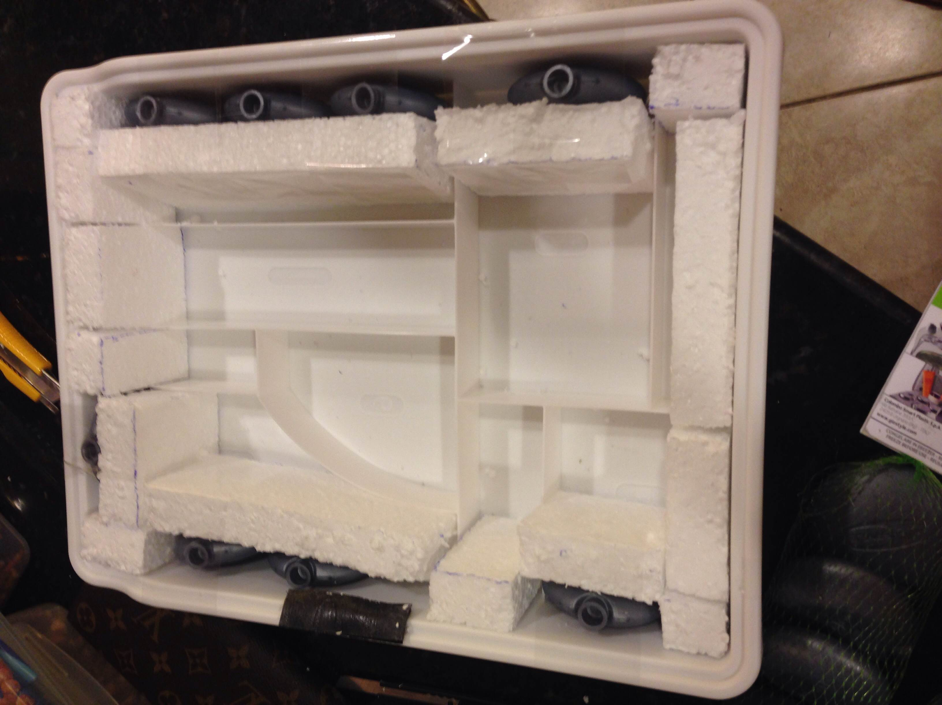
Styrofoam
Ice packs
Data Analysis - Strategy 9
What do I need?
To find out how to ensure that the items stored inside the plastic box are kept cool and do not over heat
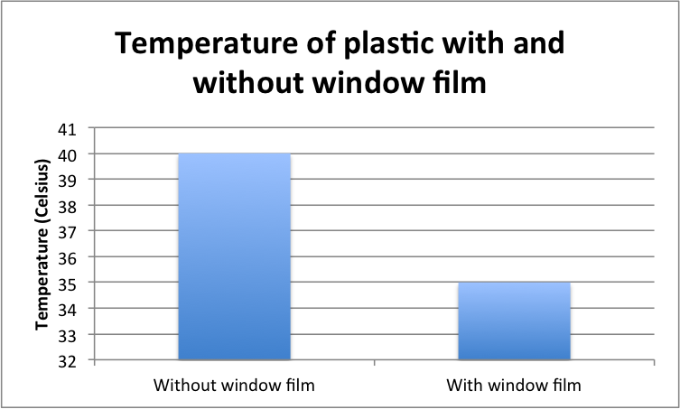
According to the graph, the temperature of the plastic box dropped significantly by 5 degrees Celsius due to the window film. This is due to the properties of the window film as it reflects sunlight. Therefore, the items kept within the product will not overheat. This is beneficial to the consumer, as they do not have to worry about their belongings becoming overheated. However, 35 °C is still hot, therefore further materials may be used in order to keep the product cool.

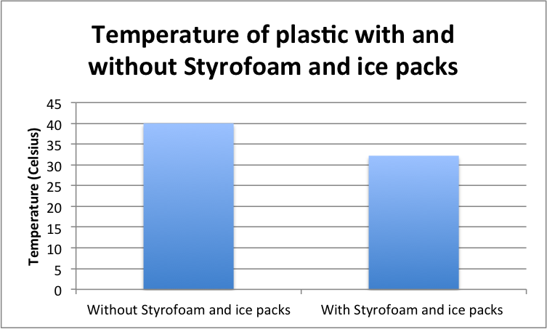
According to the bar graph, the Styrofoam and icepacks in conjunction with the window film had a large impact on the temperature of the plastic box, as the temperature dropped by 7.8 °C. Overall, all three materials should be used in the production of the final product in order to keep the consumers belongings within the plastic box cool.

Strategy 10
What do I need?
To decide on how to attach the pillow to the plastic box
Possibilities
Velcro
Velcro with canvas
Attaching loops to the pillow

Material | Testing
Velcro | One side of the Velcro was first placed firmly on the plastic, and the other side on the terry towel. There were no specific measurements of where the Velcro had to be placed on the towel or plastic box, as this was merely test to see how the materials stick together.  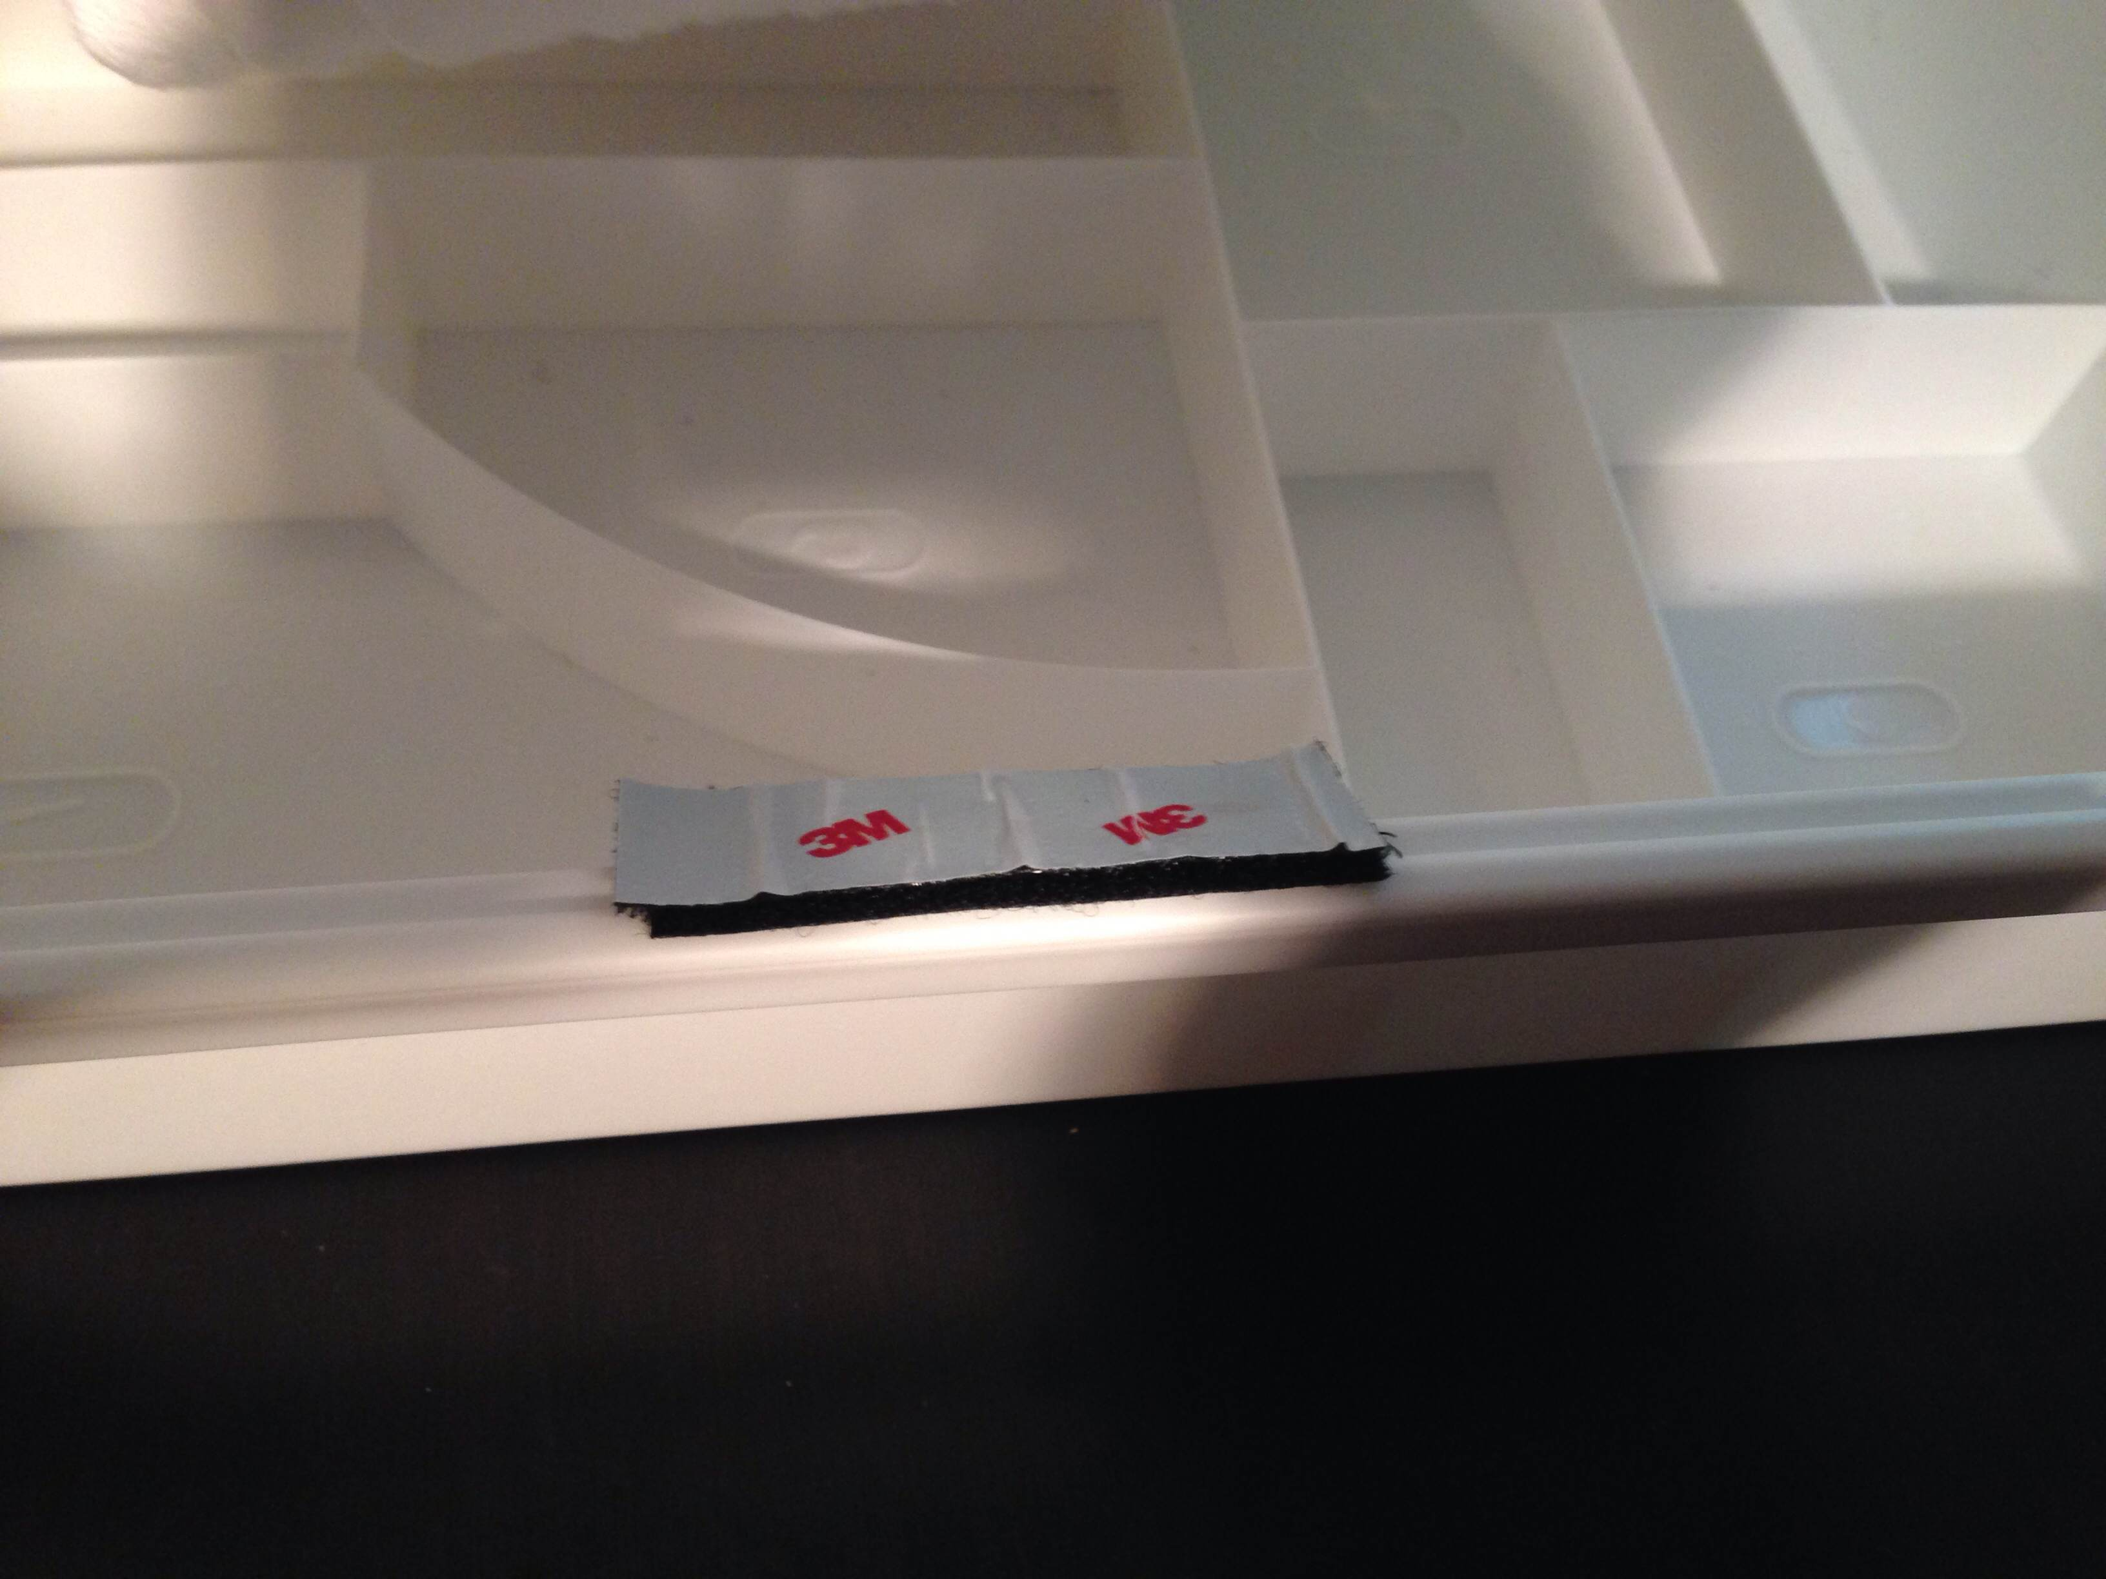  The towel was then placed on the plastic in order to see how firm they stick together with the Velcro, and then removed in order to see if the Velcro removes.  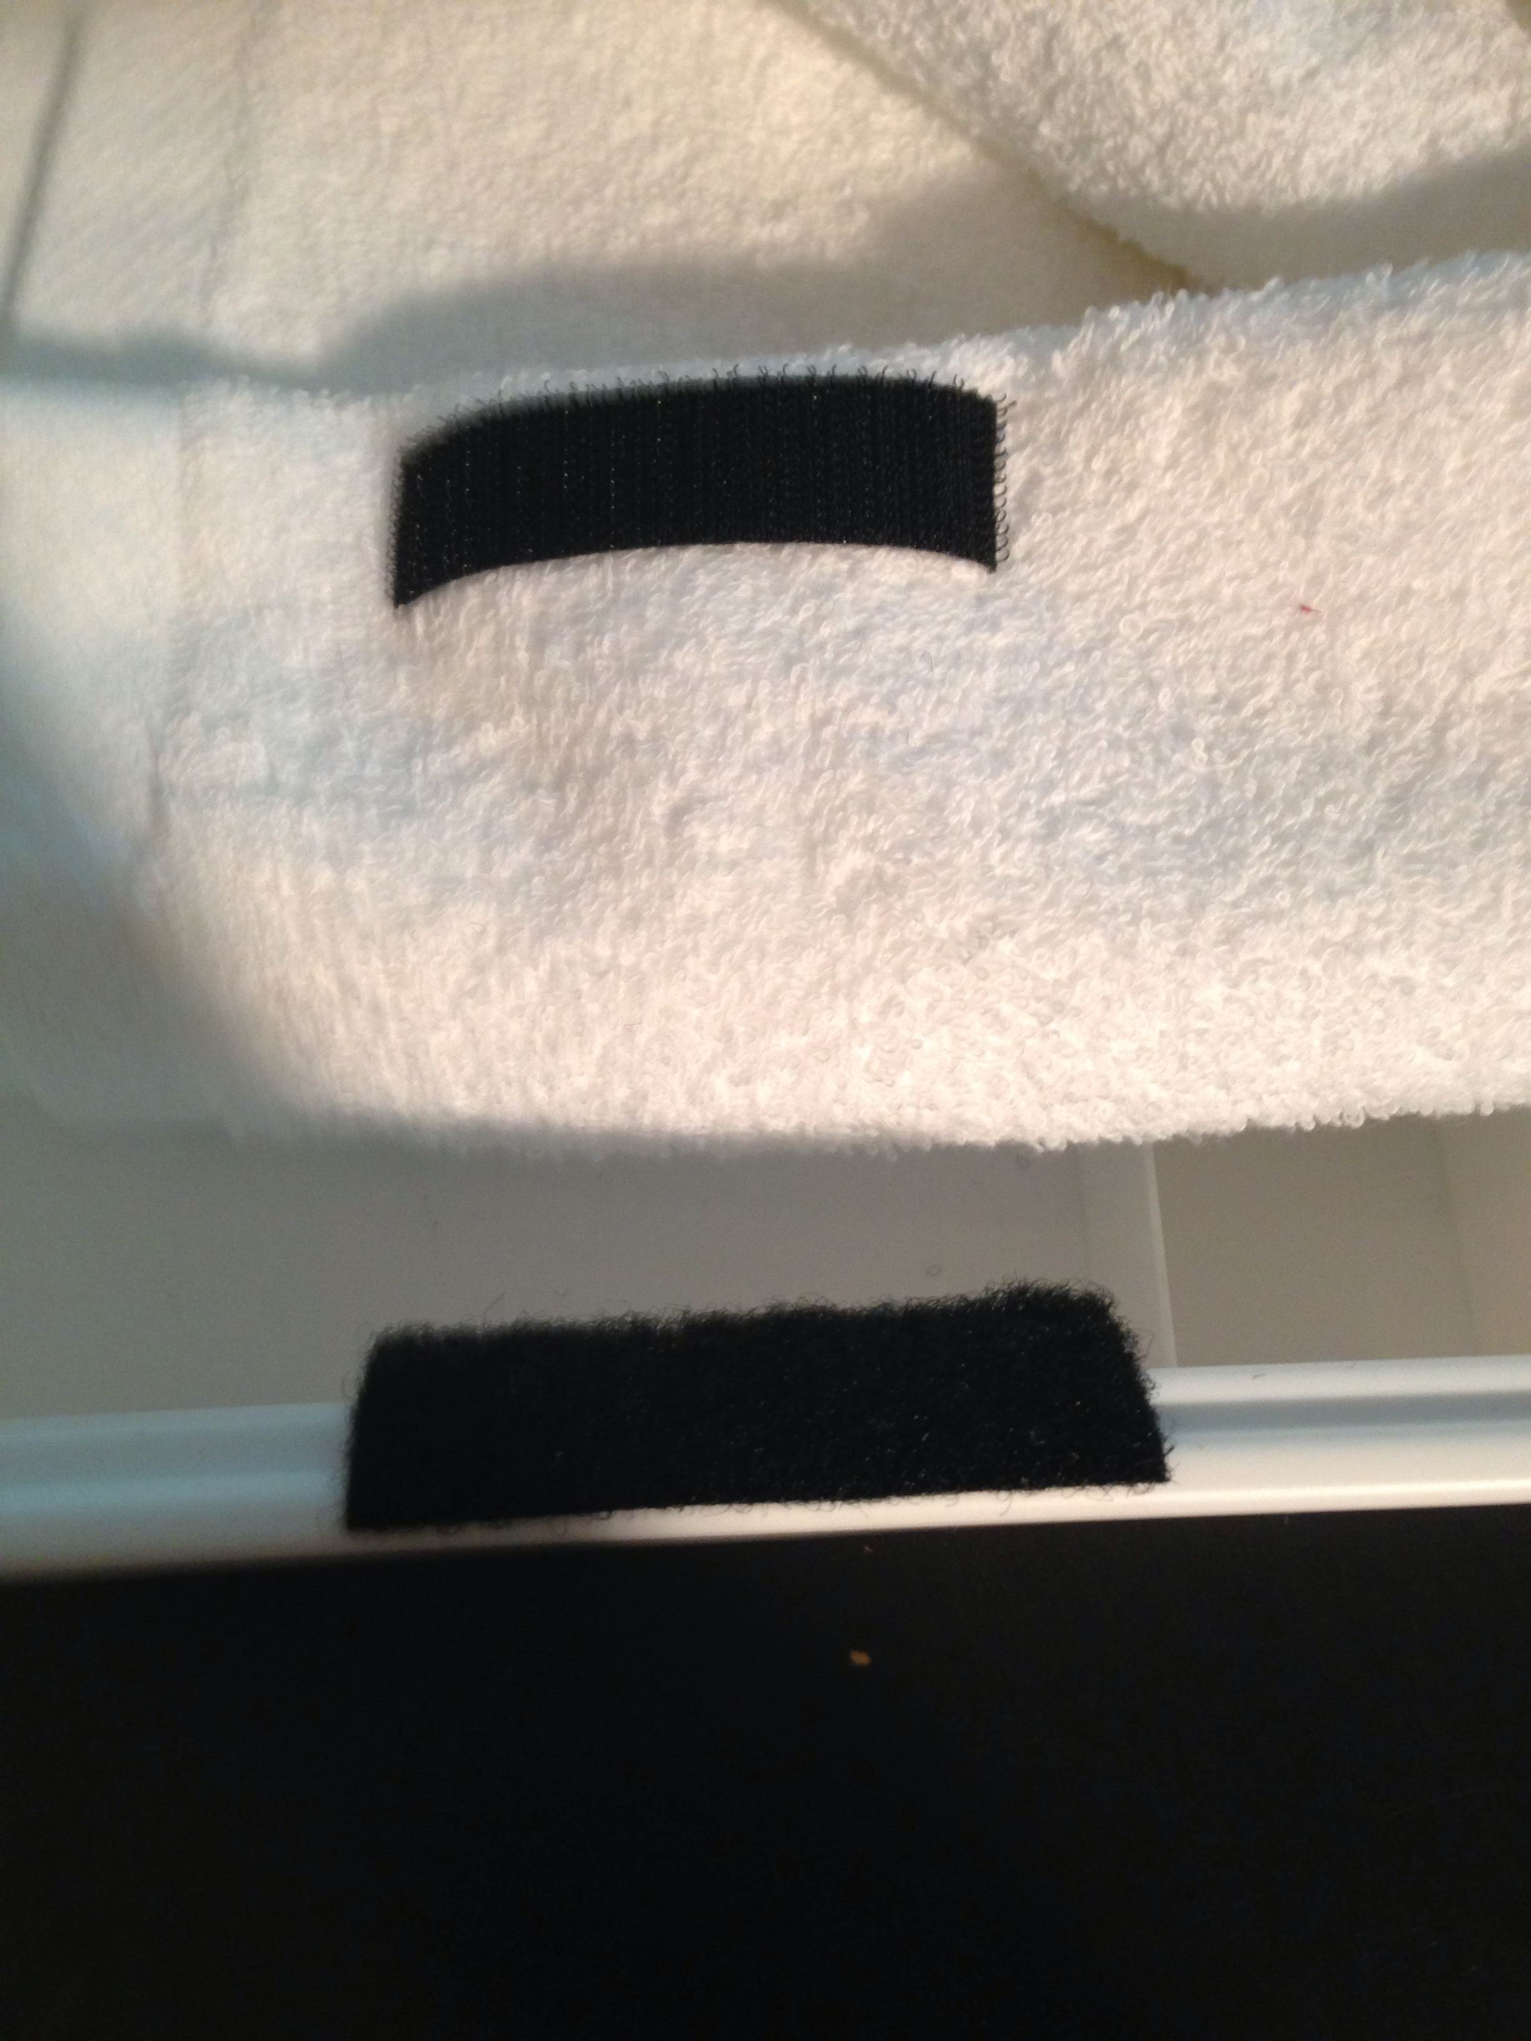

Strategy 10
What do I need?
To decide on how to attach the pillow to the plastic box

Overall, the Velcro worked perfectly in securing the plastic box to the pillow. Other possibilities were considered, such as using canvas in conjunction with the Velcro, as well as attaching loops to the pillow. However, the Velcro on it’s own worked very well as it held on strong to the plastic box and towel. The use of only Velcro is beneficial in the manufacturing and design of this product as it limits the costs in purchasing more materials. Also, the use of Velcro is beneficial to the customer as it is easy to use and keeps the pillow secure to the plastic box. Therefore, when an individual leaves the product on the sand while in the ocean, their belongings will be secure within the product.

Final Specification:
- Must include a zipper within the pillow in order to insert further necessities such as light clothing (E.g. T-shirt)
- Must be stable in order to support a teenagers up to an adults head size and weight
- May include miniature drawers within the compartment box
- May include a cushion
- May include a compartment on the side to place mini ball speakers
- Should have black UV rays surrounding the compartment box in order to resist heat
- Should include Styrofoam and changeable ice packs within the box in order to keep it cool

Materials for final model:

EVALUATION POINT:
- I only considered the iPhone 5 (most used phone) as during the design and development of this product. Apple has released a larger phone of (this size), and it is likely that other phone companies follow Apples design as it is the leading phone company in the world. Therefore, this can be fixed making this space for the phone larger.

Bibliography
"Cotton Australia." Fact Sheets. N.p., n.d. Web. 03 Sept. 2014.

"Textile Learner." Characteristics of Nylon Fabrics. N.p., n.d. Web. 03 Sept. 2014.

"What Makes A Good Towel." What Makes A Good Towel. N.p., n.d. Web. 03 Sept. 2014.

BBC News. BBC, n.d. Web. 03 Sept. 2014.

"Acrylonitrile Butadiene Styrene (ABS) Plastic." Plastics. N.p., n.d. Web. 03 Sept. 2014.

"Plastic Properties Of Acrylonitrile Butadiene Styrene (ABS)." Acrylonitrile Butadiene Styrene Properties. N.p., n.d. Web. 03 Sept. 2014.

"Acrylic Plastic Properties - Acrylic Plastic." Acrylic Plastic RSS. N.p., n.d. Web. 03 Sept. 2014.

"Types of Plastic." Types of Plastic. N.p., n.d. Web. 03 Sept. 2014.

"Plastic Properties Of Polyvinylchloride (PVC)." Polyvinylchloride Properties |Technical Information (PVC). N.p., n.d. Web. 03 Sept. 2014.

"70 items in Terry Cloth Fabric." Terry Cloth Fabric. N.p., n.d. Web. 03 Sept. 2014.

"Facilities & Services." Jumeirah Beach Hotel. N.p., n.d. Web. 13 Sept. 2014

"Molecular Weight Review." Molecular Weight Review. N.p., n.d. Web. 20 Sept. 2014.

"What Everyone Ought to Know about UPVC, the Advantages and Disadvantages | Here Today." Here Today RSS. N.p., n.d. Web. 20 Sept. 2014.

"DIY UV Protection Window Films." Guard against UV Rays with Specialist Film from the Experts. N.p., n.d. Web. 20 Sept. 2014.

"SANELA Cushion Cover - IKEA." IKEA AE/EN. N.p., n.d. Web. 20 Sept. 2014.

"Wholesale Nylon Pillow Cases." Online Buy from China Nylon Pillow Cases Wholesalers. N.p., n.d. Web. 20 Sept. 2014.

"Search Result - IKEA." Search Result - IKEA. N.p., n.d. Web. 20 Sept. 2014.

"Thermometers." Wholesale. N.p., n.d. Web. 20 Sept. 2014.
"HÄREN Bath Towel - 70x140 Cm - IKEA." IKEA AE/EN. N.p., n.d. Web. 20 Sept. 2014.
"HÄREN Bath Towel - 70x140 Cm - IKEA." IKEA AE/EN. N.p., n.d. Web. 20 Sept. 2014.
"HÄREN Bath Towel - 70x140 Cm - IKEA." IKEA AE/EN. N.p., n.d. Web. 20 Sept. 2014.
"HÄREN Bath Towel - 70x140 Cm - IKEA." IKEA AE/EN. N.p., n.d. Web. 20 Sept. 2014.
"ANTHROPOMETRY AND BIOMECHANICS." ANTHROPOMETRY AND BIOMECHANICS. N.p., n.d. Web. 20 Sept. 2014.
"Jack Sparrow." FXP. N.p., n.d. Web. 20 Sept. 2014.
"NANIG 3-piece Bedlinen Set for Cot - IKEA." IKEA AE/EN. N.p., n.d. Web. 20 Sept. 2014.
"Wholesale Nylon Pillow Cases." Online Buy from China Nylon Pillow Cases Wholesalers. N.p., n.d. Web. 20 Sept. 2014.
"Search Result - IKEA." Search Result - IKEA. N.p., n.d. Web. 20 Sept. 2014.
"Acrylonitrile Butadiene Styrene (ABS)." CES EduPack Software—ABS. N.p., n.d. Web. 20 Sept. 2014.
"Acrylonitrile Butadiene Styrene (ABS)." CES EduPack Software—ABS. N.p., n.d. Web. 20 Sept. 2014.
"Promotional Household Goods." Household Goods. N.p., n.d. Web. 20 Sept. 2014.
"Styrofoam." Welcome. N.p., n.d. Web. 20 Sept. 2014.

