Folding Product
FULL NAME
IB Year 1 11B HL
TEACHER NAME

Introduction:
Looking at my room, family/friends rooms, and shops it occurred to me that many people are lazy at folding laundry, and in fact if they have to do it, they hate it and it takes them a long time to do. In my opinion, I think that folding laundry should not be not be very time consuming and it should not make people just shove their laundry into cupboards and closets. Being able to fold laundry really easily from a young age can make it fun and can keep you organized for your whole life. Due to this problem I decided to head into the direction of making laundry folding more fun and faster. This problem, of organization of laundry, initiated a desire to find a solution.
Folding laundry faster can help in saving time in finding what to wear and keeping your closet organized in general. The reason why the organization of folding laundry should be focused on because people do laundry at least weekly, therefore it would not be a waste to use it. Also, it gives adults an easier way to teach their kids how to fold their laundry.
The ultimate problem that everyone faces is the organization aspect of folding laundry. How should people fold their laundry faster if they do not know how to fold laundry in the first place?
Design Brief:
What the product is: Organizational supply to help fold clothing
Major Constraints: Popularity and cost of product
Target Audience: House wife’s, clothing store staff, domestic staff

Specification | Justification
Pine wood | Most IB students use pinewood in order to make their products look somewhat professional. And for this product I would like it to not to look childlike though to come across as a product that could be used by anyone.
Recycled Materials | This product will promote reusing recycled materials for the good of the earth. This makes people to be more creative and imaginative and use products around their house to create an environmentally friendly product. Using recycle material will also cut down on costs.
Product to make folding easier | Most people do not like to do laundry or have someone do it for them. This product will make it so much easier for folding laundry so that anyone could use it without any trouble.
Easy storage | Not everyone has enough space to store many things, so this product should be easy to keep away in cupboards or corners of the house so that it does not take too much space.
Different Colors | Depending on what color the creator likes they can change up the look of the product in any way they want.
Different sizes | Depending one how big or small the laundry size is, the product could be made to fold specific products.
Easy to work with | This product must be produced in a way that ages 5 and up could use it without any trouble.
Construction/Hygiene | If using recycled material the producer needs to make sure all material is clean in order to ignore any health hazards.

In order o find out whether a folding product would help anyone I created a small survey on www.surveymonkey.com, and got 20 people to respond and help with the research. I did this to see what people want/need in this product, due to the fact that they could be potential costumers of my product.

Collected Data from Surveys:
This pie chart asked (adults aged 20 and up) on whether they fold their own laundry or not. I was expecting more to say that they fold their clothing however as shown more than half of the adults do not fold their own laundry. This shows that perhaps there could be an interest in a product that would help with the folding of clothing faster and easier then they would fold their own clothing.

4 people

16 people

This pie chart shows the response of (adults 20 years old and up) whether having an organized closet would save them time. Majority of the responses were yes. This shows that many people think that if they have a more organized closet then they could save time later on when trying to find things in there closet.

The (adults 20 years old and up) were asked on if they would do their own laundry instead of paying someone else to do it for them if it was an easier task and more than 50% of them said yes. What I hope to do with my product is to help people to be more organized and to help fold laundry in less amount of time.

This survey asked the (adults 20 years old and up) on which characteristics of the product would be the most important to them. The option majority agreed on was the price of the product. This shows that people are willing to use a product to make folding easier as long as it is affordable.

This survey was to see whether or not people would be in favor of using recycled material in order to make the product. Using recycled material would cut the cost and also be an environmental friendly product. More than half the people were in favor of using recycled material.

The (adults 20 years old) were also asked in the survey on how much they would pay for the product to help with folding clothing and the answers ranged from 20AED-130AED.

Main information to be concluded from collected data:
- More people would fold their own laundry if it they could do it faster and easier.
- Most people would save more time in finding things in their closet if everything is neater.
- Most people would buy the product if it were at an affordable price.
With all the data that I have collected I can now see which direction I will have to go for my design process regarding the information that is given to me by the potential customers.

Research regarding whether both genders would use the product for folding laundry:
I had an interview with 1 male and 1 female (ages 20-40) about whether or not they would use this product to fold their own clothing rather than paying someone else to do it for them. This survey will help me see if my product is worthy of being built and if it will actually be useful for the target audience. Interviews between the producer and the target audience helps to see what the target audience is looking for and what they should take into consideration. The adults I interviewed accepted to have their answers mention in this report but they had to be mentioned anonymously.

Blank Interview
- Why do you not fold your own laundry? Is it because of time, or is it its easier because someone else can do it, or an other reason

- Do you think being organized would help you in saving time in finding things in your closet later on? Why or why not?

- Would you teach your children to fold their own laundry in a fun and easy way if possible?

- How long does it take you to fold one batch of your clothing? And how many pieces of clothing does it include?

- How often do you do laundry?

Person 1: Female
-Teacher in DAA

- Why do you not fold your own laundry? Is it because of time, or is it its easier because someone else can do it, or an other reason
- It takes a really long amount of time, and coming back from school I am really tired, and its easier if someone else does it for me. When I go home afterschool I have to cook lunch, and take care of the kids, so it just takes away so much of my time.

- Do you think being organized would help you in saving time in finding things in your closet later on? Why or why not?
- Definitely, everything being organized is something that I sometimes struggle with in my children’s closets because of how they take everything out and don’t fold it and put it back in their closet.

- Would you teach your children to fold their own laundry in a fun and easy way if possible?
- Yeah if there was an easy way then I would because then if they can’t find anything in their closet then I could tell them fold your laundry properly and clean your closet then you will find what you need!

- How long does it take you to fold one batch of your clothing? And how many pieces of clothing does it include?
- I don’t fold my own laundry owr maid does it for us.

- How often do you do laundry?
- Our maid does it every other day.

Person 2: Male
-Parent of a student in DAA

- Why do you not fold your own laundry? Is it because of time, or is it its easier because someone else can do it, or an other reason
- It takes a long time, and I usually get home at 6 or 7 and I’m really tired.

- Do you think being organized would help you in saving time in finding things in your closet later on? Why or why not?
- Well I guess yes in a way, but most of the time my wife set out what I’m going to wear so that doesn’t effect me so much.

- Would you teach your children to fold their own laundry in a fun and easy way if possible?
- I wouldn’t personally, because 1) they would say why do I need to learn this and 2) they would not sit there for me to tell them how to do it.

- How long does it take you to fold one batch of your clothing? And how many pieces of clothing does it include?
- I don’t do the laundry but my wife always complains that it takes a long time.

- How often do you do laundry?
- She does laundry almost 3 times a week, depending what is going on that week.

Research regarding which recycled material/ new material to be used:
To help on cut down on the cost and reusing the material for an environmentally friendly reduce so that everyone could make their own product with using resources around them with the smallest amount of money. This will make the users of the product to help the environment and become eco-champions.

Item that can be reused | Why could this be used?
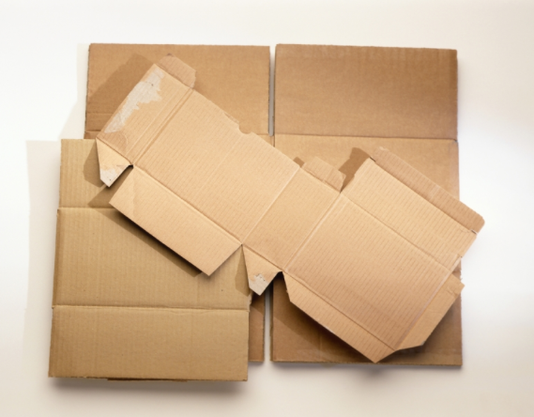 | Cardboard is a hard product and it is very common in every household and it is always available to be reused. By cutting pieces of cardboard and taping them together you can make a folder like product to fold clothes.
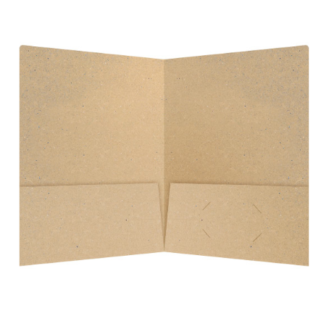 | Using a folder from school or work it can easily be using to fold small pieces of laundry
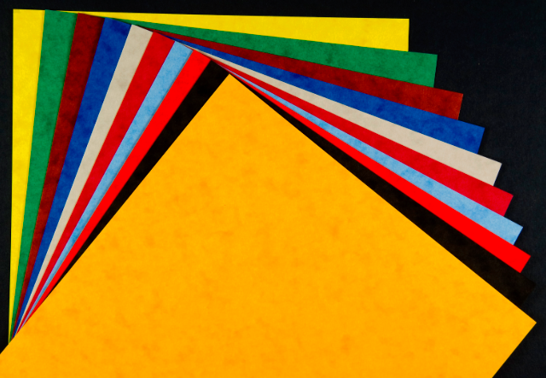 | Using thick pieces of scrap paper it can easily be taped together to make a product to fold pieces of laundry.

Other than using recycle materials, materials like wood and plastics like polypropylene plastic. This way the material will be more substantial and the materials can be easily bought from local hardware store or online. Though using hard wood would be more expensive than soft wood, though soft wood would be fine in this case of making this product. And polypropylene plastic would have to be bended in a factory or somewhere that the plastic could be melted in order for it to be bended.

Types of Hardwood and Softwood:
The research below shows the properties of different kinds of hardwoods and soft woods. Depending on the customer one type of wood may look more appealing than the others. Though pinewood is more lightweight so if the product needs to be mood around then it will be easy for anyone to carry. Researching about these characteristics it will help me know more information about the type of wood that would be good for me to use in my product.
If living in Dubai the most common place and the cheapest place to buy would is in Satwa. By going straight to Satwa rather than going to a hardware store the cost will be less substantially. Pine wood cost from 7AED to 81AED in American¹, which should be about the same in Dubai.

¹http://www.ezwoodshop.com/lumber-prices.html
www.hoovedesigns.com/woods.html

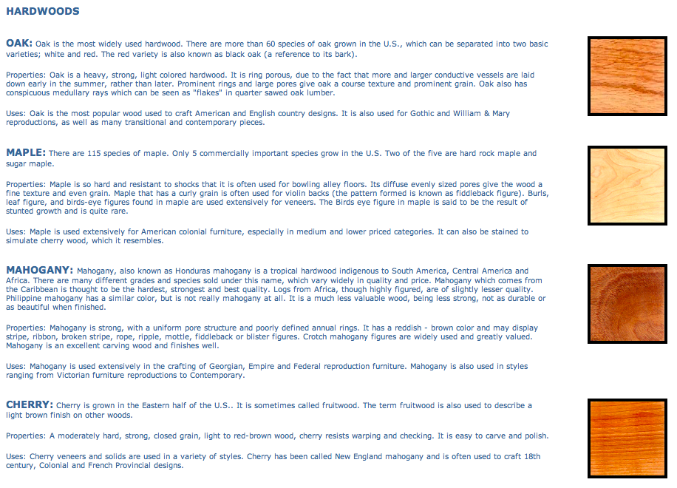

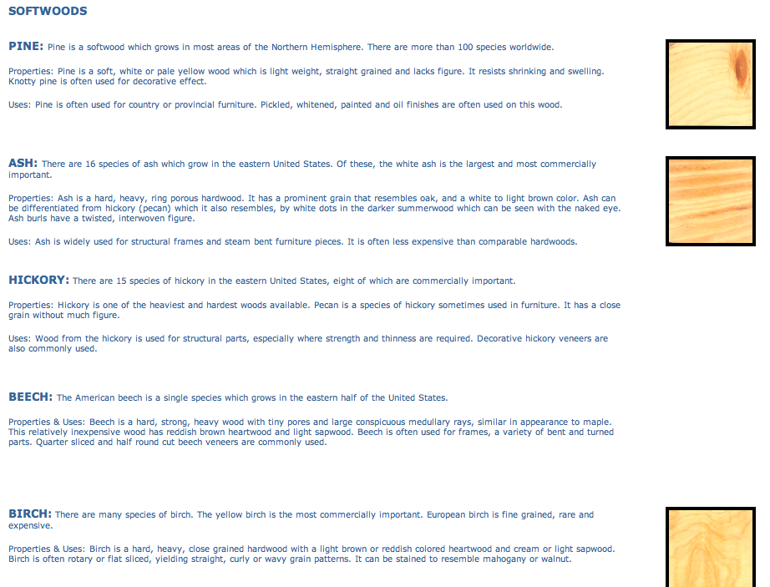

Extra Research
The extra research the average size of both men and women shoulder breadth in order to see what size the actual product should be.

http://www.roymech.co.uk/Useful_Tables/Human/Human_sizes.html
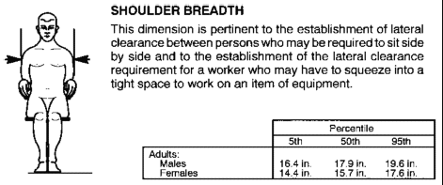

Cutting List:
-Using recycled material
- Cardboard: (18.36 AED) http://www.alibaba.com/product-detail/Kraft-corrugated-cardboard-box-for-shipping_1564146716.html?s=p
- Cloth Duct Tape: (2.39 AED) http://www.alibaba.com/product-detail/Colorful-Printed-Cloth-Duct-Tape_1871818792.html?s=p

Scale model

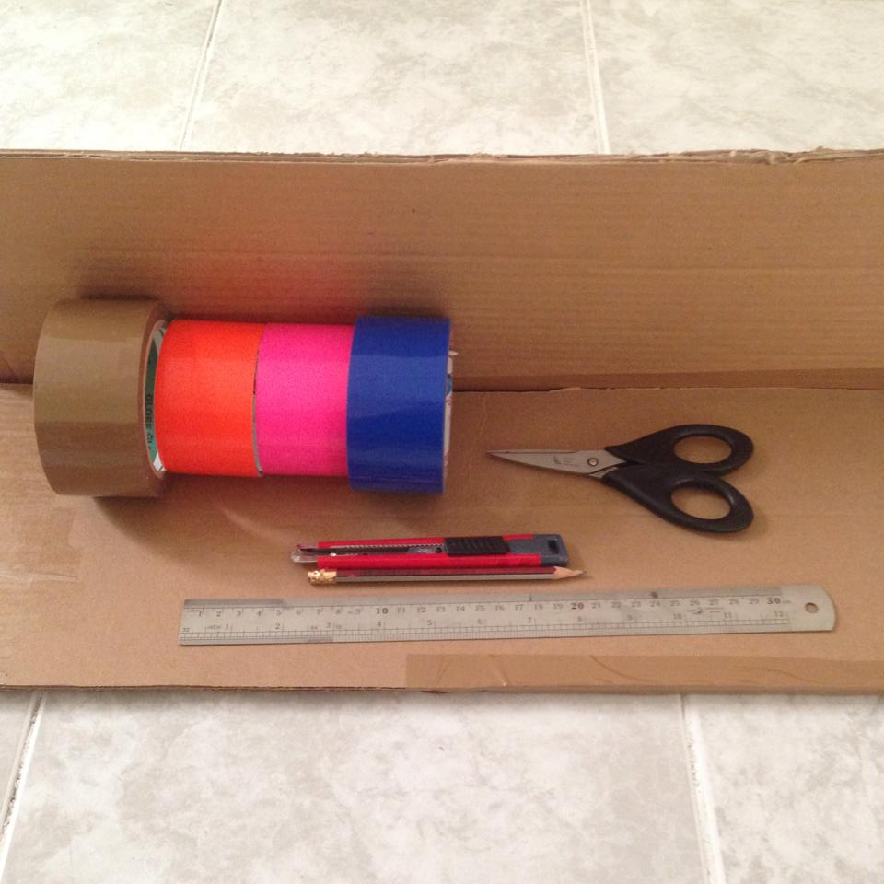
1
2

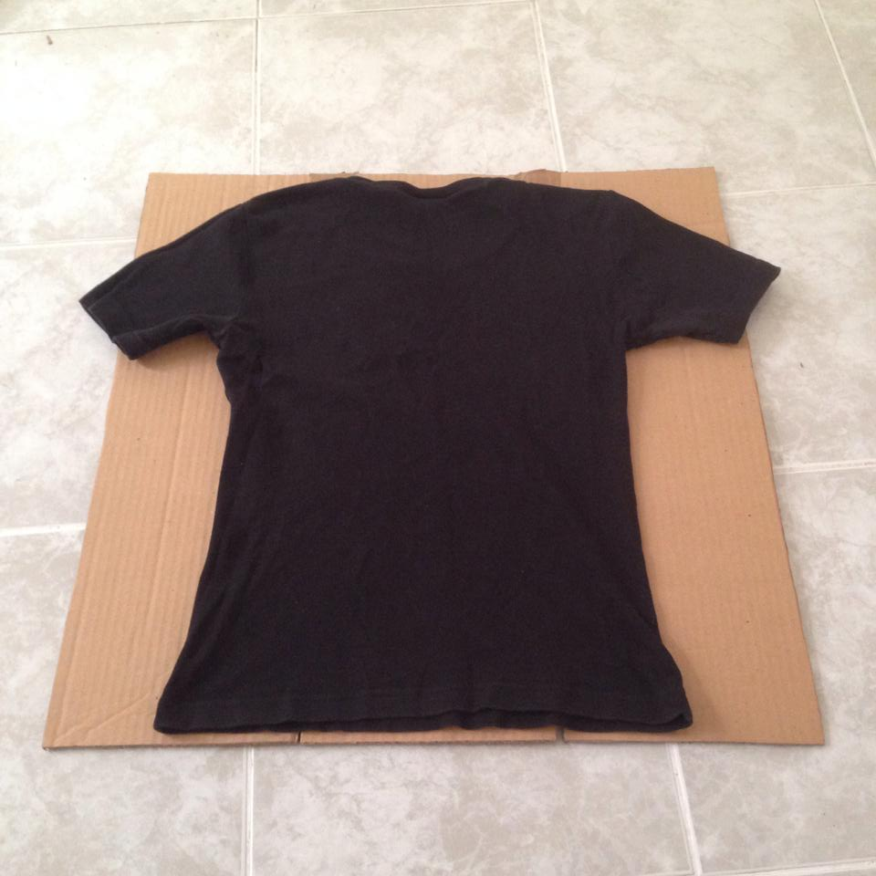

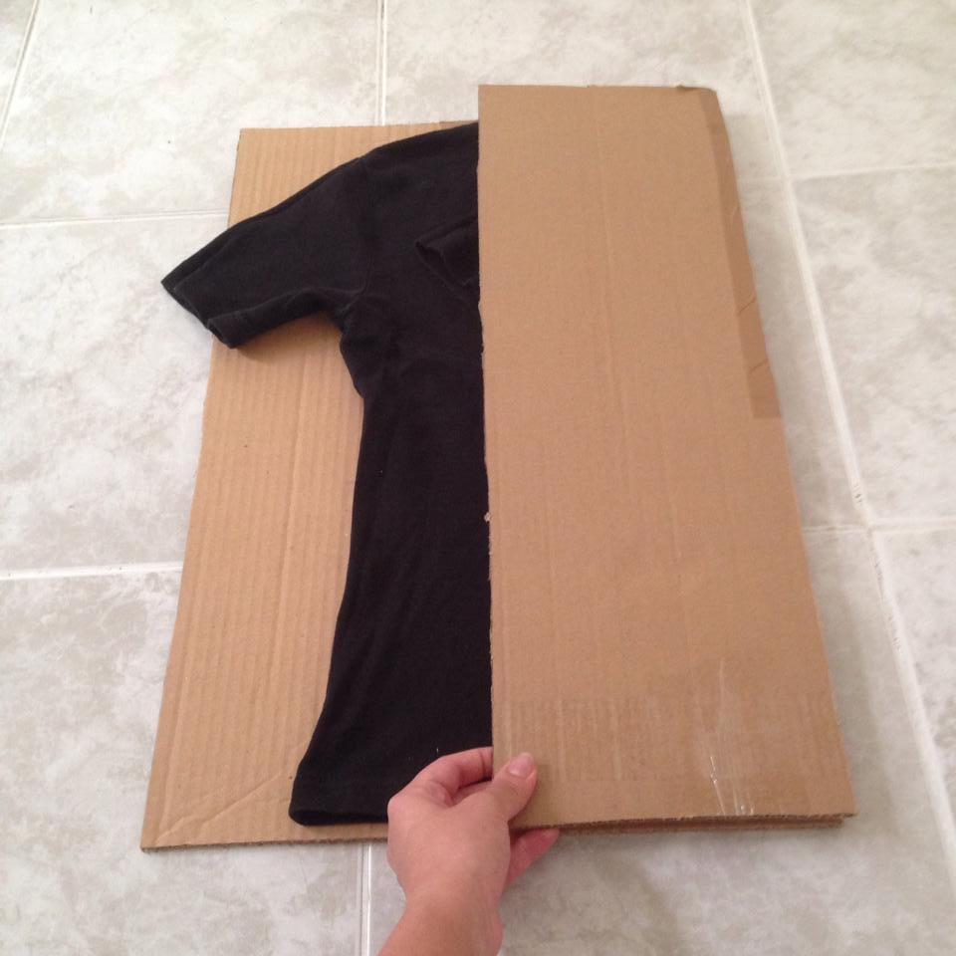
4
3

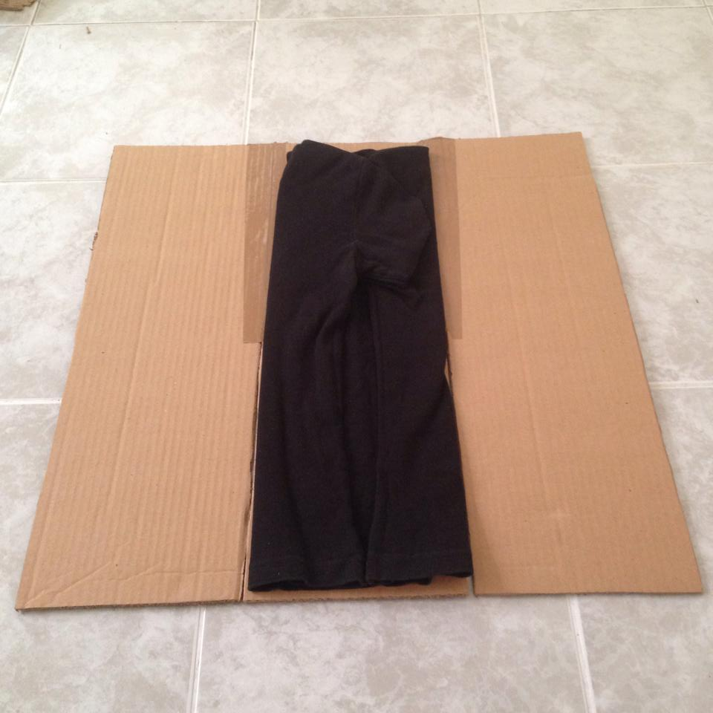
6
5

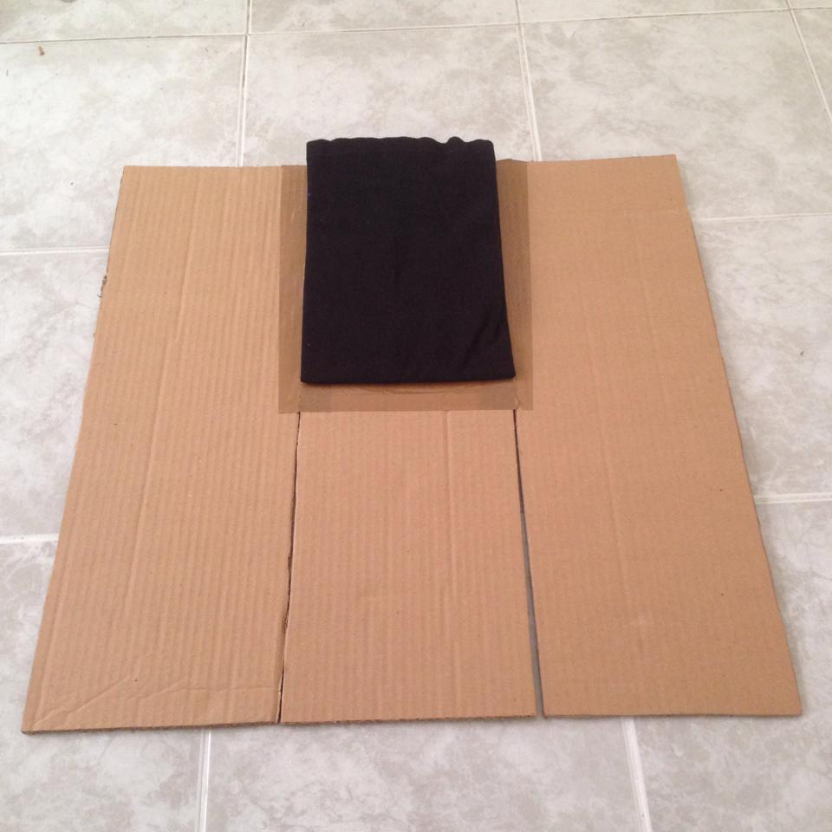
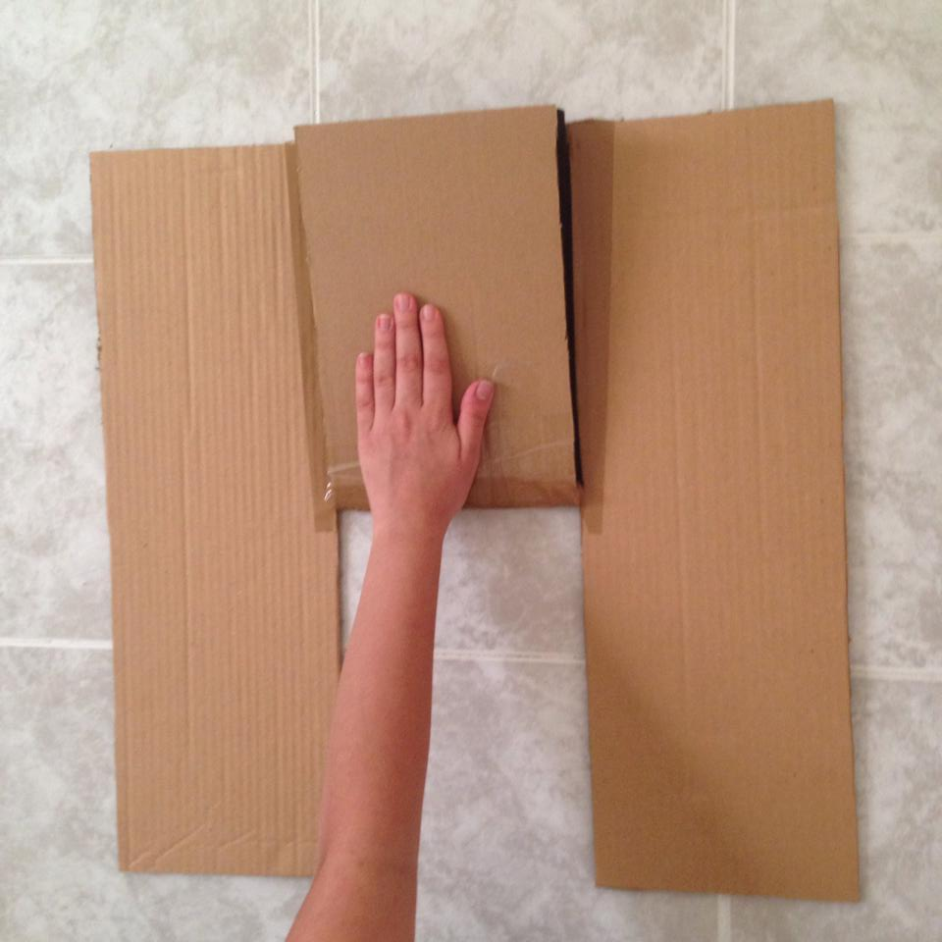
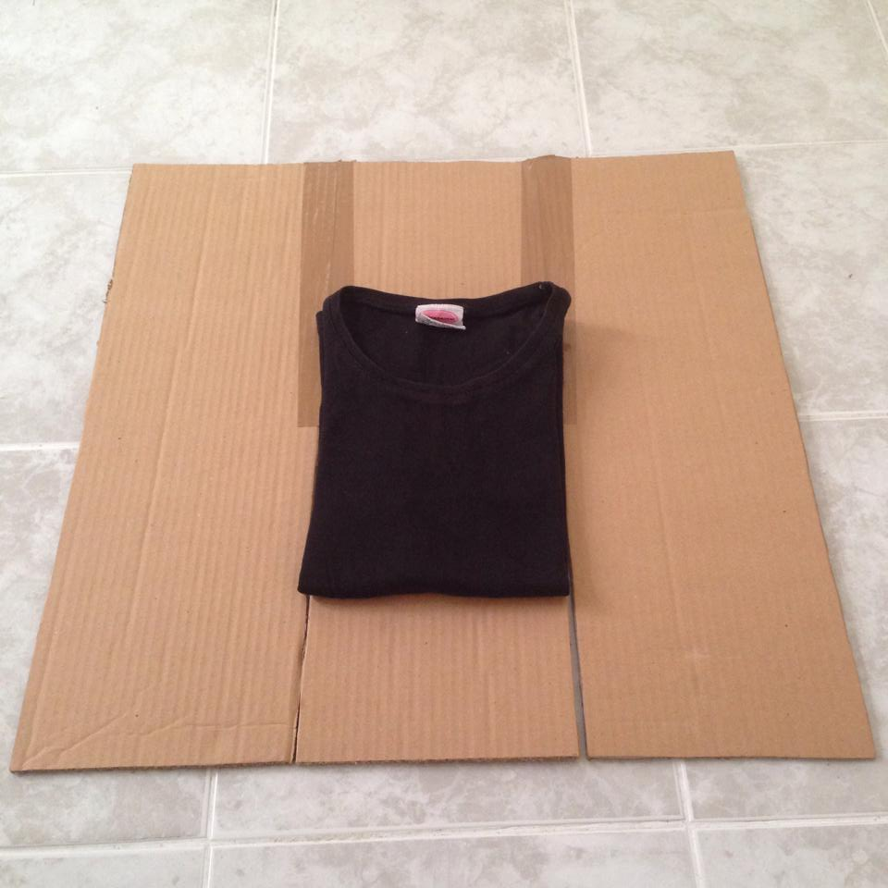
9
8
7

