Homework for Sept. 30th:

1. Write a verbal statement and give the same info in interval notation
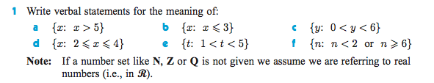

2.
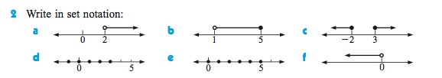

3. Sketch on a number line, and give the same information in interval notation (but only if possible )
