HOMEWORK due Thursday, May 8th. Please leave on my desk before Homeroom.
- Finish the following questions:

Q1
Q2
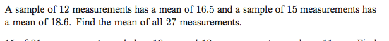

Q3
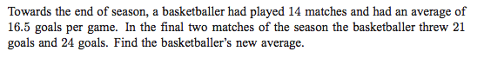

Q4
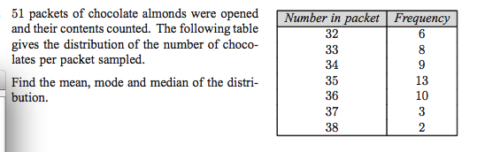

Q5
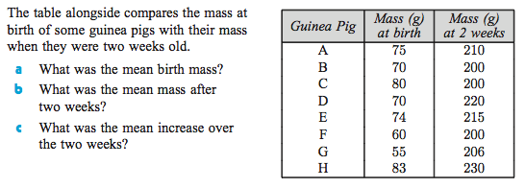

Q6
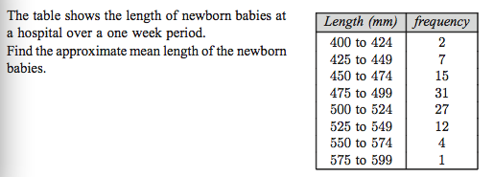

Q7
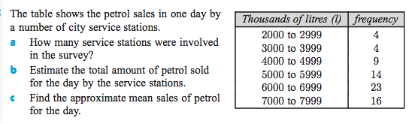

Q8
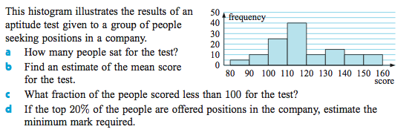
Q9
