IB1 MID YEAR EXAM SECTION A MARK SCHEME BLOCK C

Multiple Choice Answers:

- D
- A
- A
- C
- D
- D
- C
- C
- D
- B
- C
- D
- C
- B
- A
- C
- C
- B
- B
- A
- B
- C
- D
- D
- C
- B
- C
- A
- B
- B

Decision Tree Question Case Study

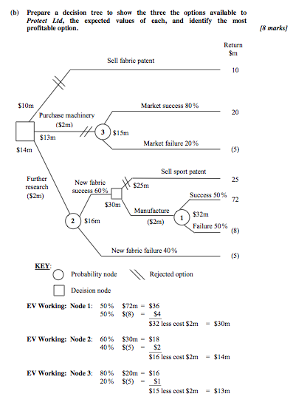

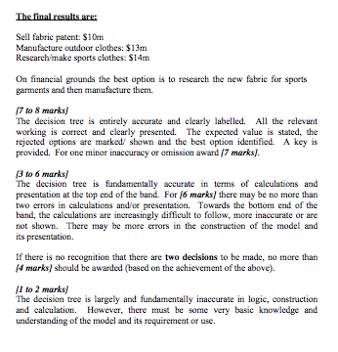

IB1 MID YEAR EXAM SECTION B MARK SCHEME

BLOCK C

(a) Explain why the Walt Disney Company can be described as a multinational company.
A global conglomerate is an organization that comprises a series of disconnected, unrelated businesses throughout the world. The connection between the various activities is not always obvious.
The Walt Disney Company is involved with theme parks, a Disney TV channel and also builds a presence on media platforms such as broadband and cell phones.
[2 marks] A clear explanation of the concept of an MNC is given. Relevant reference is made to Walt Disney.
[1 mark] Some explanation of the concept of an MNC is given though this may lack relevant reference to Walt Disney.

(b) (i) With reference to the Walt Disney Company, analyse the potential effects on two stakeholder groups of a global conglomerate investing in China.
Some of the possible positive effects of the Walt Disney Company investing in China may include:
capital and technology transfer and upgrade will improve production efficiency of local businesses. Also, competition will increase efficiency of local businesses big boost to the Chinese economy in terms of upgraded infrastructure, employment, increased exports, increased GNP and therefore, standard of living of the Chinese citizens. More spending power will generate more revenues for local businesses as well as more taxes for the Chinese government
more choice and possibly lower prices for consumers training of employees and local managers – skills are updated accept any other relevant benefit or stakeholders.
Some of the possible negative effects of the Walt Disney Company investing in China may include:
increased competition may result in local and often smaller businesses being unable to compete and therefore, closing down local unemployment may increase if local business close down with further negative effects on the demand for other local business products.
Chinese workers may lose their jobs due to closure. The standard of living of these employees/citizens and their families will fall. the Walt Disney Company may become a monopoly in the theme park sector with overwhelming market power regarding prices and quality. The welfare of the Chinese consumers will be reduced
tension between different national and organizational culture may upset the employees of the conglomerate or the citizens of China a MNC may benefit from lower taxes and other financial incentives – the opportunity cost of government spending in terms of welfare provision to its citizens – while repatriating the profit to the home country
accept any other relevant negative effects or stakeholders

[5 to 6 marks]
The analysis of possible positive and negative effects on two external stakeholders is detailed, balanced and well illustrated. Direct reference is made to the case study when appropriate.
[3 to 4 marks]
There is some analysis of possible positive and/or negative effects on two external stakeholders though this may tend to be descriptive at the lower end of the band. Direct reference to the case study may be limited. If only positive effects are mentioned, award no more than [3 marks].
[1 to 2 marks]
A limited and essentially descriptive answer.

(ii) Explain one advantage and one disadvantage for the Walt Disney Company of entering China as part of a joint venture.
The possible advantages for the Walt Disney Company of entering China through a joint venture method of entry are:
the Walt Disney Company and Shanghai government-backed group can combine their resources. The Walt Disney Company will acquire land for technology and capital. A synergy can be created and strengths are drawn together
risk is shared local companies can enable the Walt Disney Company to overcome some cultural and linguistic difficulties that an American company may encounter in China a larger company may further exploit economies of scale.
The possible disadvantages for the Walt Disney Company of entering China through a joint venture method of entry are:
conflicts and disagreement due to different corporate cultures and leadership style of an American company cooperating with a Chinese one diseconomies of scale may occur due to a larger size
time is wasted on meetings and administration, which may also result in an inability to make quick decisions.
[3 to 4 marks]
One advantage and one disadvantage for the Walt Disney Company are clearly explained. Reference is made to the case study.
[1 to 2 marks]
One advantage and one disadvantage for the Walt Disney Company are clearly explained. Reference is not made to the case study.
One advantage or one disadvantage is clearly explained with reference to the case study.
One advantage and one disadvantage for the Walt Disney Company is listed.

2. (c) Explain how being an MNC enables News Corporation to benefit from economies of scale.
One of the principal ways that News Corporation will benefit from economies of scale through being a media conglomerate is in marketing economies of scale. Their interests range across a number of different types of media as well as both content and distribution. This enables them to use marketing across a number of different media and will allow them to reduce the unit costs of marketing.
They may be able to use information gained in one area of the business to help them with marketing elsewhere in the business, e.g. they may be able to use subscriber information or user information gained from television and internet businesses to help them identify appropriate target markets for generating advertising revenues elsewhere. They may also benefit from marketing economies of scale with the sale of advertising space. Being involved in a number of media businesses means that they can offer advertisers an integrated solution across a number of different media.
They may also be able to benefit from technical economies of scale, e.g. their skills in distribution through satellite television may help them develop their Internet services. Internet development could perhaps be spread across a number of their web sites and technologies developed in other parts of the business could be used for other media. All these would help them develop economies of scale, therefore reducing unit costs.
There may be some possible bulk-buying economies of scale as well, e.g. the purchase of server space for their web sites may be cheaper if purchased on a larger scale across a number of web sites. This may also be true for their newspaper and magazine interests – bulk-buying of printing and other services across the different business may enable them to benefit from economies of scale and therefore reduce unit costs.
Financial economies of scale may be possible with the firm able to finance projects in an integrated way across the whole group. Film financing may also include financing for distribution and marketing across the different media businesses within the group. This may help reduce the unit cost of finance.
[5 to 6 marks]
There is a clear explanation of how at least two types of economies of scale may arise from being a News Corporation conglomerate. The explanation is related to the case study and business terminology is used appropriately.
[3 to 4 marks]
There is some explanation of how economies of scale arise from being a conglomerate, though this may be limited and points may simply be general, descriptive or perhaps unrelated to being a News Corporation conglomerate at the bottom end of the range.
[1 to 2 marks]
A limited and essentially descriptive answer.

(d) Discuss how external influences are shaping News Corporation’s strategy. [7 marks]
External influences are arguably the main forces driving change at News Corporation as they move away from the more traditional “old media” and develop their interests in “new media”. One of the key areas of external change is the ongoing development in technology. The move away from traditional print media, the growth in digital piracy and the development of integrated broadband and voice services are all factors driving changes in their strategy. This has prompted a series of acquisitions of internet and other new media companies. New technical methods to distribute their existing content (e.g. Internet video on demand) are also driving change, though concerns about whether this may affect other areas of the business (e.g. DVD and other sales) may affect their strategic thinking. A further issue will be concerns among senior managers about the dotcom boom and crash 2000 to 2002. This may lead many to believe that the Internet is not such a reliable source of revenue and profit. This means that external technological influences are one of the main factors shaping their strategy. Access to broadband and the changes taking place may be a further consideration.
It is stated in the case “Keeping up with technology is one part of News Corporation’s businesses sometimes damages another part.” The technological environment clearly poses a threat as well as perhaps more significant opportunities for News Corporation and it appears that the organization responded appropriately.
Regarding the political/legal environment, external legal influences also have an impact on News Corporation’s strategy. Digital piracy is growing and the difficulties faced by companies in controlling this may be an influence on their strategy and the ways they choose to distribute their content. Given the rapid changes in the technological environment, News Corporation will likely be able to respond to this threat. Perhaps this threat is a less significant one.
External social influences are also clearly an influence on their strategy. Many of their media interests have a target market with an older demographic. To attract a new demographic, that is the younger people who are using the Internet to get their news, News Corporation is making Internet acquisitions that target this younger demographic. As demographics continue to change, they will need to adapt their strategy to maintain growth across all groups. However, with such wide media interests, it could be argued that growth in one area will compensate for a possible fall in sales in other areas and so this will be less of a determinant of strategy. It appears that News Corporation did respond appropriately to the threats in political/legal/economic competition, social and technological environment by capturing the opportunities that exist, especially in terms of more advanced technology.

[7 to 8 marks]
A balanced and detailed discussion of the role of external influences in determining strategy. The discussion is related to the case study and is balanced across the different types of external influences. Business terminology is used appropriately throughout.
[4 to 6 marks]
Some discussion of the role of external influences in determining strategy though this may not be balanced across all areas of external influences. The discussion is generally related to the case study though it may tend to be more descriptive at the lower end of the band.
[1 to 3 marks]
A limited and essentially descriptive answer that may consider some external influences though these may simply be listed and/or not appropriate to the case study.

