All Questions on Normal Distribution

1. A random variable X is distributed normally with a mean of 20 and standard deviation 3.
(a) Find P(X ≤ 24.5).
(3)

(b) Let P(X ≤ k) = 0.85.
(i) Represent this information on the following diagram.
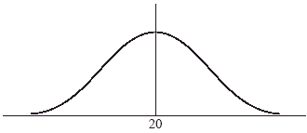

(ii) Find the value of k.
(5)
2. Let X be normally distributed with mean 100 cm and standard deviation 5 cm.
(a) On the diagram below, shade the region representing P(X > 105).
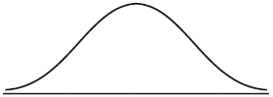
(2)

(b) Given that P(X < d) = P(X > 105), find the value of d.
(2)

(c) Given that P(X > 105) = 0.16 (correct to two significant figures), find P(d < X < 105).
(2)
(Total 6 marks)

3. The heights of certain plants are normally distributed. The plants are classified into three categories.
The shortest 12.92% are in category A.
The tallest 10.38% are in category C.
All the other plants are in category B with heights between r cm and t cm.
(a) Complete the following diagram to represent this information.
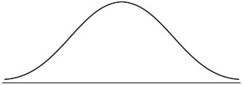
(2)
(b) Given that the mean height is 6.84 cm and the standard deviation 0.25 cm, find the value of r and of t.
(5)
(Total 7 marks)

4. The weights of a group of children are normally distributed with a mean of 22.5 kg and a standard deviation of 2.2 kg.
(a) Write down the probability that a child selected at random has a weight more than 25.8 kg.
(b) Of the group 95% weigh less than k kilograms. Find the value of k.

(c) The diagram below shows a normal curve.
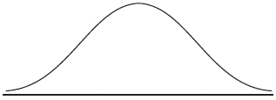
On the diagram, shade the region that represents the following information:
87% of the children weigh less than 25 kg
(Total 6 marks)

5. The heights of a group of students are normally distributed with a mean of 160 cm and a standard deviation of 20 cm.
(a) A student is chosen at random. Find the probability that the student’s height is greater than 180 cm.
(b) In this group of students, 11.9% have heights less than d cm. Find the value of d.
(Total 6 marks)

