**Mark scheme for all questions on Normal Distribution**

**1.** (a) *σ* = 3 (A1)

evidence of attempt to find P(*X* ≤ 24.5) (M1)

*e.g. z* =1.5, 

P(*X* ≤ 24.5) = 0.933 A1 N33

(b) (i)  
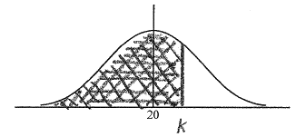 A1A1N2

**Note:** Award A1with shading that clearly extends to right of the mean, A1for any correct label, either k, area or their value of k

(ii) *z* = 1.03(64338) (A1)  
attempt to set up an equation (M1)  
*e.g.* *  
k* = 23.1 A1N35

[8]

**2.** (a)  
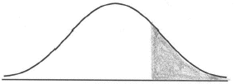 A1A1 N2

**Note:** Award A1for vertical line to right of mean, A1  
 for shading to right of **their** vertical line.

(b) evidence of recognizing symmetry (M1)*e.g.* 105 is one standard deviation above the mean so *d* is one standard  
deviation below the mean, shading the corresponding part,  
105 – 100 = 100 – *d*

*d* = 95 A1 N2

(c) evidence of using complement (M1)*e.g.* 1 – 0.32, 1 – *p*

P(*d* < *X* < 105) = 0.68 A1 N2

[6]

**3.** (a)



A1A1 N2

**Notes:** Award A1 for three re.g.ions, (may be shown  
 by lines or shading) A1 for clear labelling of  
 two re.g.ions (may be shown by percentages or  
 cate.g.ories).

r and t need not be labelled, but if they are,  
 they may be interchanged.(b) **METHOD 1**

P(*X* < *r*) = 0.1292 (A1)

*r* = 6.56 A1 N2

1  0.1038 (= 0.8962) (may be seen later) A1

P(*X* < *t*) = 0.8962 (A1)

*t* = 7.16 A1 N2

**METHOD 2**

finding *z*-values 1.130..., 1.260... A1A1

evidence of setting up one standardized equation (M1)

*e.g.* 

*r* = 6.56, *t* = 7.16 A1A1 N2N2

[7]

**4.** (a) 0.0668 A2 N2

(b) Using the standardized value 1.645 (A1)

*k* = 26.1 kg A1 N2

(c)

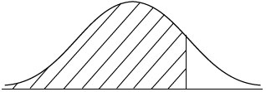

A1A1 N2

**Note**: Award A1 for vertical line to right of the  
 mean, A1 for shading to left of **their**  
 vertical line. [6]

**5.** (a)  (A1)

** (1) = 0.8413 (A1)

P(height > 180) = 1  0.8413

= 0.159 A1 N3

(b) *z* = 1.1800 (A1)

Setting up equation 1.18 =  (M1)

*d* = 136 A1 N3

[6]