IB TEST 2 GBANK BURGERS

MARKSCHEME

- Strategy is the term used to refer to the various methods that businesses can use in an attempt to achieve their mission or vision. Strategies then form the long-term plans for the whole organization. In the case of GBank Burgers, their strategy to achieve their long term vision of growing globally whilst thinking locally, was to try and attract different customers to enhance the good value of products to appeal to customers during the economic recession. Tactics on the other hand refer to the various short-term methods that firms can use to achieve their strategies and objectives. In the case of GBank Burgers, one of their first tactics that was designed to help achieve their long-term strategies and objectives was to introduce ‘tiny bites’ which offered new products, in smaller portions at low prices for a trial period of a few months.

(2 Marks for correct definitions of Tactics and Strategies. A clear difference in terms of short vs long term must be shown)

(1 mark for each relevant point from the case study used to explain a tactic or strategy)

- There were numerous economies of scale that could have been listed here for GBank Burgers both internally and externally (e.g. Purchasing, Marketing, Risk-Bearing, Managerial, Technological etc etc). 2 Marks were given to two correctly defined economies of scale that they could have benefitted from and 1 mark for explaining how GBank Burgers will have benefitted from each economy of scale in relation to the case study, ensuring the answer fully explains how each method employed by GBank Burgers lowers the average unit costs for the company.

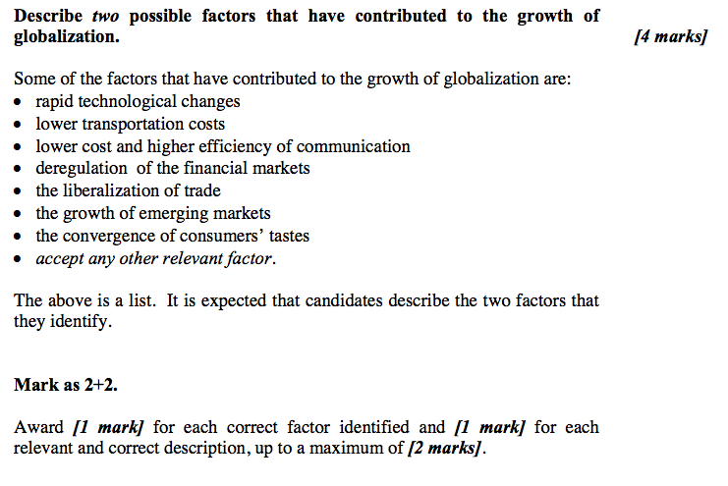

d) Draw the Ansoff’s matrix and use it to explain two of the growth strategies used by GBank Burgers (6 Marks)

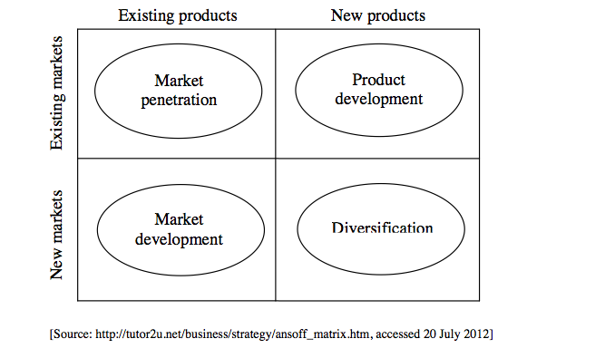

GBank Burgers strategic growth can be classified as:
Product development: • different products with different ingredients / different size for the same / current / existing national/international markets.
Market development:
- • targeting new segments like young mothers who did not eat at GBank Burgers before due to the large portions of its meals
- • attracting health-conscious customers with more chicken-based products (an assumption is made that very few chicken products were offered before).
- Market penetration:
• the upgrade of facilities for the existing and any new customers that previously have not used GBank Burgers in the current / existing markets
• offering good value items to recession-prone existing and new customers.
Award candidates who see targeting new segments like young mothers with the “Little Tasters®” menu and possibly attracting health-conscious customers with chicken-based products as related diversification.
[1 to 2 marks]
A list is provided. The answer lacks considerable depth and application. No reference is made to the information in the stimulus material.
If the Ansoff matrix is accurately drawn but the growth strategies are just placed on it, award a maximum of [2 marks].
[3 to 4 marks]
One relevant growth strategy is fully explained and applied. The Ansoff matrix is accurately drawn and labelled. Reference is made to the information in the stimulus material. Or:
Two relevant growth strategies are identified or described, but the response lacks explanation and/or lacks constant reference to the information in the stimulus material.
If the Ansoff matrix is not drawn, award a maximum of [4 marks] even if an appropriate explanation is given for the two growth strategies.
[5 to 6 marks]
Two relevant growth strategies are fully explained and applied. The Ansoff matrix is accurately drawn and labelled. Reference is made to the information in the stimulus material.

(e) Analyse the possible impacts of multinational companies like GBank Burgers on the host countries.
Although the question may seem rather theoretical, nevertheless, it is expected that candidates make some reference to GBank Burgers as a multinational company (MNC) and use information from the stimulus material.
Some of the positive impacts may include the following:
• GBank Burgers provides employment and training to its employees in its restaurants. The quality of the labour force can increase.
• GBank Burgers® improved the menu choice: healthier food, local food so customers do not have to rely only on local food providers. Hence more choice is provided for the citizens.
• Global competition clearly exists in this market. Competition between GBank Burgers and other food and drink suppliers like Burger Fuel and Costa can lead to reduced prices, an improvement in choice as well as improvements to the service to customers. Transfer of knowledge/ know-how (is done through franchising).
• It is mentioned in the stimulus material that GBank Burgers (and other MNCs) source local construction material and local labour – more revenue in terms of expenditure and wages is injected into the economy. Wider economic benefits can be gained (the multiplier effect).
GBank Burgers tends to be profitable and is taxed by the host governments. Revenue is hence generated for host governments providing further positive consequences for the host economies.
[6 marks]
Accept any other relevant positive impact.
However, being a dominating global company, one may argue that companies like GBank Burgers® encourage Western consumption of fast food around the world. Local competitors cannot compete with its resources/ expertise and have to close down especially now when these MNCs actually adapt to local taste. There is a danger that companies like GBank Burgers® actually monopolize a market rather than encourage healthy competition and choice. One may also argue that they destroy local ways of life. Local unemployment may increase if local businesses cannot compete. Due to some practices of transfer pricing and/or local government support, not much taxes on profit are paid to the host government.
Accept any other relevant analysis.
To achieve the top markband candidates must give a balanced analysis of two positives and two negatives of the impacts of MNCs like GBank Burgers® on the host countries.
For one relevant positive impact and one relevant negative impact award up to a maximum of [3 marks].
If the response is a one-sided relevant approach with no balanced analysis, award a maximum of [4 marks].
Marks should be allocated according to the markbands

