The Miracle of Miracles:
Name:
Date:
Class:
The Story of Prophet ‘Isa Test Answers

Circle True or False. If false correct answer in the given space below the question.
- Prophet Isa was one of the seven messengers who is described in the Qur’an as the messengers power and determination. T/F
False
Prophet Isa was one of the five messengers who is described in the Qur’an as the messengers power and determination
- The baby miraculously began to speak, inspired by Allah, and he spoke in defense of his blessed mother and he preached the truth to the unbelievers. T/F
True
The baby miraculously began to speak, inspired by Allah, and he spoke in defense of his blessed mother and he preached the truth to the unbelievers.
- Prophet Isa’s mission was only to send Allah’s message to the Children of Israel. T/F
False
Prophet ‘Isa was then sent mainly as a messenger to the Children of Israel.
- Prophet ‘Isa could cure people with serious handicaps and diseases, as Allah enabled him to cure the sick by simply whipping their diseased spot. T/F
True
Prophet ‘Isa could cure people with serious handicaps and diseases, as Allah enabled him to cure the sick by simply whipping their diseased spot.
- The name of Muhammad still appears in the current gospels, even after the Injeel was changed or lost after Prophet ‘Isa. T/F
False
The name of Muhammad does not in the current gospels, even after the Injeel was changed or lost after Prophet ‘Isa.

Short and Long Answers
- Who is Prophet ‘Isa? And what are his main miracles?
Prophet ‘Isa, or Jesus Christ, was one of the greatest prophets Allah ever sent to mankind. Prophet Isa was one of the five messengers who is described in the Qur’an as the messengers power and determination.
- What are some facts revealed about the uses of dates? And why did Allah recommend for Maryam to eat date?
Dates also contain a form of sugar that gives the body high levels of mobility and heat energy, which can easily be broken down in the body. Allah recommended Maryam to eat dates as the dates energize and invigorate women and ensure the emergence of milk, the only food for the baby.
- Describe how Maryam’s return to Jerusalem. How was the birth of Maryam’s new born described?
After some time, Maryam returned to Jeruslem carrying her newborn baby in her arms. The town’s people were shocke; Allah describes what happened in Surat Maryam.
- What is Crucifixion? What is said about it in the Qur’an?
The belief in the crucifixion is very prominent among Christians. They believe that Jesus Christ was captured by the Romans and was crucified, or nailed to a cross, and left to die. All Christian culture promotes the crucifixion through speeches, books, movies, and other means. Al-Qur’an is clear and firm that Prophet ‘Isa was neither crucified nor killed.
- List 10 out of the 15 facts about what the Qur’an says about Jesus Christ?

Fill in the blank

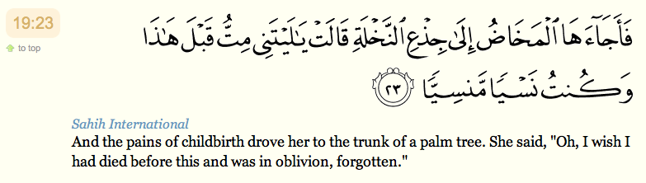

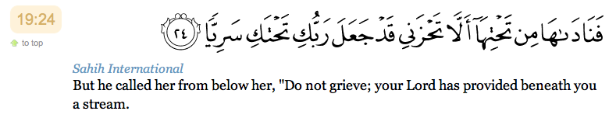

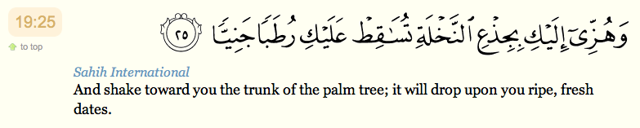

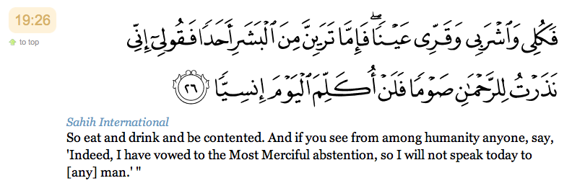

- Jesus did feed his disciples by miracle. But he claimed with no divinity: he was a true servant of God, to Whom doth belong The dominion of the Heavens and Earth: Glory and power are His, and His alone.
- “And remember, Jesus, the son of Mary, said: “O Children of Israel! I am the apostle of Allah (sent you, confirming the law (which came before me, and giving glad tidings of of an Apostle to come after me, whose name shall be Ahmad.' But when he came to them with Clear Signs, they said, 'this is evident sorcery!' [61:6]
- Always refute others’ maligning by using short but convincing defense, just like Maryam did. Avoid getting involved in long arguments.
- Muslims do not believe in crucifixion the truth is that ‘Isa ascended to Heaven alive , by the will of Allah and he will return before the Day of Judgment.

Match the statements with suitable answer:

Hawariyyoon | And remember, Jesus, the son of Mary said: “O Children of Israel! I am the apostle of Allah (sent) to you.” 1
Tawheed | The twelve devoted people are known as the Disciples
“… If any of you after that resisted faith, I will punish him with a penalty such as I have not inflicted on anyone among all people.” [Surat-ul Maidah 5:112-115] | And [appointed Jesus a messenger to the Children of Israel 2
2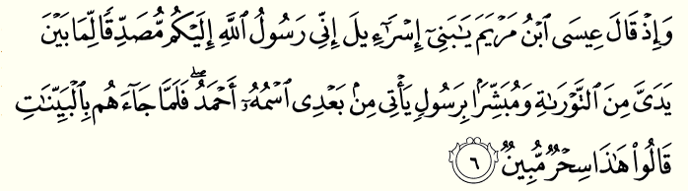 | (The oneness of God)
The incident of ‘Isa speaking when he was an infant in the cradle. | God promised him that banquet on condition that:
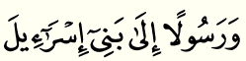1 | Only in the Qur’an is it mentioned that…

