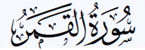

Significance
The significance of the surah Al-Qamar, it that it has the meaning of the moon in Arabic. The surah foreshadows the inevitable Day of Judgment that will divide those who believe from those who disbelieve. This shows the believers who are destined to Paradise and the others who are destined to Hell. The primary theme of this surah is around fate and those who disbelieve. The moon symbolizes the warning to the disbelievers of their forthcoming fate in the first verse as it says: “the hour draws near; the moon is split.” And an addition to that the crescent moon acts as the spirited symbol of Islam, which may denote the importance of religion and the lunar cycles which determine the structure of the Islamic Calendar.

{54: 49}
Indeed, all things We created with predestination.
Pickthall: Lo! We have created every thing by measure.
Yusuf Ali: Verily, all things have We created in proportion and measure.
Shakir: Surely We have created everything according to a measure.
Muhammad Sarwar: We have created everything to fulfill a certain purpose.
Mohsin Khan: Verily, We have created all things with Qadar (Divine Preordainments of all things before their creation, as written in the Book of Decrees Al-Lauh Al-Mahfuz).
Arberry: Surely We have created everything in measure.

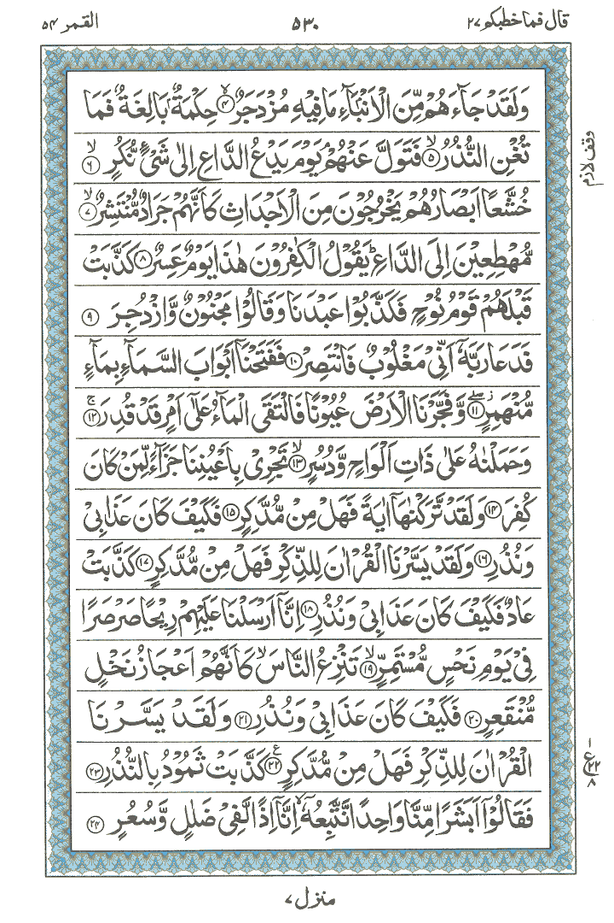

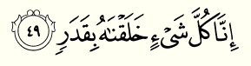

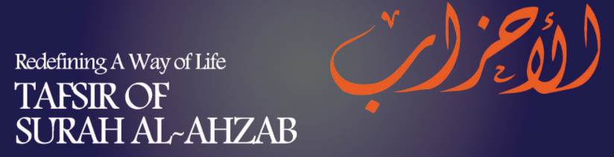

Surat Al-Ahzab (The Clans, The Coalition, The Combined Forces) is the 33rd surah of the Wu’an with 73 ayat.
This surah mentions what happened at the Battle of the Trench to remind believers the mercy and power of God since God made the various tribes who attacked Medina leave. Due to this surah being a Medinan surah contains instructions concerning the treatment of the prophet and his wife and the warnings for hypocrites for their bad behavior. Surah’s, which are part of the Medinan versus usually, contain rules and regulations for the believers to follow.
Verses 49-59detail who the prophet can marry or not. Verse 50 was revealed pertaining to Mayumuna bint al-Harith

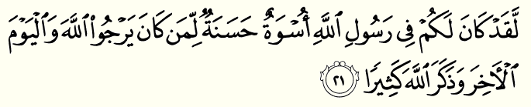
Meaning
There has certainly been for you in the Messenger of Allah an excellent pattern for anyone whose hope is in Allah and the Last Day and [who] remembers Allah often.

There has certainly been for you in the Messenger of Allah an excellent pattern for anyone whose hope is in Allah and the Last Day and [who] remembers Allah often.

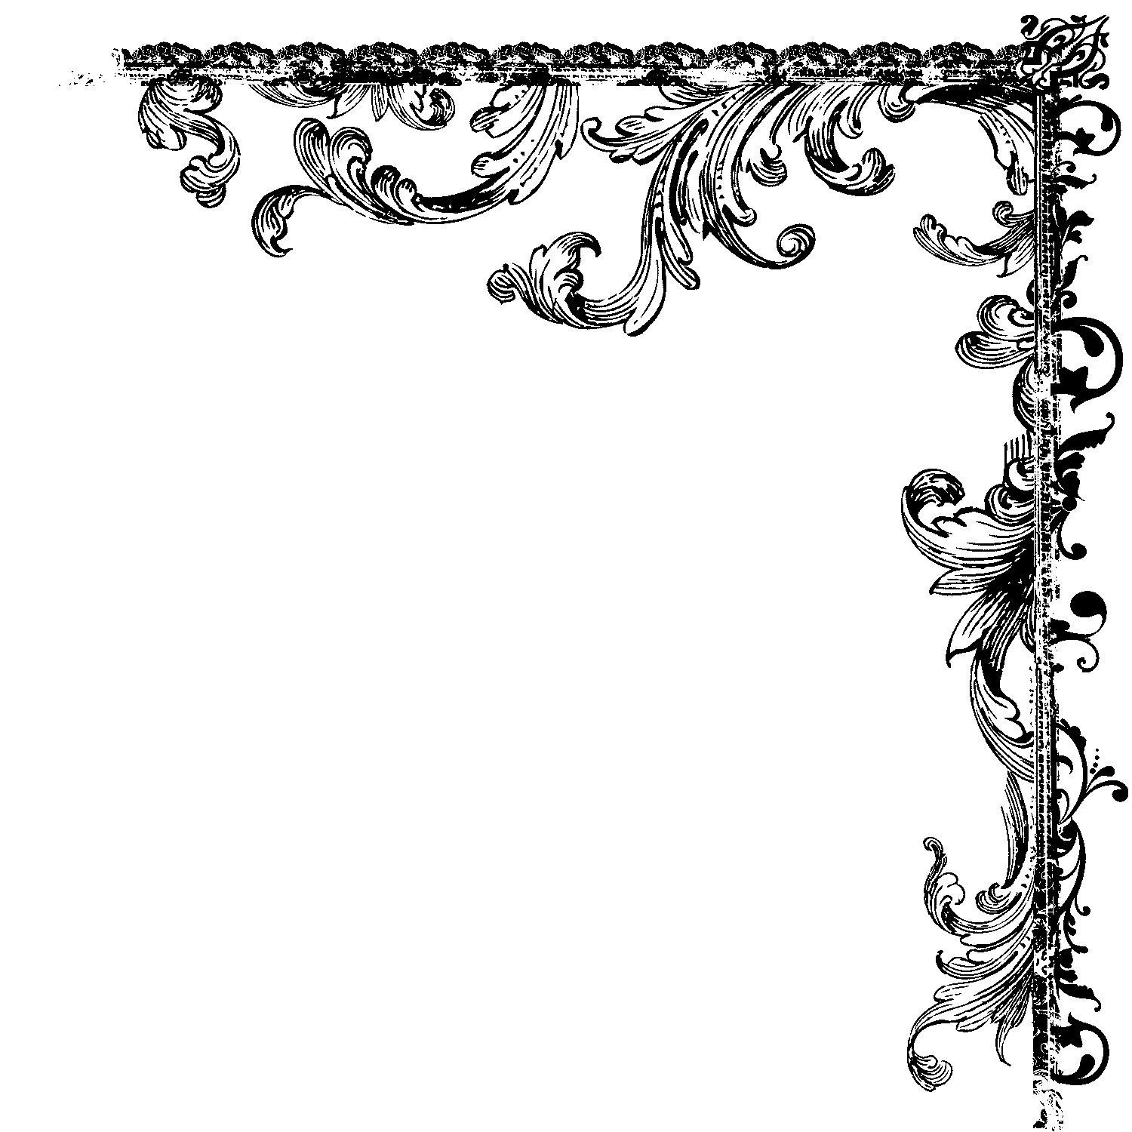
Chapter (51) Surat Adh-Dhāriyāt (The Wind that Scatter)
Surat Adh-Dhariyat (The Winnowing Winds) is the 51st surah of the Qur’an with 60 ayat. It mentions Abraham, Noah, the Day of Judgment and otherwise reiterates the essential Quranic message.
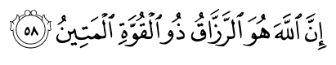
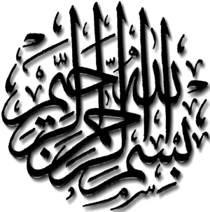
Indeed, it is Allah who is the [continual] Provider, the firm possessor of strength.

Pickthall: Lo! Allah! He it is that given livelihood, the Lord of unbreakable might.
Yusuf Ali: For Allah is He Who gives (all) Sustenance,- Lord of Power,- Steadfast (for ever).
Shakir: Surely Allah is the Best owner of sustenance, the Lord of Power, the Strong.
Muhammad Sarwar: It is God Who is the Sustainer and the Lord of invincible strength.
Mohsin Khan: Verily, Allah is the All-Provider, Owner of Power, the Most Strong.
Arberry: Surely God is the All-provider, the Possessor of Strength, the Ever-Sure.

Praising Allah!

I know you are there Little bird, Covered by rich green,
talking to the tree Yes,
a talking tree!

I know you are hiding Little ant, Under the solid brown,
listening to the song Yes, t
he singing earth!

I know you are relaxing Tiny drop of rain,
Inside the airy white,
hearing the laugh Yes,
a laughing cloud!

I know you are dancing Little bee, Beside fresh colors, joining a prayer Yes, a praying flower!

I know you are breathing Little fish,
Deep in the wide blue,
amazed by stories Yes,
the Historian Ocean!

I am sitting in my room
Seeing you all in the heart of my eye
Praising the work of God
Wishing to add more before I die

Talking tree
Singing earth
Laughing cloud
Praying flower; and
Historian Ocean
Let me join you,
and be sublime
Praising God till the end of our time!

By: Zoya
Pakistan

The Believers

In this life we have a great job to do;
It is a trial for us and we're just passing through.

The Holy Qur'an will always be our Guide:
It is ALLAH's Final Revelation that we must abide.

We constantly combat wrong and strive for Right...
We're champions of the oppressed, in a worldwide fight!

Working together to establish our place;
Falsehood, ignorance, and poverty we will erase!

Let us build model communities throughout the land...
Our descendants will know we followed ALLAH's Command.

We will produce from ALLAH's Earth our material share:
Don't give us things such as food stamps and welfare!

Our Islamic communities will produce everything we need...
May ALLAH bless us with faith, patience, and perseverance to succeed!

By: Muhammad
USA

Do you write? Take pictures? Create art?
Send us your work on islamicmagz@gmail.com
Riddle of the day:
What is brighter than day darker than night, haram if eaten, halal if drunk, man uses thrice in a day, woman uses once in life, it is mentioned 5 times in Quran and starts with meem having 5 letters?
The answer is Maqabir (Graveyards). Mentioned in surah “Takarthur” ie. “Hata Zurtum al-Maqabir”
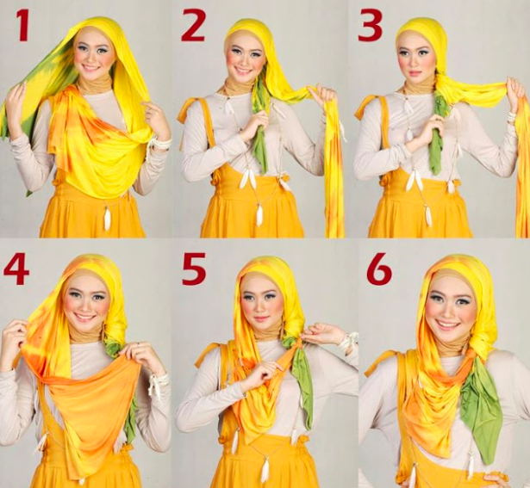
Going to a family gathering? Need a new style for your hijab?

Easy ways to look fashionable yet covered up, check out http://fashionsmagz.com/how-to-wear-a-hijab-in-different-styles/ for more fun and fashionable tips.

