RECRUITMENT PROJECT

Learning Outcomes
- Describe methods of recruitment, appraisal, training and dismissal.
- Discuss advantages and disadvantages of different methods of recruitment, appraisal and training.
- Examine how recruitment, appraisal, training, dismissal and redundancies enable the firm to achieve workforce planning targets (HL).
- Analyse the impact on the firm of legal employment rights (HL).
- Describe Leadership styles in a given scenario
- Analyse the best form of communication in a given scenario

Application Pack

Application form
- This should be no more than one A4 page and should seek to find out all the relevant information required to shortlist the candidate.

Job advert
- The advert can be in any style, but must be suitable for the job, i.e. you will not advertise on TV for a receptionist.

Interview Checklist
- This should consist of approximately 10 questions you intend to ask at an interview.

New Staff Guide
The New Staff Guide should be in the form of a booklet and comes in 9 parts.

Introduction to the business
Can get this information from the web or own personal knowledge.

Job Description
Details of the job title, duties, location, etc…

Person Specification
Details of the type of person, experience, skills, etc…..

Appraisal
What kind of appraisal system can the employee expect?

Training
What induction, on-the-job, and off-the-job is likely to be provided

Dismissal
What are the grounds for dismissal at your place of work

Equal Opportunities
How does your firm conform to various employment legislation namely (anti-discrimination, equal pay, health and safety, statutory benefits, NMW
Communication Methods
Justify what you think are the most appropriate communication methods in your given organization
Leadership Style
Justify what you think is the most appropriate leadership style for your given organisation

Presentations

- You will be required to present your application packs (these must be printed in colour and be presentable as if it was the actual company’s application pack) and guides to the rest of the class.
- It should last no more than 10 minutes and can be in the form of…..
  - a dramatic production (you may want to act out the interview, some of the duties involved, training, etc)
  - film, or
  - PowerPoint presentation.
- Every team member must be involved.
- This will be 10% of your semester grade so give it your all!

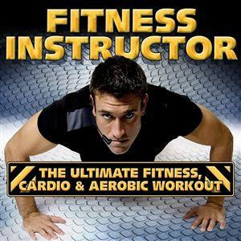

FITNESS INSTRUCTOR - BODYWORX

