Revision on factoring
I do not think you need more revision on solving quadratics. Factoring is the key.

EXERCISE 2B: Not all of them are quadratic expressions, but it is still good practice of finding common factors.
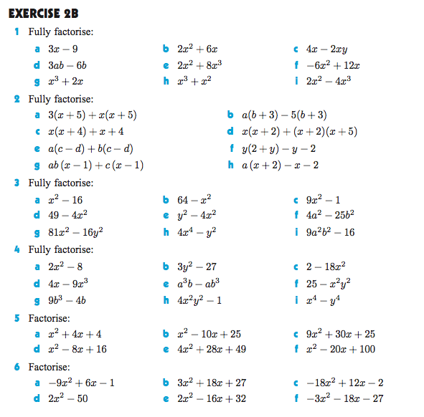

EXERCISE 2E: Factorize by grouping:
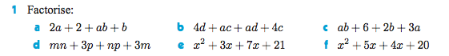
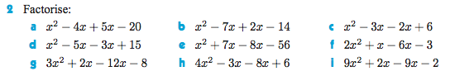

EXERCISE 2F
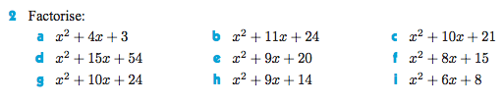
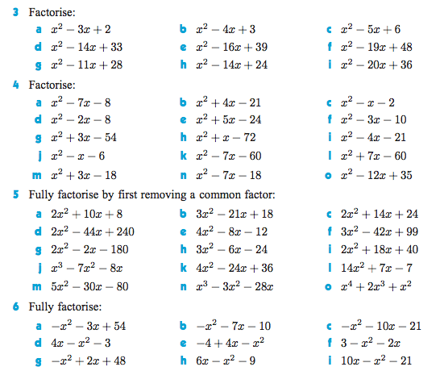

ANSWERS:
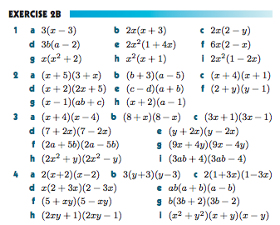
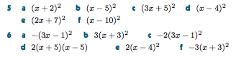
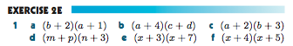
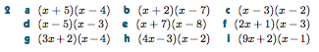
EXERCISE 2F
