SCHOOL NAME
Theatre HL
NOH Theatre (Japan)
Hagoromo by Zeami Motokiyo
What would the set look like and how would it be used, in a traditional NOH performance of Hagoromo by Zeami Morokiyo?
FULL NAME
DATE
Word Count: ______

Contents
Title Page Page 1
Contents Page 2
Subject Essay Page 3-13
Bibliography Page 14
Critique of Sources Page 15-17

What would the set look like and how would it be used, for a traditional Noh performance of “Hagormo” by Zeami Motokiyo?

Hagoromo, is from a Japanese legend, and acknowledges as The Feather Mantle. This performance is one of the most popular plays of the Noh theatre. For anyone that is interested in recreating the traditional Noh performance of the performance of Hagoromo needs to follow the rules of the creation of the performance. In that case, research will be required for the features of the performance such as assemblage of the stage, the design features for a traditional Noh production. Other than the importance of the set, the way, which props and materials are used on stage, and the actions of the actors are also important for the performance.
Researchers do not know exactly when Feather Mantle, was written or created because it is created upon the idea of two ancient Japanese legends in which one explains the backgrounds of the Suraga Dance (Suruga-mai) and other describing the “descent of an angle onto Udo Beach.” The Feather Mantle is scripted in traditional Noh poetic style which is “mugen noh” or the dream of Noh. Hagoromo is set in the Pine grove of Miho is the Suraga Bay on a spring evening. The play commences with the intoxicated fishermen (Hakuryo) and his cohorts (the Chorus) who are returning home from their long, hard day at work. On their walk home, the fisherman finds a feather mantle which is hanging on a pine tree, and decides to keep it, though the angel says: “give it back, in charity give it back” ultimately Hakuryo says: “Now that I have seen you in your sorrow, I yield and give back your mantle” as the angle says: “Oh, I am happy! Give it me then!” when the scene finishes the Mythical Suraga dance is performed.
For traditional Noh performance of the play of Hagoromo, one has to know all the state-of-art requirements of not only the set but the surrounding elements. The Noh plays traditionally began in olden Japan back in the 14th century, which was at the time of (1333-1573) which was during the Muromachi period. During that time the acting of the performances took place under the shrine temples, and they were called ‘sermons’. The traditional Noh stages are very similar to Shinto Shrines because originally they were based upon the designs of the Shinto Shrines. The designs affect the main stage (Honbutai or the butai) as their architecture is similar to Japanese Shinto Shrines.
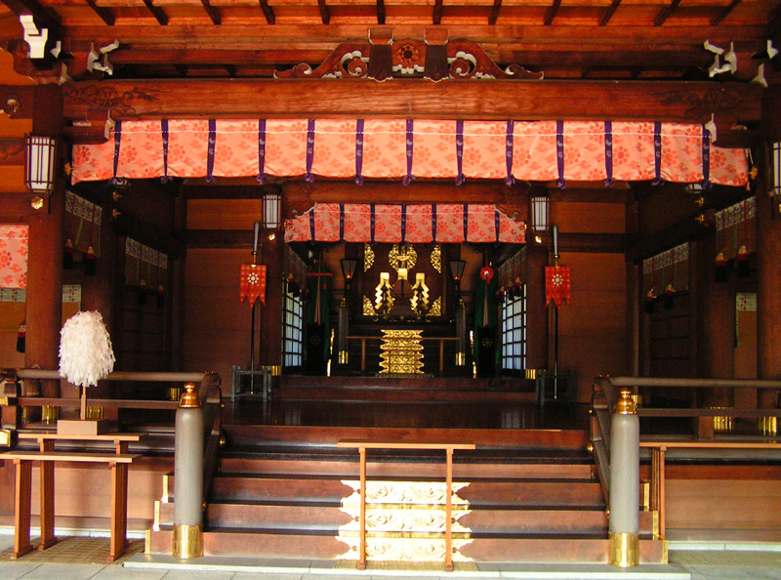
The following image was taken off from blog post on an old Noh Theatre stage in Itsukushima Shrine, Japan. This shows how a traditional Noh stage would have looked like.

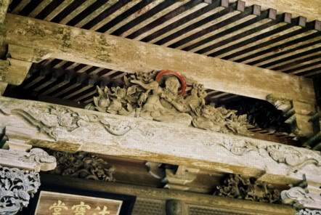
Figure 1- Details from the Shinto Shrines
Figure ones image has been taken by an online sources,, and the design above displays the wooden designs that would have been seen in a Shinto Shrine walls. Due to the Noh theatre deriving from the Shinto Shrines, in traditional theatres most features would resemble or look like the carvings from the inside of the Shinto Shrines.

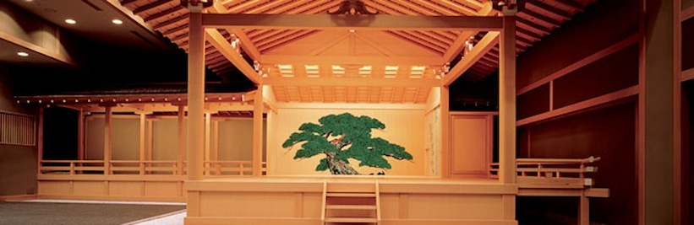
Figure 2- Pine Tree (Oi-Matsu) in a Noh Theatre
The picture above shows a modern Noh stage, and on the back wall it is seen that there is a painting of the Oi Matsu or the Old Pine. This tree must be painted as traditionally painted. The stage size must be about 6 meters which is around twenty feet square.

Traditionally the stage is wooden, Japanese Cypress (Hinoki), that is then built on a raise square stand, roof above stage, a bridge that connects to the upper-right hand corner of stage (See Figure 2), and a painted pine tree, that is painted on the back wall of the stage, and is painted in a certain way (See Figure 2), to create a religious allusion.

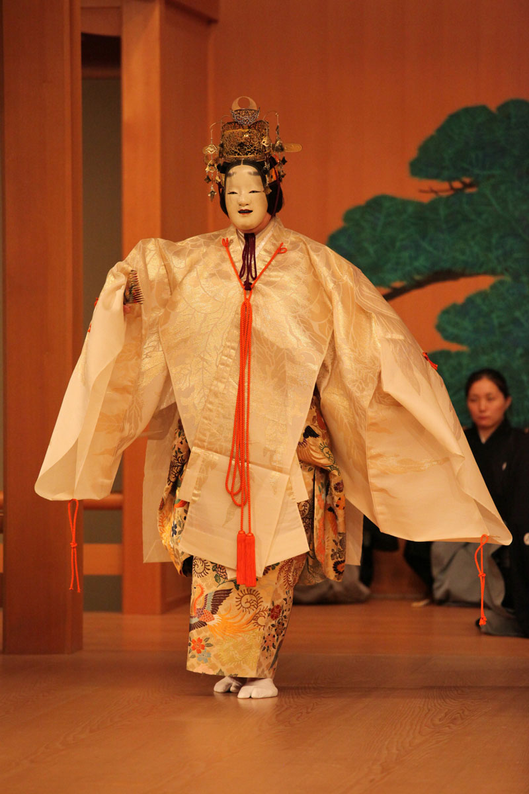

Figure 3- Angel character in Hagoromo
The image of the Angel character was taken from the TomoeArts website and this shows the Angel character dancing in Hagoromo, with the chorus in the background.

Actors who have been chosen or want to perform as the Angel character in Hagoromo (See Figure 3), must know all of the physicality’s of Butai and Hashigakari (See Figure 4), before any rehearsals.
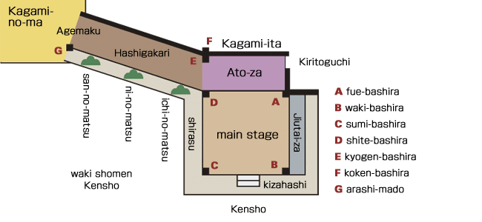
Figure 4-Diagram of traditional Noh Stage
This image of the traditional Noh stage was taken off a website dedicated to Noh Theatre and it shows the traditional Noh stage layout along with the names of the each section.

On a traditional Noh stage, there is a bridge (See Figure 4), that has three small trees the (no matsu), and the pines are put at the back of the stage (ato-aza) next to the mirror room (Kagami no ma). These pine trees “are used to create perspective by the sizes of the pine trees being reduced; the largest is by the stage, and smallest by the gangway”. The chorus sit by the side stage, the (waki-za) and the orchestra sits next to (ato-aza) which is next to the stage. The individuals are not able to enter the mirror rooms in the Mugen Noh plays, because it is a lavishness only for the (hashigakari). In the production the chorus (jiutai) in Hagoromo enter from (kiritoguchi) and it is a space between the space of the bamboo poles. In the script by Motokiyo, the second fisherman and the jutai in Hagoromo enter from the (kiritoguchi) and sit in (waki-za). This is done because both Chorus and the orchestra are like instruments that enrich the notion of the Hagoromo performance. The jutai /chorus don’t have specific characters or parts but they can change their standpoint, unlike in the Western Theatre.
The stairs (Kizahashi) are located on the center upstage and are not used during performances, because it is considered to be disrespectful to the Japanese gods. Though that is not a concern in Hagoromo as if the set is going to be used traditionally then the cast/characters do not have to be worried about the (kizahashi), do to the reason stated before. The floor of the stage is faintly sloped facing the audience, and embossed about 1 meter or (3 feet) in the air. Beneath the stage floor there are holes that are four feet deep and have concrete jars, produce a thump like sound on stage. These sounds create an intense reverberation and this shows the importance of music in Noh theatre.

On the stage there are four columns (bashira), which holds the stage (See Figure 4), each pillar has certain perseverance. The pillar is used by the accompanying actors such as the fisherman, or Hakuryo. This pillar is called the waki, or (wakibashira). The Angel is usually seated by (Shitebashira) which is set by the entry way of (Kagami no ma) in which the (shite) is also seated by. One of the other pillars (Fuebashira) which is the seat of (Sumibashira), and the “masked performer”, though this information is not applicable to Hagoromo as there are no masked performers in the production.
The audience must be “oriented toward north and arranged in multiples of three, five and fifteen; as these numbers relate to the numbers of days in moon cycles”, if wanting to use a traditional stage. These numbers are important, and relate to the script as it is shown through “The five signs of an angel’s decline”, “twin bands, each fifteen”. This shows how religious motifs are orientated in all parts of the play.
The traditional Noh stage floor is made from Japanese Cypress wood, (Hinoki) and is then refined with pine resin, this is so that the dancers can stamp and slide easily on the floor wearing tabi, (particular white socks) (See Figure 5). The climax of the play is when the Angel does its dance of the Rainbow Skirt and the Robe of Feather, and this is important as it connects back to if the stage was not made traditionally with the Japanese Cypress wood, then the Angel would not be able to do her dance. In a traditional performance of a Noh play there is barely any lighting used, as originally the Noh stage was located in shrines outside and only natural lighting was used.

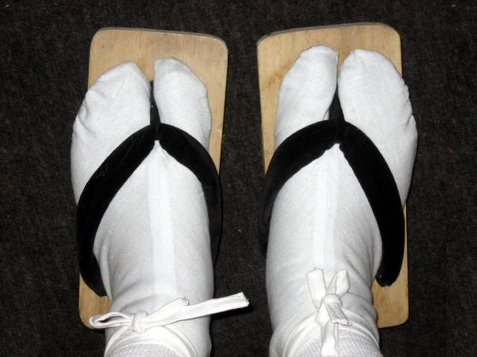
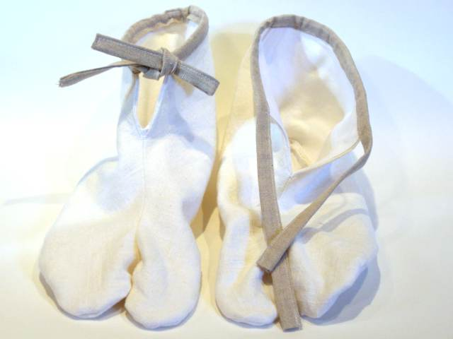
Figure 5- Particular White Socks (tabi)
This picture was taken from an online source, to show what the dancers would wear on their feet while dancing and sliding on the floor.

A traditional Noh stage has a very simple set up as it is only a wooden stage and no curtains between the acting part of the stage and the audience. This is because initially the performance were performed outdoors, though now the modern Noh staging is indoors and it includes a roof, painted Yōgō no matsu on the back wall, and a bridge. Another modern staging technique that is now being used in a mix with the traditional Noh stage is having three pine trees on the hashigakari (bridge way). The largest tree is closer to the stage and the smallest is the farthest from the stage in order to create a distancing viewpoint. Along with this simple lighting is used to create a naturalistic effect.
The Noh stage is made up of different types of special woods, and one who is interested in creating the stage must be educated because there are specific rules that need to be followed as they are connected to religious Japanese legends, unless not creating a traditional stage.
In a traditional Noh stage the oi-matsu, (pine tree) is painted in the middle of a wooden backdrop, (See Figure 2), it is the only stable ornamentation/prop on the stage. The oi-matsu on the wooden backdrop on the stage represents the setting in Hagoromo, which is “the Pine grove of Miho in Suraga Bay”. This theme is flagrant in ‘Hagoromo’, when Hakuryo (the fisherman) discusses the scenery of the play at the start of the performance, and while this is happening the Angel converses about going back to her home.

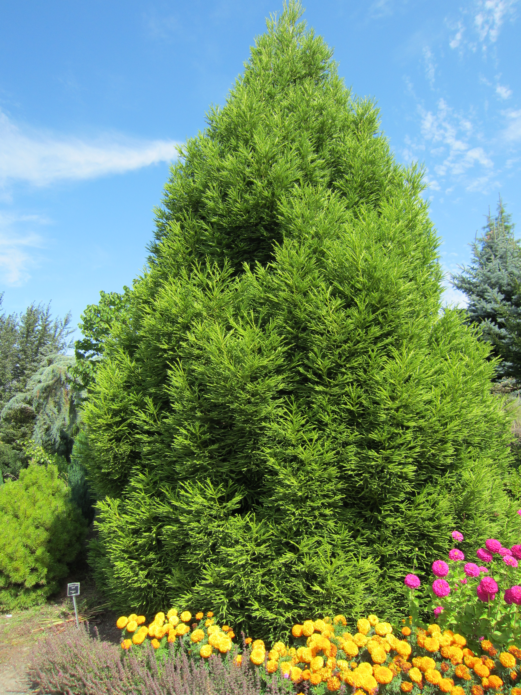
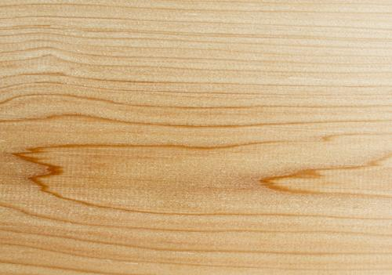
Figure 6-Japanese Cypress
“Chamaecyparis obtuse (Japanese cypress, hinoki cypress or hinoki) is a species of cypress native to central Japan. It is a slow-growing tree that grows to 35m tall with a trunk up to 1m in diameter. The bark is dark red-brown.”

Both the modern and traditional roof of the Noh stage is built from the use of (Hinoki) or Japanese Cypress, (See Figure 6). The rood is shaped in a triangular prism from two large pieces of wood. Spiritual characteristics are exhibited through the architecture in traditional Noh theatre due to the use of (Hinoki) or Japanese Cypress wood.
When Hakuryo and the fisherman want to enter, they would enter from (kitoguchi). When finding the feather mantle, Hakuryo “would walk four steps towards the Waki’s pillar carrying the feather robe ”, and the fisherman would be amid of both jiutaiza and Hakuryo while they recite a poem about fishing. Motokiyo has incorporated that “a framework with a pine branch fixed to it is placed in the front of the stage”, as in the opening acts of the play, Hakuryo walks towards the upstage to the midpoint, which is located in front of the kizahashi, (See Figure 4), and then take away the feather mantle from the pine branch. If this were not done, then Hakuryo will continue to stand in the same place. In Motokiyo’s script, the directions points out that the Angel enter is “through the curtain at the end of the gallery” this means that the angel walks past the (agemaku) curtain, walks down the (hashigakiri) bridge, and then stands subsequent to the (shitebashira) the shite’s pillar.
A traditional Noh set, the (kizohashi) stairs are never used in a performance, and the walkway of (hashigakiri) is only used by the shite character, that is why Hakuryo would stay next to (fuebashira) the flute player, upstage left (See Figure 4). In that part of the play Hakuryo stays in his place until later on he goes to return the mantle back to the angel, as Motokiyo edicts; “he gives it to her and shakes it in both hands.”
Then, the Angel presents her dances on the butai, (See Figure 4); “the Dance of the Rainbow Skirt, of the Robe of Feathers”, “The Dance of the Suraga, with the music of the East” then, “she dances three of the five parts of the dance calle ‘Yo no Mai’, the Prelude dance… Springing from side to side… She dances ‘Hai no Mai’, the Broken Dance,” to give back Hakutyo for his kindheartedness. The quality of the Angel’s dance all depends on the polished floor, the type of wood use, the resin pine, and the pots beneath the stage to accentuate the clomping sounds in the Angel’s dance.

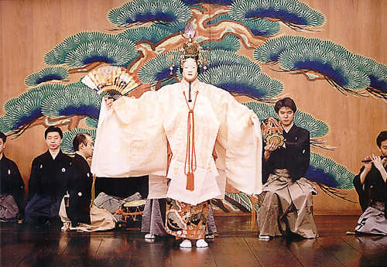
Figure 7-Ho no Mai dance
This image was taken from an online source, and it shows the Angel character in Hagoromo dancing the Ho no Mai.

In the final scene, the Angel again dances the “Ho no Mai, the Broken Dance” (See Figure 7), while the chorus describe her, “she flies, over the mountain of Ashitaka”, “very faint her form, Mingles with mists of heaven; Now lost to sight”. While the act is finishing up, the Angel dances back the way she entered, up the walkway of (hashigakari) through the (agemaku) parting from the chorus, orchestra and Hakuryo the being the only ones on stage.

In conclusion, I believe that if any individual is interested in creating a traditional Noh production such as the play ‘Hagoromo’ in a traditional Noh style, they must first be aware of all the rigorous instructions of the traditional Noh set design, including all the other characteristics, such as makeup, props and costumes. As it is very essential for one to know the purpose of the set elements, design, constructions, usage of props, the materials that are used and the restrictions, that a character has for their actions. All these components are fundamental for any traditional Noh performance, as they impact all parts of the performance, and due to exact established rules of the Noh theatre, they have to be followed. As if the rules are not followed then it will not be considered a traditional Noh performance and could also be considered disrespectful for failing to follow the guidelines and rules of the respected tradition.

Word Count: 2,494

Bibliography
Online Sources

- Script of Zeami’s Hagoromo website
http://www.sacred-texts.com/shi/npj/npj31.htm

- Video by Takipon of a performance of the Suraga Dance in ‘Hagoromo’
http://www.youtube.com/watch?v=D_GmybFUYSA&playnext_from=PL&feature=PlayList&p=BIF5C01EBC01EBC0B66B5&playnext=1&index=3

- NOH Theatre http://www.the-noh.com

Published Sources

- Waley, Arthur “The Noh Plays of Japan” Published: Forgotten Books, Washington, USA, 1921. (Republished in 2007).

- Ronald Cavaye, Paul Griffith and Akihiko Senda “A Guide to the Japanese Stage” Publisher: Kondansha, Japan, 2004

- Ernest Fenollosa & Ezra Pound, “Noh’ or Accomplishment: A Study of the Classical Stage of Japan.” Publisher: Macmillan and Co., London, UK, 1916 Mitchell, John Dietrich, Miyoko Watanabe, Frank Hoff, William Packard, and Zenpõ Motoyasu. Komparu.

- Staging Japanese Theatre: Noh & Kabuki: Ikkaku Sennin (The Holy Hermit Unicorn) and Narukami (The Thunder God). Key West, FL: Institute for Advanced Studies in the Theatre Arts in Association with Florida Keys Educational Foundation, Florida Keys Community College, 1994. Print.

- Tyler, Royal. Japanese Nō Dramas. N.p.: Penguin Classics, n.d. Print.

- Fenollosa, Ernest, and Ezra Pound. The Noh Theatre of Japan with Complete Texts of 15 Classical Plays. N.p.: Dover, n.d. Print.

Bibliography (Critique of Sources)

Literary Sources

- Waley, Arthur “The Noh Plays of Japan” Published: Forgotten Books, Washington, USA, 1921. (Republished in 2007).

“The Noh Plays of Japan” is a translated version from the assortment of the Noh theatre tradition works. This book was very useful as it gave me abstracts about the different production and stage elements of a traditional Noh theatre, and how they were used in different productions. This book also provided me with the translations of Hagoromo’s stage directions. In the introduction the author states that he translated the meaning of the actual script, instead of him changing the text to fit a certain format. Though while reading the book I did notice that there could have been more information regarding the Noh staging, as there was only about a page about that certain topic.
Since this book is republished I believe that the information in the book is very reliable, as I know that the information is revised and edited again before being published again.

- Ronald Cavaye, Paul Griffith and Akihiko Senda “A Guide to the Japanese Stage” Publisher: Kondansha, Japan, 2004

In my opinion “A Guide to the Japanese Stage” was the most beneficial source for this research investigation. The book had summaries on the different traditions of Japanese theatre and it also wrote about the most famous Noh Theatre performances, and their production elements such as costume, staging, props, etc. Though what I would have like to read more about in this book is about the plays, as the book gave me more information about the elements of the performance m and the tradition of the Noh Theatre performance.
This book is very reliable , as it was written by famous authors whos works are very realiable, such Cavaye who is an expert in Kabuki, Griffith a professor at Saitama University and Senda who is also a professor at Saitama University and the president of IATC (International Association of Theatre Critics.)

- Ernest Fenollosa & Ezra Pound, “Noh’ or Accomplishment: A Study of the Classical Stage of Japan.” Publisher: Macmillan and Co., London, UK, 1916

Out of all the books that I have used,“Noh’ or Accomplishment: A Study of the Classical Stage of Japan.” Was the best resource for this research investigation, As I believe this book was too advanced for my knowledge and it was more geared towards people who have previous knowledge about Noh Theatre.
And another limitation that I had with this book is that I did not have the book physically so I had to use sections of it which were available online. And it was useful to me as it gave me background knowledge about the Japanese stage and it also helped me finding a few quotes to use in my research regarding the audience positioning and the way in which the stage was built.

- Mitchell, John Dietrich, Miyoko Watanabe, Frank Hoff, William Packard, and Zenpõ Motoyasu. Komparu. Staging Japanese Theatre: Noh & Kabuki: Ikkaku Sennin (The Holy Hermit Unicorn) and Narukami (The Thunder God). Key West, FL: Institute for Advanced Studies in the Theatre Arts in Association with Florida
Keys Educational Foundation, Florida Keys Community College, 1994. Print.

Even though this book was reliable and had a lot of information about staging of Japanese theatres such as the Noh Theatre, it did not focus on the play of Hagoromo which I wanted research on. Though it did give me some information about staging, that helped me link to my other book and online sources. But I did not use any direct quotes from this book for my research investigation, as it did not have specific information related to my play ‘Hagoromo’.

- Tyler, Royal. Japanese Nō Dramas. N.p.: Penguin Classics, n.d. Print.

Japanese Nō Dramas again like Staging Japanese Theatre: Noh & Kabuki was not a very useful book as it only gave me the understanding of the overall idea of the plot, music, dance, costumes, and masks. I was hoping that while reading this book I would have a greater understanding of performances such as the play Hagoromo that I was focusing on, though it did not have that.
Due to the lack of information, this book was not used very much other than giving me an overall idea, that is why specific quotes were not taken from this book.

- Fenollosa, Ernest, and Ezra Pound. The Noh Theatre of Japan with Complete Texts of 15 Classical Plays. N.p.: Dover, n.d. Print.

Again another not so useful book, for this specific research investigation. The only use that I had from this book was only a small chapter that had a translation of a part of the Noh play Hagoromo, Though two quotes were directly used from the book to emphasize the points that were being talked about in the research investigation.
But like the other last two books that I talked bout, this book did not give me much information as I hoped for.

Online Sources

- Script of Zeami’s Hagoromo website
http://www.sacred-texts.com/shi/npj/npj31.htm

The website for Script of Zeami’s Hogoromo was a very useful and reliable website. As first of all I know it was reliable as it had footnotes, where the information had come from, and the author. And another reason that I know that this was a reliable is that the script matched every other script that I had read of the play Hagoromo. From this book I used specific quotes in order to emphasize my points in my research investigation.

- Video by Takipon of a performance of the Suraga Dance in ‘Hagoromo’
http://www.youtube.com/watch?v=D_GmybFUYSA&playnext_from=PL&feature=PlayList&p=BIF5C01EBC01EBC0B66B5&playnext=1&index=3

This video was a popular video on YouTube, and it was the most useful visual source that I had, as it gave me the opportunity to see a part of the performance. Though I wish that I had the chance to watch the full production of the Noh performance Hagoromo. I believe that if anyone that is doing a similar research investigation should use this video or if they have the privilege to go and watch this performance live then they should do so as it gives a great visual effect to know exactly what you are reading and what you are trying to portray in your research paper.
I believe that this was a credible source as it presented its purpose of having a visual effect for the researcher and audience of the production.

- NOH Theatre
http://www.the-noh.com

Overall I believe that this was the most useful site and source that I had used. As this website had information about the performance, staging, costume, props, anything and everything from a Noh Theatre performance. I did use a lot of my information and direct quotes from this website. As well as I used a lot of my images from this website as well.
I know that this website is reliable as the website had an author, and the information that I read from the website matched the information that I had read from the books.

Critique of Image Sources

While finding images online it was difficult to say if something was credible of reliable, as most of the images were not acknowledge or referenced properly. Other than the few images that I had taken off http://www.the-noh.com. The images that I chose to use in my research investigation were only used in order to emphasize and illustrate the points that I were talking about in my essay. I believe that for anyone that wishes to perform or learn about the Noh Theatre in general or just on a certain production like Hagoromo should not only use books and websites to educate oneself on the theatre form of play, but also use videos and images in order to help them visualize their facts and research.

http://www.the-noh.com/en/world/stage.html
Pg 86, “Japanese Noh Dramas” by Royall Tyler (Penguin Classics, 1992).
Pg 170, “A Guide to the Japanese Stage” by Cavaye, Griffith and Senda (Kodansha, 2004)
Staging Japanese Theatre: Noh & Kabuki: Ikkaku Sennin (The Holy Hermit Unicorn) and Narukami (The Thunder God)
http://www.sacred-texts.com/shi/npj/npj31.htm
http://www.the-noh.com/en/world/stage.html
http://www.the-noh.com/en/world/stage.html
http://www.the-noh.com/en/world/stage.html
http://travelpast50.com/noh-theater-stage-itsukushima-shrine-japan/
http://www.travelphotogallery.net/japan/kyushu/japan-a-shinto-shrine-in-kyushu-photo-01.jpg.html
http://s4.photobucket.com/user/Pandabonium/media/Monju.jpg.html
http://www.pages.drexel.edu/~eh364/Class/Stage.html
http://www.the-noh.com/en/world/stage.html
http://www.tomoearts.org/Performances/HagoromoWEB.jpg
http://www.the-noh.com/en/world/stage.html
http://www.the-noh.com/en/world/stage.html
http://www.the-noh.com/en/world/stage.html
Staging Japanese Theatre: Noh & Kabuki: Ikkaku Sennin (The Holy Hermit Unicorn) and Narukami (The Thunder God)
Staging Japanese Theatre: Noh & Kabuki: Ikkaku Sennin (The Holy Hermit Unicorn) and Narukami (The Thunder God)
Staging Japanese Theatre: Noh & Kabuki: Ikkaku Sennin (The Holy Hermit Unicorn) and Narukami (The Thunder God)
http://www.the-noh.com/en/world/stage.html
Pg 58, “’Noh’ or Accomplishment: A Study of the Classical Stage of Japan” Ernest Fenellosa & Ezra Pound (Macmillan and Co., 1916)
Pg 58, “’Noh’ or Accomplishment: A Study of the Classical Stage of Japan” Ernest Fenellosa & Ezra Pound (Macmillan and Co., 1916)
Pg 58, “’Noh’ or Accomplishment: A Study of the Classical Stage of Japan” Ernest Fenellosa & Ezra Pound (Macmillan and Co., 1916)
Pg 58, “’Noh’ or Accomplishment: A Study of the Classical Stage of Japan” Ernest Fenellosa & Ezra Pound (Macmillan and Co., 1916)
Pg 176, “A Guide to the Japanese Stage” by Cavaye, Griffith and Senda (Kodansha, 2004)
Staging Japanese Theatre: Noh & Kabuki: Ikkaku Sennin (The Holy Hermit Unicorn) and Narukami (The Thunder God)
http://www.ee0r.com/proj/tabi.html
http://www.the-noh.com/en/world/stage.html
http://www.the-noh.com/en/world/stage.html
http://www.the-noh.com/en/world/stage.html
Pg 57, “’Noh’ or Accomplishment: A Study of the Classical Stage of Japan” Ernest Fenellosa & Ezra Pound (Macmillan and Co., 1916)
Pg 57, “’Noh’ or Accomplishment: A Study of the Classical Stage of Japan” Ernest Fenellosa & Ezra Pound (Macmillan and Co., 1916)
Farjon, A. (2005). Monograph of Cupressaceae and Sciadopitys. Kew: Royal Botanic Gardens.
http://www.the-noh.com/en/world/stage.html
http://www.the-noh.com/en/world/stage.html
http://www.sacred-texts.com/shi/npj/npj31.htm
http://66.218.69.11/search/cache?ei=UTF-8&p=pine+tree+in+hagoromo&fr=b2ie7&u=aris.ss.uci.edu/rgarfias/courses/japan/hagoromo.pdf&w=pine+tree+trees+hagoromo&d=KAQIK52uSWJ5&icp=1&.intl=us
http://66.218.69.11/search/cache?ei=UTF-8&p=pine+tree+in+hagoromo&fr=b2ie7&u=aris.ss.uci.edu/rgarfias/courses/japan/hagoromo.pdf&w=pine+tree+trees+hagoromo&d=KAQIK52uSWJ5&icp=1&.intl=us
http://www.the-noh.com/sub/jp/index.php?mode=db&action=e_index&class_id=1
http://www.the-noh.com/sub/jp/index.php?mode=db&action=e_index&class_id=1
http://www.the-noh.com/sub/jp/index.php?mode=db&action=e_index&class_id=1
http://www.the-noh.com/sub/jp/index.php?mode=db&action=e_index&class_id=1
http://www.the-noh.com/en/world/dance.html
Pg 184, “The Noh Plays of Japan” by Arthur Waley. (Forgotten Books, 1921)
Pg 184, “The Noh Plays of Japan” by Arthur Waley. (Forgotten Books, 1921)
Pg 184, “The Noh Plays of Japan” by Arthur Waley. (Forgotten Books, 1921)
Pg 184, “The Noh Plays of Japan” by Arthur Waley. (Forgotten Books, 1921)

