Research Proposal
Research Question
Should SD Concept Furniture Factory replace the current 3-axis CNC wood router with a 4-axis CNC wood router to improve quality and productivity?

Rationale
SD Concept is a manufacturing company specialized in the production of fine crafted and higher quality furnishings and furniture. The quality of product is essential for the satisfaction of the customers and therefore the efficiency of the machinery involved in the manufacturing process is imperative. At current moment, management of SD Concept is considering the introduction of a newer 4-axis CNC wood router, largely due to recent breakdowns of the current router machine. Therefore, to help the company acquire improved quality and productivity of its wooden dining chair (CH088), I will be conducting research into the benefits and drawbacks of the introduction of the 4-axis CNC word router.

Theoretical Framework
This report will focus on both financial and non-financial aspects pertaining to the possible introduction of a newer model of CNC wood router. There will be strong emphasis on four areas: quality, productivity, motivation and finance. Perception maps will be utilized to evaluate customer view on quality. Focus will also be on two motivational theories: that of Abraham Maslow and Frederick Herzberg. Furthermore, investment appraisal and efficiency ratios will be used to outline return on investment, and to determine whether there will be sufficient finance for the purchase of the machine. To finish, SWOT and Lewin’s Force Field analysis will be considered, allowing an appropriate conclusion and final decision to be drawn.

Key areas of the syllabus
- Unit 1.5 & 1.8- External Environment & Change and the Management of Change
- Unit 2.5- Motivation
- Unit 3- Accounts and Finance
- Unit 4.2- Market planning
- Unit 5.1- Production Methods
Methodology
Primary research-
- Issue questionnaires to the two current operators of the 3-axis router, and the manually adapted carpenters. Questionnaires will focus on staff motivation and productivity levels.
- A questionnaire will be issued to existent customers to gain insight on current perception on quality.
- Conduct an in-depth interview with the partners of the company to obtain information on the present router, and to allow a thorough exploration into the driving and restraining forces concerning the new 4-axis router.

Secondary research
- Financial documents: balance sheet and profit and loss account to allow financial ratios and investment appraisal.
- Gather information on maintenance costs of the new machine
- Internet to investigate the demand for furniture in Dubai for 2012, to gain detail 4-axis routers in general, and to obtain further information on the SD Concept’s major competitor, Greenline Interiors.

Limitations and possible solutions
Limitations | Possible Solutions
Employees may be unwilling to truthfully rate their motivational levels | Note that higher levels of management will not view the results
Management may be reluctant to provide certain financial data | Include limitation in conclusion
Information obtained from the internet may be limited and bias | Balance with further data
Owner may be reluctant to give full access of financial documentations | Mention in the conclusion
Bias in interview with Mr. X, as interviewee is my father | Use another individual to interview the partner
Action Plan
Date | Task | Modification
13th June 2011 | Decide research question | None
16th September 2011 | Prepare interview questions and write out research proposal | None
1st October 2011 | Prepare questionnaires for workers and existent customers | None
20th October 2011 | Conduct interview with Mr. X, and hand out questionnaires to workers and customers | Interview was only conducted
22nd October 2011 | Research information on internet; demand and competition | Questionnaires to customers and workers handed out
November 2nd 2011 | Prepare main findings and results | Further research on Greenline Interior (competition)
November 10th 2011 | Conduct analysis and discussion | Add SWOT analysis
November 29th 2011 | Draw up Lewin’s Force Field Analysis and form conclusion | None
December 7th 2011 | Submit first draft | First draft not submitted
December 9th 2011 |  | First draft submitted
December 15th 2011 | Consultation with Mr. Greenbank | None
December 18th 2011 | Submit final copy | None

To: Partners of SD Concept ltd.

SD Concept Furniture Factory
Title:
Should SD Concept Furniture Factory replace the current 3-axis CNC wood router with a 4-axis CNC wood router to improve quality and productivity?

Business & Management Internal Assessment

Author:
Candidate number: 000666-041
Date:
Subject and level: Business and Management, Higher level.
Circulation: Partners of SD Concept ltd.
Number of words:
- Main essay- 1999
- Research proposal- 495
- Executive Summary- 200

I confirm that this work is my own work and is the final version. I have acknowledged each use of the words or idea of another person, whether written or oral.

Signed:

Acknowledgements

I would like to take the time to thank:
- Mr. Liam Greenbank for his guidance and help in the achievement of this report
- One of three Partners, Mr. X, for his time and patience
- And ultimately, all the employees and customers who were willing in the contribution to my research

Contents Page

Research proposal………………………………………………………………………………..………0-1
Action Plan…………………………………………………………………………………………………......2
Acknowledgements………………………………………………………………………………………....4
Executive summary…………………………………………………………………………………………6
Introduction……………………………………………………………………………………………………7
Research Question………………………………………………………………………………..8
Procedure or method……….……………………………………………………………………..……8-9
Main results and Findings…………………………………………………………………...……10-15
Analysis and Discussion………………………………………………………………………………...16
Productivity……………………………………………………………………………..………...16
Quality………………………………………………………………………………………..……...17
Motivation………………………………………………………………………….…………18-19
Financial analysis……………………………………………………………..……………19-20
Conclusion………………………………………………………………………………………………21-22
Recommendations……………………………………………………………………………………..….23
Bibliography…………………………………………………………………………………………………24
Appendix 1…………………………………………………………………………………………25
Appendix 2…………………………………………………………………………………………26
Appendix 3……………………………………………………………………………………27-28
Appendix 4…………………………………………………………………………………………29
Appendix 5…………………………………………………………………………………………30
Appendix 6………………………………………….……………………………………………..31
Appendix 7……………………………………………………………………………………32-33
Appendix 8…………………………………………………………………………………………34
Appendix 9……………………………………………………………………………………35-36
Appendix 10………………………………………………………………………………………37
Appendix 11………………………………………………………………………………………38
Appendix 12…………………………………………………………………………………39-40
Appendix 13…………………………………………………………………………………41-42
Appendix 14………………………………………………………………………………………43

Executive Summary

Management at SD Concept Furnishing Factory is currently considering the introduction of a newer 4-axis CNC wood router to improve quality and productivity of its wooden dining chair (CH088). This is largely due to recent breakdowns of the present 3-axis router. Therefore, the research question is:
Should SD Concept Furniture Factory replace the current 3-axis CNC wood router with a 4-axis CNC wood router to improve quality and productivity?

The discussion and analysis of this report consisted of relevant research, allowing a SWOT and Lewin’s force field to be drawn. Primary resources included a thorough interview with one of three Partners, and questionnaires handed to the labor and customers of the machine’s product. Secondary sources comprised of a balance sheet and profit and loss account, and the Internet, including the website of competitor, Greenline Interiors.

The findings and analysis conclude that the introduction of the 4-axis router is most appropriate due to greater productivity and quality, an ARR of 19% and finance attainable to accommodate the investment.

However, Further research is required and so my recommendation is as such:
- Lease the machine for three months to obtain specific output levels per day, and to better assess the machine’s productivity.

Introduction
SD Concept ltd began trading in Beirut, Lebanon, in 1968. The founders’ proposal was to create a combination of furniture and furnishings using only the finest design materials and craftsmanship. In 1995, the company established a branch in Dubai, United Arab Emirates as SD Concept Furnishing Factory, manufacturing furniture for interior projects including palaces, villas, hotels, and yachts.

The factory employs 500 employees, and manufactures its furniture with a balanced combination of capital-intensive productions and manual carpentering. In total, the company uses 100 pieces of specialized machinery. The factory made revenue of AED 31.9m with a net profit of AED 9.7m for the year 2011.

The 3-axis CNC router provides the manufacturing and intricate detailing of the company’s dining chair (CH088). On average, output is 10 chairs per day.

Rationale
Recently, SD Concept has noticed breakdowns of its 3-axis router and customer complaints of lower quality. As such, management is considering the introduction of an improved, 4-axis router; the machine will allow the spindle head to rotate in one additional plane, thus increasing productivity and detail of carving to enhance matching of design requirement. Therefore, this investigation will focus on the benefits and possible drawbacks of purchasing a 4-axis router.

Research Question:
Should SD Concept Furniture Factory replace the current 3-axis CNC wood router with a 4-axis CNC router to improve quality and productivity?

Procedure/ Methodology
Primary research:
- Thorough interview with Mr. X achieved in depth knowledge concerning the two routers, and major competitor, Greenline Interior.
- Questionnaires given to the operators of the 3-axis router and the total 27 manual laborers; this comprised of multiple-choice questions to allow unproblematic quantitative analysis (linked to relevant motivational theories)
- Questionnaires to 30 customers of the dining chair within the past year allowed views on quality, and perception maps to be drawn.

In terms of secondary research:
- Balance sheet and profit and loss account allowed appropriate investment appraisals and efficiency ratios.
- Maintenance costs of the 4-axis router.
- Internet used to receive information concerning the furnishing industry and details on the 4-axis CNC wood router.

In all, the research provided relevant information to construct a SWOT and Lewin’s force field analysis.

Limitations of Research
- Close relationship between interviewee and Mr. X may have caused biased interviews.
- Only one partner interviewed: narrow perspective may result.
- Certain financial figures are simple estimates; this may affect validity of conclusion.

Main Results and Findings

A comparison of the productivity of the 3-axis and 4-axis CNC wood router:
Relating specifically to the 4-axis router, the output of dining chair is calculated to increase by 20%, thus advancing daily and annual output by 2 and 730 units respectively (figures 1 & 2).

Figure 1:

See Appendix 5- Daily and annual output of the 3-axis and 4-axis CNC wood router

Figure 2:

See Appendix 5- Daily and annual output of the 3-axis and 4-axis CNC wood router

Findings gathered in relation to quality:
Figure 3:

See Appendix 2- Questionnaire to customers of the dining chair (CH_088) within the past year
According to Figure 3, 76% of customers rated the quality at good or excellent. In addition, on a scale of 1 to 10, the greater part of existent customers valued quality at 8, when deciding on a purchase. Furthermore, 4 out of the 5 customers that rated the quality poor were those that had purchased the chair in the last 2 weeks (figure 12).

Manual laborers’ views on quality:
During the breakdown of the 3-axis router, the production of the chair continues entirely through manual labor. Results demonstrate that the majority of workforce rate the quality of product produced through this process at level 5 (figure 4)

Figure 4:

See Appendix 6- Questionnaire to manual labor

Findings that correspond to the motivation of the two operators, and the 27 manual laborers

Manual workforce
Results found that 74% of manual labor do not only refine the products produced by the 3-axis router, and the majority agreed that 50% percent of their workload entails concentrating on such products. Although 6 laborers will be made redundant by the new machine, the majority 41% would only be demotivated at a level 3 (figure 5). Also, 56% agreed that they would welcome the new router (figure 6).

Figure 5:

See Appendix 6- Questionnaire to manual labor

Figure 6:

See Appendix 6- Questionnaire to manual labor

Results from the questionnaires handed to the two operators were as follows:
The operators are unable to complete their work without the machine, and when this occurs, they are demotivated at a high level 4 and 5 (figure 7).

Figure 7:

Financial findings:
Figure 8:
Interview with Partner, Mr. X
Question | Response
How will the purchase of the 4-axis CNC wood router be financed? | “The cost of the 4-axis router is AED 750,000. The finance required for the purchase will be obtained through a down payment of 20% from retained profits, and medium-term bank loan of three years for the remaining 80%.”

Analysis and Discussion
Productivity:

Through the superior set-up of the 4-axis router, it is possible to achieve far better precision, and production at an increased rate. Consequently, such efficiency will allow SD Concept to operate at its maximum output with minimum costs per unit; the 6 fewer employees will further lessen labor costs.
Moreover, the reduction in variable cost per unit from AED 740 to AED 660 will lessen the price of chair from AED 1035 to AED 1000. (This reduced price still yields greater profit margins).

The furnishing industry in Dubai is particularly competitive and thus, the decreased price may serve to provide SD concept with a competitive advantage. The company’s principal competitor, Greenline Interiors, charges their customers AED 1020 for their standard wooden dining chair. In theory, SD Concept’s lesser price should attract further clientele; customers are more willing to purchase furniture of the same quality at lower prices.

The predicted increase in demand for furniture in 2012 further justifies the switch for a more efficient machine.

Quality:
Initially, the highly rated quality of product manufactured entirely by hand suggests that perhaps the new machine may not be needed. However, as the manual workforce ranked the quality of product, we must take into consideration the reluctance associated with denouncing one’s work and/or the image of the company. As such, customer views on the quality of the dining chair were obtained for more reliable data.

From figure 12, it appears that those 17 % of customers rating the quality of product as poor were those that had recently purchased the chair. This suggests that the recent perception of lower quality is due to the recent breakdowns of the 3-axis router. The recent perceptions of poor quality, average price, is also evident in the analysis of position maps. However, the maps do not clarify why quality is poor.

Such results imply that SD Concept should purchase the 4-axis router to improve quality and to shift perceptions; this is important when retaining existing customers in a competitive market. If rival firm, Greenline Interiors, present a higher quality of chair, there is the possibility that SD Concept may lose some of its consumers.

Furthermore, the company does not only manufacture chairs. SD Concept sells a variety of furniture, and thus, poor quality of product due to one machine may affect customer perception of the company’s other products. Essentially, by introducing the new 4-router axis, the assured quality will remove the possible disadvantage of SD concept gaining a reputation for poor quality.

Motivation
Motivation of current operators
The machine has been estimated to breakdown twice every week, and when this occurs, the operators are unable to work. If the business were to continue production by the 3-axis router, the consequence of the operator’ inability to work may contribute to continuously decreasing motivational levels. This is because-according to Herzberg-responsibility is a motivating factor and therefore its removal can cause dissatisfaction and poor work performance.

Oppositely, if the router is to be replaced, the two current operators will not be made redundant but instead trained to function the new machine; the training may even increase motivation as it satisfies Maslow’s self actualization needs.
However, the operators of the machine only constitute two people of the entire workforce. Therefore, in order to further analyze the effect of demotivation, I looked at the questionnaires handed to the manual laborers.

Motivation of manual labor
The 27 manual craftsmen are responsible for applying the finishing touches to the chairs produced by the 3-axis router; and as the 4-axis router will reduce the manpower needed, 6 laborers will be made redundant.

According to Maslow’s hierarchy of needs, the anticipated redundancies associated with the 4-axis router will most probably disrupt security needs. Furthermore, the manual workforce will be incapable of accomplishing the needs higher up the hierarchy; this will decrease motivation and therefore productivity. However, the majority of workforce ranked their demotivation at level 3 due to redundancies. This is average and thus, demotivation does not seem to be the greatest force in deciding whether to introduce the 4-axis router.

Furthermore, if SD Concept were to choose either option-continue production with the 3-axis router or purchase the 4-axis router-the majority of manual labor would still be capable of working elsewhere within the company. Therefore, the loss of work in either case-breakdown of 3-axis router and the lessened manual labor required by the 4-axis- does not appear to disrupt their motivation levels.

However, according to Kruger’s Iceberg model, managers essentially focus on cost, quality and time as compared to the people when deciding change. Therefore, the cost of the machine is arguably of greater importance.

Finance and its effect on deciding whether to purchase the new router
The major drawback to introducing the 4-axis router is the purchase and training costs. Nevertheless, as a private limited company, and with a stable and recommended acid test ratio of 1.1:1, the likelihood of achieving the preferred loan is highly probable. The only major downside to the bank loan is the interest costs of AED 54,000 per year.

Investment Appraisal- Pay Back Period
The pay back period demonstrates the period of time needed for the 4-axis router to earn enough profits to repay the cost of the investment. At a period of 27 months, the figure indicates that profits will be generated before the full loan has to be repaid and before its 4-year lifespan expires. However, the payback method concentrates on time rather than profit, and so accounting rate of return was also calculated.

Investment Appraisal- Accounting Rate of Return
The ARR of the new router was calculated at 18.75%. On the other hand, if SD Concept chooses to continue the last year of the 3-axis router’s 3-year lifespan, the ARR was a calculated 7.95%. The 4-axis router has a greater ARR and so generates greater profits. Nevertheless, it must be considered that the net cash flows are only an estimate; there is no way to verify that 98 chairs will be sold each month.

Efficiency Ratio - Return on Capital Employed
The ROCE of SD Concept exceeds the 20% benchmark at 36.4%. Not only does the figure give the bank reason to lend money for the purchase of the machine, it also gives confidence for investment in the machine. Alternatively, the figure can demonstrate that the company may not need to invest further as they are already making a good return.

Conclusion
Given that recent customer perception has shifted towards poorer quality of product, it appears the introduction of the 4-axis router is the better of the two choices. This is reinforced by the apparent correlation between recent breakdowns and negative customer perceptions. The 4-axis router is also estimated to lower production costs, thus allowing a decreased price in product. This is beneficial if SD Concept is to retain a competitive advantage, especially as the price of Green-line’s dining chair is currently lower. Although redundancies in theory reduce motivation, the effect was established as minimal; if the company were to purchase the machine, manual labor could work elsewhere within the company, and the two operators trained in the operation of the new router. Consequently, as supported by SWOT Analysis, training may even increase motivation due to boosted self-esteem. In all, the greater return on investment appears the largest force in deciding whether to purchase the 4-axis router. The greatest drawback associated with the purchase of the new router is the large cost, however, SD Concept’s net profit for 2011 is sufficient in the down-payment for the machine, and efficiency ratios suggest that obtainment of a loan will not be a difficulty. To conclude with Lewin’s force field analysis (figure 9) there are greater forces for the change and so the purchase of the 4-axis router seems most appropriate.

Figure 9: Lewin’s force field analysis allows an investigation of the driving and restraining forces in relation to the purchase of the 4-axis router. It also allows managers to investigate how the restraining forces can be reduced.

Driving Forces Restraining forces

Cost of training (3)
Lower costs of output (4)
Finance sufficient in the purchase of the machine (4)
Increased competitiveness (2)
Lower motivation levels (2)
Manual staff may lose their jobs (2)
Cost of purchasing the router (4)
Increase output and quality (4)
Greater demand for the chair (3)

Plan to introduce a new 4-axis router to replace the 3-axis one

Total: 17 Total: 11
___________________________________________________________________________

Limitations
However, my analysis is limited; firstly, the percentage increase in productivity of the new router was a mere estimate; there is no substantial proof that annual output will increase by 730 units. Furthermore, quality perceptions of Green-line Interior’s customers were not gathered. With only one partner of the company interviewed, further perspectives from the other partners should be obtained before arriving at a conclusion.

Recommendations
As such, my recommendations would be:
- Lease the machine for three months to obtain specific output levels per day, and to better assess the machine’s productivity.
- Release questionnaires to customers of the dining chair after the three-month period, to establish differences in perceptions of quality.
- Perhaps introduce non-financial motivation for those manual workers demotivated by the change to the new router. Workers are reasonably unskilled yet flexible; job enlargement appears suitable as responsibility is not added.

Bibliography

Books

Paul Hoang. 2009. Business and management. Victoria, Australia. IBID Press

Websites
"CNC Woodworking Machines Types and Features." CNC Woodworking Machines: Types and Features Buy, Build, Learn. Web. 29 Feb. 2012. <http://www.cncroutersource.com/cnc-woodworking.html>.

"Furnishing Profits in Middle East." Franchise Business, Business Opportunities, Franchise Opportunities, Business Opportunities for Sale. Web. 29 Feb. 2012. <http://www.franchise.ae/article/opportunity/new-franchises/Furnishing-profits-in-Middle-East-11/>.

"Greenline Interiors." Greenline Interiors. Web. 01 Mar. 2012. <http://www.greenline-interiors.com/>.

"S.d Concept - Furniture - Emirates Factories." UAE Manufacturers and Suppliers Portal. Web. 29 Feb. 2012. <http://www.emiratesfactories.com/supplier/221/sd-concept/>.

Interviews
Interview: X (2011, October 20th), Partner of SD CONCEPT LTD

Appendix 1- SWOT ANALYSIS
SWOT analysis is an analytical tool utilized to determine internal strengths and weaknesses of a business, and the external threats and opportunities.
Note: All information in SWOT, other than that further referenced, was gathered from interview with Mr. X. (See Appendix 12- Interview with Mr X.)
Strength  - Unique selling point- sells fine crafted furniture  - Ideal ROCE and acid test ratio; not difficult to accommodate investment  - Manual labor are flexible- can work elsewhere within the company  - Listed limited company; access to finance is not restricted | Weaknesses  - Recent breakdowns of the 3-axis CNC router (twice weekly)  - Higher price for standard wooden dining chair in comparison to competitor, Green line interiors  - Recent customer complaints of poor quality of chair  - Competitive market- many factories in Jebel Ali free zone produce furniture  - Low motivational levels of the two operators during breakdown of the 3-axis router
Opportunities  - Lower labor costs as a consequence of estimated redundancies  - Demand for furniture in Dubai is rapidly increasing  - Technological improvement can result in economies of scale  - Better quality and productivity of the dining chair (CH088) through introduction of 4-axis router  - Training will fulfill self-actualization needs of the current two operators; motivation results.  - New 4-axis router is estimated to reduce variable costs per unit from AED 740 to AED 660  - Lower production costs of the 4-axis router can reduce price of chair below that of Greenline Interiors; SD Concept can gain a competitive advantage | Threats  - Price competition from rival, Greenline Interiors  - Redundancies as a consequence of the new investment may demotivate manual labor  - Large cost in relation to the purchase of the machine, and costs of training the two operators  - SD Concept manufactures and supplies a portfolio of products; hence poor quality of the dining chair (CH_088) can affect perception of quality of all products

Appendix 2
Questionnaire issued to 30 existent customers of SD Concept’s dining chair (CH_088), within the last year

Questions | Answers
- When did you last purchase the wooden dining chair | 1 week ago |  |  |  | 2 weeks ago |  |  |  | More than one month ago |  |  |  | More than 6 months ago
- What is the quality of the wooden dining chair? | Excellent |  |  | Good |  |  | Satisfactory |  |  |  | Poor |  |  |  | Very poor
- On a scale of 1 to 10, how important is quality of product to you? (10 being highly important) | 1 | 2 | 3 |  |  | 4 |  | 5 | 6 | 7 |  | 8 |  | 9 |  | 10
- In what other furnishing company in Jebel Ali Free Zone, would you prefer to purchase a wooden dining chair?
- On a scale of 1 to 5, how affected are you by a decrease in price of product, if quality remains the same? (5 being greatly affected) | 1 |  | 2 |  |  |  |  | 3 |  | 4 |  |  |  | 5
- Other than the wooden dining chair, have you purchased further products from SD Concept? | Yes |  |  |  |  |  |  |  | No

Appendix 3
Findings gathered from the questionnaires issued to 30 existent customers within the year, of SD Concept’s dining chair: See Appendix 2- Questionnaire to customers of the dining chair (CH088) within the past year

Figure 10:

Figure 11:

Figure 12: Relationship between timing of purchase and quality of product perceived
 | Time in which customers purchased the chair
Quality of product rated
 | 2 weeks ago | One month ago | 6 months ago | More than one year ago
Excellent | 1 | 1 | 7 | 1
Good | 2 | 2 | 5 | 4
Satisfactory | 2 | 0 | 0 | 0
Poor | 4 | 1 | 0 | 0
Very poor | 0 | 0 | 0 | 0
See Appendix 2- Questionnaire to customers of the dining chair (CH088) within the past year

Appendix 4
Position map categorizing customer perception of SD Concept’s dining chair in relation to quality and price

To those 30 customers selected for the questionnaires, a template of a position map was attached. Customers were required to dot their perception of quality of SD
Concept’s dining chair (CH_088), in relation to its price and quality.

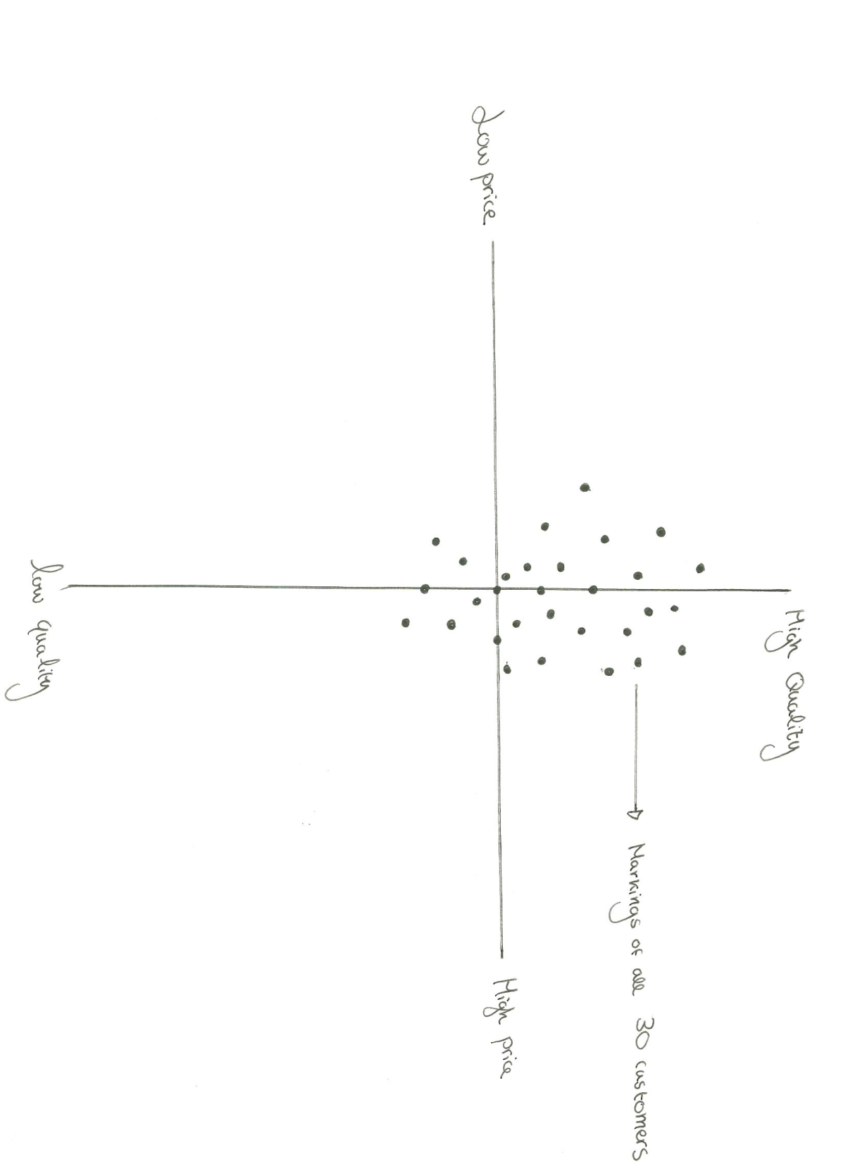
By combining all positioning of SD Concept’s dining chair by each customer, a perception map of all 30 marks was constructed.

Figure 13:

Results demonstrate that the majority of customers rank the quality of product as high quality, average price, however, there are several marks that indicate a product of low quality, average price.
Appendix 5
Daily and annual output of the 3-axis and 4-axis CNC wood router
See Appendix 12- Interview with Mr. X for confirmation of figures

Mr. X has confirmed that the new router will increase productivity by 20%. If the current output of the 3-axis router is 10 chairs per day, then the 20% will generate an improved 12 chairs per day.

Output per year of 3-axis CNC wood router
365 (days) x10 (output per day)=3,650 chairs.

However, if the business chooses to decline the 4-axis router and remain production using the 3-axis CNC router, the outcome per year will be a lower,

Output per year of 4-axis CNC wood router
365 (days) x12 (output per day)=4,380 chairs.

Difference in daily output: 12 chairs – 10 chairs= 2 chairs
Difference in annual output: 4,380 chairs-3, 650 chairs=730 chairs

Appendices 6-
Questionnaire for manual workers

Please complete this questionnaire by ticking only ONE box for each question.
The information is confidential and will not be shown to any higher levels of management. The results are needed for a school project.

Questions | Answers
Have you ever operated a machine? | Yes |  |  |  |  | No
Do you only work on the products made by the 3-axis CNC router? | Yes |  |  |  |  | No
If no, what percentage of your work is fixing up the products produced by the machine? | 10% |  | 20% |  |  | 50% |  |  | 75%
On a scale of 1-5 (5 being the highest quality), what do you think is the quality of products created entirely and manually by hand? | 1 | 2 |  |  | 3 |  | 4 |  |  | 5
What percentage of products have mistakes after fixing is done on the manufactured goods made by the 3-axis CNC router? | 10% |  | 20% |  |  | 50% |  |  | 75%
On a scale of 1 to 5, how demotivated would you be if your colleague lost their job? (5 being very demotivated) | 1 | 2 |  |  | 3 |  | 4 |  |  | 5
How often are you absent from work in a month? | Often |  |  | Sometimes |  |  |  | Never
Would you welcome the introduction of a new machine, to replace the 3-axis CNC router? | Yes |  |  |  |  | No

Appendices 7 - Questionnaire for the two current operators of the 3-axis router

Please complete this questionnaire by ticking only ONE box for each question.
The information is confidential and will not be shown to any higher levels of management. The results are needed for a school project.
Questions | Answers
- How often do you use the 3-axis CNC router? | Very often |  | Quite often |  |  |  | Not often
- How many workers use the 3-axis CNC router approximately every day? Write the amount in the answer box
- Were you given any training for the use of the 3-axis CNC router? | Yes |  |  |  | No
- How often does the 3-axis CNC router break down? | More than once a day | Once a day |  | More than once a week |  | Once a week |  | Once a month
- When it breaks down is it difficult to carry out your job without the machine? | Yes |  |  |  | No
- As a member of staff how reliant are you on the 3-axis CNC router on a scale of 1 to 5? 5 being very reliant | 1 | 2 |  | 3 |  | 4 |  | 5
- Is it possible to produce the product without the machine? | Yes |  |  |  | No
- If yes, how much would the breakdown of the machine affect quality of product on a scale of 1 to 5? (5 being the largest effect) | 1 | 2 |  | 3 |  | 4 |  | 5
- When the 3-axis CNC router breaks, how demotivated are you, on a scale of 1 to 5?  5 being very demotivated | 1 | 2 |  | 3 |  | 4 |  | 5

Appendix 8- information gathered from questionnaire issued to the manual carpenters (See Appendix 7- questionnaire to manual labor)

Figure 14:

From those who answered no to the previous question, a pie chart was drawn to demonstrate the percentage of their work focused on perfecting the products produced by the machine

Figure 15:

Appendix 9- investment appraisal and efficiency ratios
See Appendix 12- Interview with Mr. X, for confirmation of figures

Calculating the Payback of the CNC router (4 axis)

Price of one chair: AED1000
Cost of raw materials to produce one chair: AED660
Contribution= Price/chair-variable cost/chair
Contribution=AED1000-AED660=AED340

According to X, an average of 98 chairs are sold in one month. Therefore, the contribution per month is:
AED340 98 chairs = AED 33,320

Maintenance costs must then be deducted. The maintenance cost per month for the machine is its yearly cost divided by 12.
Therefore; $71,690/12= AED 5,974 per month

Final contribution per month is:
AED 33,320 – AED 5,974= AED 27,346
Payback method is:
Initial investment ($)/ contribution per month ($)
=AED 750,000/ AED 27,346
= 27 months

Accounting Rate of Return for 4-axis CNC router

(Total profit during lifespan/number of years of machine x 100)/ initial amount invested ($)

According to X, the lifespan of the machine will be 4 years.
Net cash flow generated by machine in a month = AED 27,346
In a year= AED 27,346 x 12 months =AED 328,152
In 4 years the profit is= AED 328,152x 4 years =AED 1,312,608
Final profit is obtained by deducting the cost of the investment of $750,000.
AED 1,312,608- AED 750,000= AED 562,608
So ARR=(AED 562,608/4 years)/ AED 750,000= 0.1875
As a percentage=0.1875 x 100=18.75%

Accounting Rate of Return for current 3-axis CNC router
According to X, the lifespan of the current machine is 3 years, and it cost the company AED 690,000 to purchase. The machine is in its 2nd year of lifespan.

The price of each chair sold is AED 1035, however the cost of producing the chair is higher, at AED 740 per piece. Maintenance cost per month is also lower, at AED 5,174 a month. In its 2 years of lifespan, the machine has produced and sold 3, 264 chairs. In its final year, the machine is estimated to produce and sell 98 chairs per month.

Therefore, the net cash flow per month of the current router is:
=Contribution per piece x chairs sold
=(AED 1035-AED 740) x 98 chairs
=AED 295 x 98 chairs= AED 28,910
Maintenance cost per month is deducted so: AED 28,910-AED 5,174=AED 23,736

The net cash flow for its lifespan is: (AED 23,736x 12 months) x 3 years
= AED 854,496

To calculate the ARR:
Net cash flow generated by machine in a month = AED 23,736
In a year= AED 23,736 x 12 months=AED 284,832
In 3 years the profit was= AED 284,832x 3 years = AED 854,496
Final profit is obtained by deducting the cost of the investment of AED 690.000.
AED 854,496- AED 690,000= AED 164,496
So ARR=(AED 164,496/3 years)/AED 690,000= 0.0795
As a percentage=0.0795 x 100=7.95%

Efficiency Ratio- Return on capital employed:
(Net profit before interest and tax/capital employed) x100
= (AED 9,752,574/ AED 26,781,604)
=36.4%

Liquidity Ratio- Acid test ratio
(Current assets-stock/current liabilities)
=(AED 26,612,156-AED 9,564,108)/AED 15,834,381
=1.07:1 =1.1:1

Appendix 10
Information on the dining chair (CH_088)

4-axis machine
Variable cost per unit: AED660
Price per unit: AED1000
Profit Margin: AED1000-AED660=AED340

3-axis machine
Variable cost per unit: AED740
Price per unit: AED1035
Profit Margin: AED295

Appendix 11
Bank loan information and calculation

According to Mr. X, the cost of the 4-axis router is AED 750,000. If the purchase of the machine will be paid by a down payment of 20% and a bank loan for the rest of the 80% then the amount of bank loan required is:

80 percent of 750 000= AED 600 000

Interest rates are 9% annually and therefore interest rates per year are calculated to be:

9% of AED 600 000= AED 54,000 interest rate per year

Appendix 12- Interview with Partner, Mr. X

Translated from Arabic to English: Major questions discussed in the interview

Tell me a bit about SD Concept Furniture Factory
Currently, our factory employs 500 employees essential in the manufacturing process.
We manufacture our furniture and furnishings with a balanced mix of capital-intensive productions and manual carpeting and so the productivity of our machinery and employees is important. As higher management, we are continuously researching ways in which to increase the productivity of the business. To date, we have 100 pieces of specialized machinery, however we are looking to replace a few of the older machinery with new improved capital.

Is your current 3-axis router a machine considered for replacement?
Yes, largely because of its recent breakdowns: to be exact, twice a week. The 3-axis router is a machine we use in the production of our wooden dining chair (CH_088). The chair is one of the more purchased pieces of furniture we have to offer; however we’ve received several complaints from our customers concerning the quality of the detailing. Our company was built on producing finer crafter furnishing, and so it is only natural that we consider a replacement. We supply a range of different products, from tables to cabinets.

What happens to production when the machine is not functioning?
When the machine breaks down, the process of production must continue, but entirely through manual labor.

Will the 4-axis router facilitate an increase in the productivity of the business?
Yes it will. With the 4-axis router, there is an extra axis to allow enhanced detailing of wood, and maneuvering at a faster rate. Therefore, not only will the machine advance productivity by 20%, but quality too is expected to improve.
Right now, the 3-axis router produces 10 chairs per day. Also the greater productivity will allow us to reduce the price of the chair from AED 1035, to AED 1000. This is because variable costs are estimated to reduce to AED 660, from AED 740.

How many chairs are sold in a month?
In average, 98 chairs are sold a month. And last year, out 3-axis CNC router produced and sold 3, 264 chairs. The 4-axis router will have a lifespan of 4 years, whereas the 3-axis router only had one of 3 years.

Do you believe the new router will increase SD Concept’s competitiveness?
The furnishing industry is a very competitive business. Our biggest competitor is Greenline interiors as they specialize in the same area of finer crafter furniture. Also, the qualities of our dining chairs are very similar, and so as Partners, we have noticed a gradual increase in price wars between our business and Greenline’s. Currently, their price is a cheaper AED 1020.

What skills would the operators of the 4-axis router require?
The two operators at current have a general knowledge on how CNC programming works, however with the 4-axis router, there are a few areas in the program that our operators will not have understanding of. For that reason, training would be provided.

Will the 4-axis router require any changes to be made in the production process?
The machine will definitely reduce the manpower required in the fixing of the products afterwards. Therefore a few of our 27 manual laborers will have to be made redundant; right now we have estimated the number at 6 personnel. However, the rest of the manual labor are flexible and can be put into other jobs within the company.

How will the purchase of the 4-axis CNC wood router be financed?
The cost of the 4-axis router is AED 750,000, compared to the price 690 000 for the 3-axis router. The finance required for the purchase will be obtained through a down payment of 20% from retained profits, and medium-term bank loan of three years for the remaining 80%

Is it possible to lease the 4-axis router for trial?
Yes it is.

Appendix 13- Balance sheet and Profit and Loss account

SD CONCEPT FURNITURE FACTORY, Dubai, United Arab Emirates
Income Statement
For the Year Ended 31 December 2011
_____________________________________________________________________________________________

Income Statement

Notes 2011 2010
AED AED

Revenue 31,881,729 31,130,021

Cost of Sales 19 (17,769,496) (16,968,108)

GROSS PROFIT 14,112,233 14,161,913

General expense 20 (3,736,066) (3,512,714)

Depreciation expense (94,515) (128,852)

Provision for doubtful (174,171) (138,188)
debts

OPERATING PROFIT 10,107,481 10,383,159

Finance cost 21 (668,507) (1,068,235)

Other income 22 313,600 312,012

NET PROFIT FOR THE YEAR 9,752,574 9,625,936

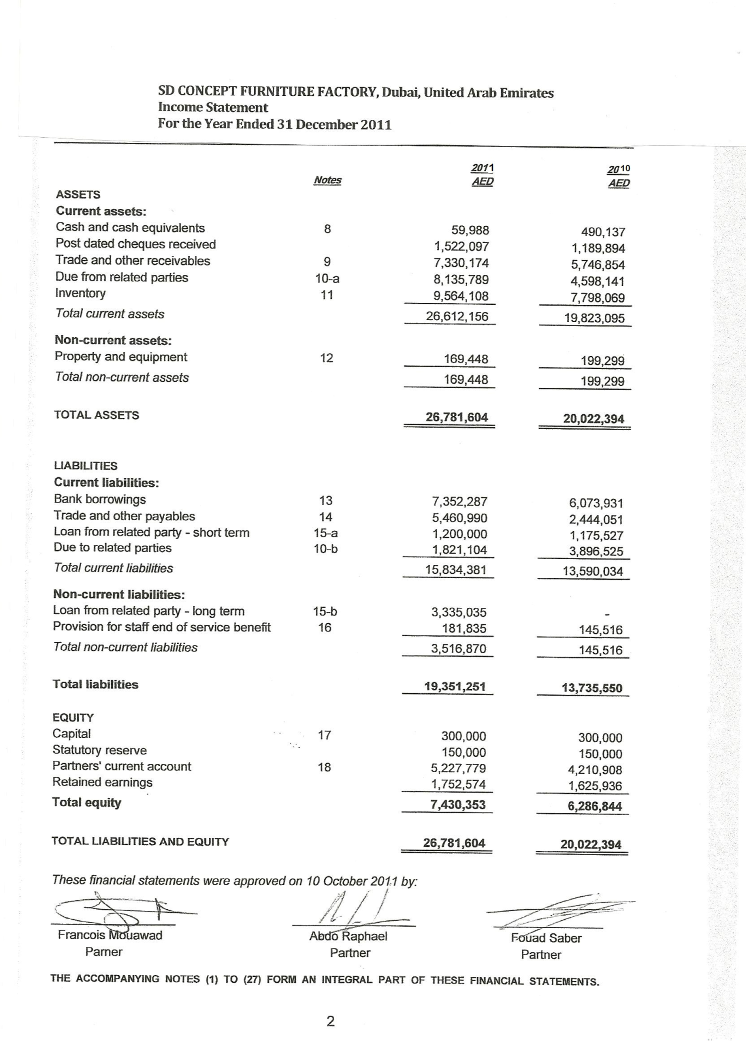

Appendix 14- Maintenance costs of 4-axis machine
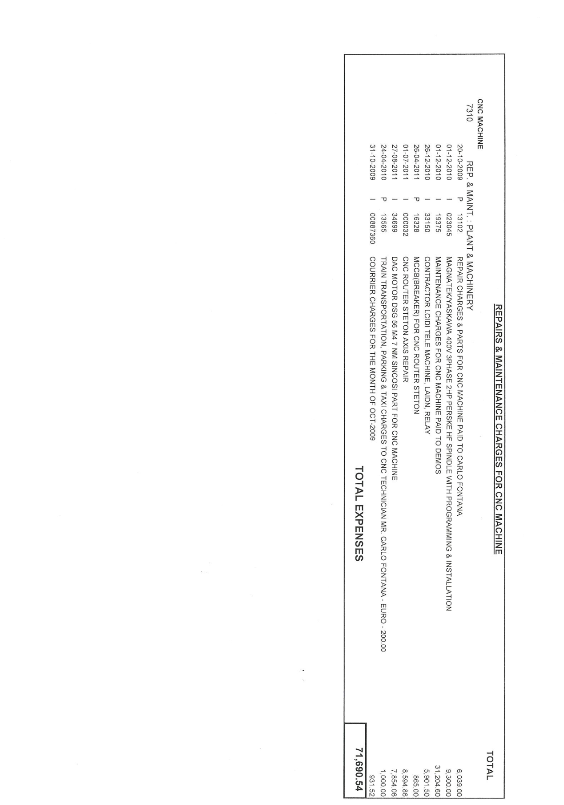

"S.d Concept - Furniture - Emirates Factories." UAE Manufacturers and Suppliers Portal. Web. 29 Feb. 2012. <http://www.emiratesfactories.com/supplier/221/sd-concept/>.
"S.d Concept - Furniture - Emirates Factories." UAE Manufacturers and Suppliers Portal. Web. 29 Feb. 2012. <http://www.emiratesfactories.com/supplier/221/sd-concept/>.
See Appendix 12- Interview with Partner,
See Appendix 12- Interview with Partner,
See Appendix 13- Profit and Loss account and Balance sheet
CNC router- a CNC wood router is a numerical tool that creates objects-in this case furniture-from wood
See Appendix 10- Image of the wooden dining chair, reference CH_088
See Appendix 12- Interview with Partner,
See Appendix 1- SWOT Analysis
"CNC Woodworking Machines Types and Features." CNC Woodworking Machines: Types and Features Buy, Build, Learn. Web. 29 Feb. 2012. <http://www.cncroutersource.com/cnc-woodworking.html>.
"Greenline Interiors." Greenline Interiors. Web. 01 Mar. 2012. <http://www.greenline-interiors.com/>.
See Appendix 7- Questionnaire to operators of the 3-axis CNC wood router
See Appendix 6- Questionnaire to manual labor
See Appendix 2- Questionnaire to customers of the dining chair (CH088) within the past year
See Appendix 13- Balance sheet
See Appendix 13- Profit and Loss account
See Appendix 9- Investment appraisal and Efficiency ratios
See Appendix 14- Maintenance costs of the 4-axis CNC wood router
See Appendix 12- Interview with Partner, Mr. X
See Appendix 5- Daily and annual output of the 3-axis and 4-axis CNC wood router
See Appendix 3- Graphs and tables formulated from questionnaire to customers
See Appendix 3- Graphs and tables formulated from questionnaire to customers
See Appendix 12- Interview with Partner, Mr. X
See Appendix 6- Questionnaire to manual labor
See Appendix 8- Graphs formulated from questionnaire to manual labor (figure 14)
See Appendix 8- Graphs formulated from questionnaire to manual labor (figure 15)
See Appendix 12- Interview with Partner, Mr. X
See Appendix 6- Questionnaire to manual labor
See Appendix 6- Questionnaire to manual labor
See Appendix 7-Questionnaire to operators of the 3-axis CNC wood router
See Appendix 12- Interview with Partner, Mr. X
See Appendix 12- Interview with Partner, Mr. X
Hoang, Paul. Business & Management. [Melton, Vic.]: IBID, 2007, Print, p. 622.
See Appendix 12- Interview with Partner, Mr. X
See Appendix 12- Interview with Partner, Mr. X
See Appendix 12- Interview with Partner, Mr. X
See Appendix 10- Variable costs and price
See Appendix 2- SWOT Analysis
See Appendix 12- Interview with Partner, Mr. X
See Appendix 3- Graphs and tables formulated from questionnaire to customers
See Appendix 2- SWOT Analysis
See Figure 4 pg.12
See Appendix 3- Graphs and tables formulated from questionnaire to customers
See Figure 3 pg.11
See Appendix 4- Position (perception) maps
See Appendix 2- SWOT analysis
See Appendix 12- Interview with Mr. X
See Appendix 2- SWOT Analysis
See Appendix 2- SWOT Analysis
Hoang, Paul. Business & Management. [Melton, Vic.]: IBID, 2007, Print, p. 275.
See Appendix 2- SWOT Analysis
Hoang, Paul. Business & Management. [Melton, Vic.]: IBID, 2007, Print, p. 272-273.
See Appendix 8-Graphs formulated from questionnaire to manual labor
See Appendix 12- Interview with Partner, Mr. X
Hoang, Paul. Business & Management. [Melton, Vic.]: IBID, 2007, Print, p. 272-273.
See Figure 5, pg.13
See Appendix 2- SWOT Analysis
Hoang, Paul. Business & Management. [Melton, Vic.]: IBID, 2007, Print, p. 145.
See Appendix 2- SWOT Analysis
See Appendix 2- SWOT Analysis
See Appendix 9- Investment appraisal and efficiency ratios
See Appendix 11- Calculation of bank loan and investment
Hoang, Paul. Business & Management. [Melton, Vic.]: IBID, 2007, Print, p. 350.
See Appendix 9- Bank loan information
See Appendix 9- Investment appraisal and efficiency ratios
See Appendix 9- Investment appraisal and efficiency ratios
See Appendix 12- Interview with X
See Appendix 9- Investment appraisal and efficiency ratios
See Appendix 12- interview with Partner, Mr. X
"S.d Concept - Furniture - Emirates Factories." UAE Manufacturers and Suppliers Portal. Web. 29 Feb. 2012. <http://www.emiratesfactories.com/supplier/221/sd-concept/>.
Appendix 9- Investment Appraisal and Efficiency ratios
"Furnishing Profits in Middle East." Franchise Business, Business Opportunities, Franchise Opportunities, Business Opportunities for Sale. Web. 29 Feb. 2012
Hoang, Paul. Business & Management. [Melton, Vic.]: IBID, 2007, Print, p. 275.
Hoang, Paul. Business & Management. [Melton, Vic.]: IBID, 2007. Print, pg. 488
Appendix 12- Interview with Mr. X

