IB Math Studies-year 1

HOMEWORK ON QUADRATICS due day of quiz

For 

1. Evaluate:

ƒ(2) g(9)

ƒ(-1) g(0)

f(x) – g(x)

1. Find the value of x

When ƒ(x) = 12 When g(x) = -3

When g(x) = 5 When ƒ(x) = -10

1. Sketch the graph: y =
2. Find the equation of the axis of symmetry
3. Find the coordinates of the Vertex
4. Sketch it.
5. State the domain and range of this function
6. After sketching it, find the x-intercepts if any. The y-intercept. Is it consistent with your sketch?
7. For each of the following graphs find the equation of the axis of symmetry:

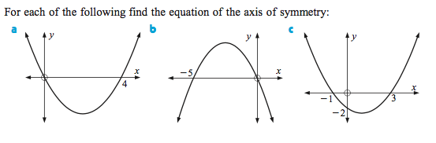

1. Graph the following parabolas. (Decide a good scale, LABEL YOUR AXIX)
2. 

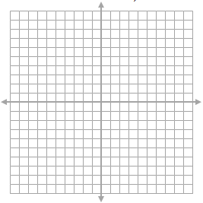

1. 



1. 



1. 



1. From the graphs given, find the equation of the function.
2. Example 1:

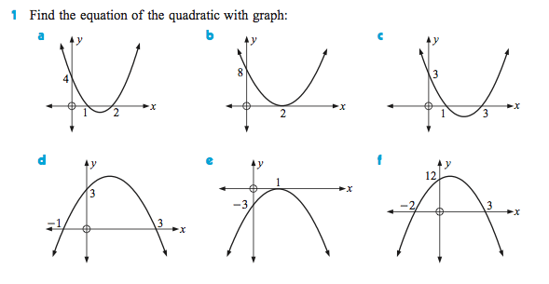

1. Example 2:

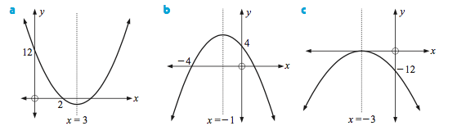

1. Example 3:

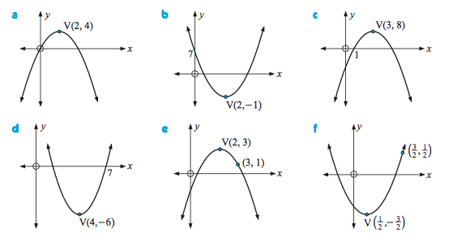

**Answers:**

**Part I:**

ƒ(2) = 2 g(9) = -76 ƒ(-1) = -10 g(0) = 5



**Part II:** x=-6.22 or x=3.22 x=2.83 (or √8) or x=-2.83 (or -√8)

x = 0 x = -2 or x =-1

**Part III:**

**Part IV:**

a) x=2 b) x=-2.5 or -5/2 c) x=1

**Part V:**

**a) b)**

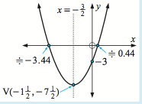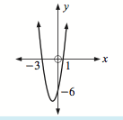

c) d)

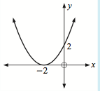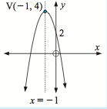

**Part VI:**

Ex. 1

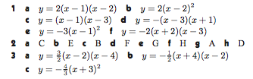

Ex.2

Ex.3

